Blueprints

Chapter V

Section 1 Introduction
- What is a blueprint, and how did it get its name?

- How are most prints used in construction created nowadays?

- List the 5 different types of blueprints that are commonly created for use in construction.

- What are two items that are used to visualize how a building should be built and what materials must be used?

- Why must planners, suppliers, and builders be able to understand a set of prints?

- List the six items that make up a set of prints or plans.

- What is Computer –Aided Drafting (CAD) (blue dialog box on top of page 5-4)

- Before CAD was introduced how were drawings created ?

- List 5 advantages that CAD has over the older method of drawing a set of plans (blue dialog box on top of page 5-4)

- What are civil plans used for?

- What are other names for civil plans?

- Architectural plans are also called what?

- What are the five parts of an architectural plan?

- Which set of blueprints shows the height of the side of the building?

- A buildings roof framing is shown on which set of blueprints?

- The layout and dimensions of rooms, stairwells, doors, and mechanical equipment are shown on which set of blueprints?

- What do the elevation drawings show? List all that applies.

- What does the section drawing show? Be specific.

- What is a detail drawing and what does it show?

- What is a topographic map?

- What do the lines on a topo map represent?

- What is a structural plan?

- What are the parts of a structural plan?

- How did blueprints start?

- What does the blue box on page 5.13 say? Be specific.

- Specifications and locations of HVAC equipment, grilles, and registers are on which set of plans?

- What are mechanical plans and what do they contain?

- What are the parts of the plumbing plan?

- What may happen if the project is commercial?

- What are electrical plans?

- What do electrical plans include?

- What may happen to the electrical plan if the project is complex?

- What do more complex electrical plans include?

- What may complex electrical plans leave out?

- What is figure 18?

- What is figure 19?

- What is an RFI and what is the chain of command for submitting one?

- What is an isometric drawing?

- What is an orthographic drawing?

- What is a schematic drawing?

- What does the line represent on a schematic drawing?

- Why should you check all of the plans and what do you do if something is missing from a plan?

Section 2 Components of a Blueprint

- What are the five parts of a blueprint?

- Where is the title block normally located on a blueprint?

- What are the two purposes of the title block?
- The title block usually contains 7 things. What are they?
- What is the sheet title?

- What is the drawing number?

- What does the revision block contain? Be specific.

- What does the border on a blueprint do?

- Where is the revision block located and what does it contain?

- What is the legend on a blueprint for?

- What does the green box on page 5.35 say about the north arrow?

Section 3 Scale

- What does the scale of the drawing tell?

- What does NTS mean?

- What are the three types of measuring tools used to draw a blueprint?

- When is an engineer’s scale used?

- When is an architect’s scale used?

- Why is an architect’s scale triangle shaped and how can it be read?

- What scales can be developed using an architect’s scale?
- What does ½ “x 1’-0” mean?

- What is a metric scale?

Section 4 Lines of Construction

- What are the common types of lines listed on page 5.40?
- What do dimension lines establish and what do they end with?

- What are “leaders” and what is another name for it?

- What do property lines indicate?

- What are cut lines?

- What are break lines?

- What are hidden lines?

- What are center lines?

- What are object lines?

- The exact location of a column on a drawing is shown by which line of construction?

Section 5 Abbreviations, Symbols, and Keynotes

- Why are abbreviations, symbols and keynotes used in blueprints?

- What is a number or letter, usually with a leader or an arrowhead which is used to identify a specific object is called?(figure 37)

- What do these symbols represent?

Section 6 Using Gridlines to Identify Plan Locations

- What are gridlines shown on a plan compared to?

- Where do the numbering and lettering system begin on a set of plans?

- What letters are omitted from the gridline system? Why?

- Draw an X at location G4.

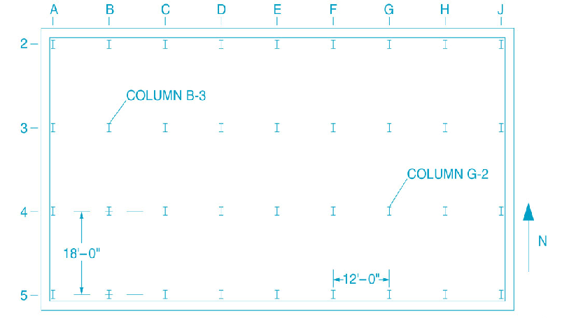

- What are the rules for taking care of blueprints?
Section 7 Dimensions

- What do the dimensions of a blueprint show?

- What does a dimension line look like?

- Label the interior and exterior dimensions of the cross section of pipe below.
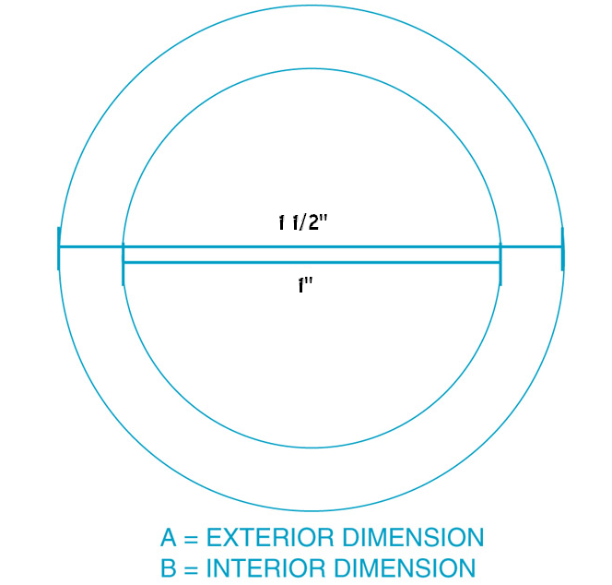

- What will happen if you have an inaccuracy or miscalculation when reading blueprints?

- What is the inside dimensions of the pipe?
- What are thee outside dimension of the pipe?
- What is the difference?

