Building Construction Cluster

Core Unit Chapter III

- How does using and maintaining hand tools relate to craft skill?

- To be a safe worker, what should you do before using a hand tool or any tool?

- According to the warning box on page 3-2 what should you do when you are using tools?

- What qualities do hammers have for different types of tasks?

- What two types of hammers are discussed in the unit?

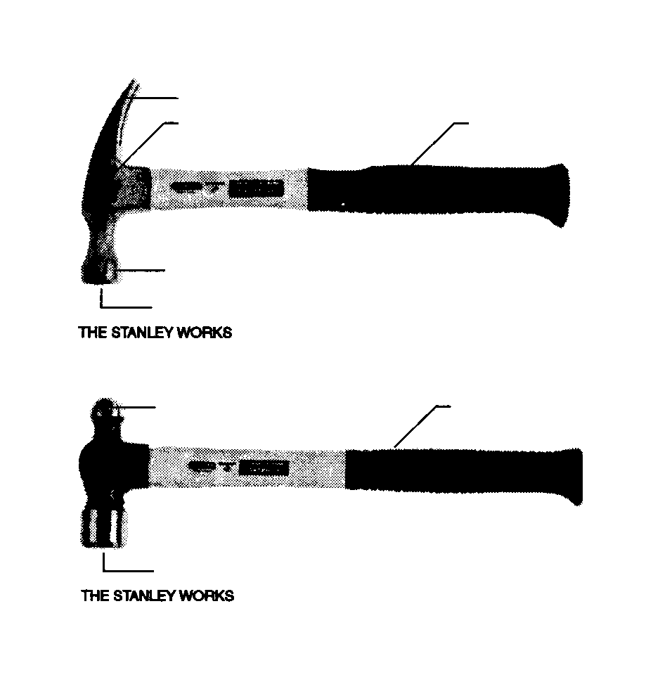
- On the pictures below label each hammer type and the parts of each hammer.
Name of Hammer
Name of Hammer
- Fill in the chart below that details about weight and purpose of each type of claw hammer

Hammer Size (weight) | Intended purpose

- What does the warning box advise doing in order to prevent an injury when driving nails etc.?

- Look at the information box on page 3-2. What are the qualities of a well-made hammer and those of a poor hammer?

- What two types of claw hammers are there?

- If a hammer has a rounded head what is it known as?

- What is the advantage of a claw hammer with a flat head, what is the disadvantage?

- What is the advantage of a claw hammer with a rounded head, what is the disadvantage?

- Write the steps for driving a nail with a claw hammer.

- Write the steps for removing nails from wood with a claw hammer.

- What should be done if the nail to be pulled out is long? Why should this be done?

- What is the rounded part of a ball peen hammer used for?

- What does the first warning box on page 3-3 state about using a hammer?

- What does the second warning box state?

- Summarize what is said in the box at the bottom of page 3-4 about Physics and the Hammer.

- What is the term for holding a hammer handle too close to the hammer head (ask instructor)?

- List the two steps for using a ball peen hammer (what was left out?).

- List the safety and Maintenance rules for hammers.

23 cont.

- List the six types of screws and a brief description of each one

Screw Type | Description

- Label the pictures of each screw head type.

- What two screw head types are the most common?

- Name the three parts of a typical screwdriver

- Which part is tempered? Why is that important?

- What does the word tempered mean
- What is the difference between poor quality screwdrivers and good quality screwdrivers

- What can result when a screwdriver is used incorrectly?

- List 5 steps for using a screwdriver

- What does the warning box on page 3-7 state about driving screws?

- In the “Did you Know” panel on page 3-8 what does the word drywall mean?

- How do drywall hangers attach the material to the building

- List the seven rules for safety and maintenance of screwdrivers

- Why might a file not work to straighten a screwdriver tip

- Why should you not expose a screwdriver to excessive heat?

- What are sledge hammers used for?

- What is the size range for sledge hammers?

- What influences the shape of the sledge hammer head?

- In the box at the top of page 3-9 what does the word mallet mean?

- List as many ways as you can for how stakes are supported as they are being driven into the ground.

- List the eight steps for using a sledge hammer properly.

- List the six safety and maintenance rules for sledge hammers.

- What are two names for a category of tools that are used to pry woodwork apart, and pull out nails?

- What are three other names for the ripping bar and what is the tool’s length range?

- What is a ripping bar used for?

- List the two steps for using a ripping bar

- List three types of nail pulling tools.

- What are another names for a Nail Claw

- What is the Nail Claw used for?

- What is a chisel bar used for?

- What other names does a flat bar have?

- List three steps for using a Nail Claw

- List three Safety/maintenance steps for using these prying/pulling types of tools.

- What is the reason that most accidents occur with a pry bar?

- What is another reason why an accident occurs

- What are wrenches used for?

- What are the two general categories of wrenches?

- What measurement groupings do no adjustable wrenches come in?

- List four nonadjustable wrench types and briefly describe each one from the text

Wrench Type | Description

- List the steps for using nonadjustable wrenches.

- Why is it important to use the correct size wrench

- What are adjustable wrenches used for?

- List 3 common types of adjustable wrenches and briefly describe each type

Adjustable Type | Description

- What is another name for a pipe wrench?

- What are other names for a crescent wrench?

- List the five steps for using an adjustable wrench

- List five safety/and maintenance steps for using adjustable wrenches.

- What is another reason not to use a handle extension on an adjustable wrench?

- What are pliers?

- What are pliers used for?

- What should pliers not be used for, why?

- What kind of steel are good quality pliers made of?

- What is hardened steel?

- List the five common types of pliers

- What does the “R” in the circle next to the words Channellock and Vise-Grip mean?

- How many jaw settings do slip-joint pliers have?

- What are three things to do to use slip-joint pliers (3 steps)

- In the Blue box on page 3-12, What construction occupation is being described?

- In order to install electrical systems in homes offices of factories what must one be able to do (first sentence of blue dialog box on page 3-12)?

- What type of pliers is used for bending angles in wire?

- What is a spring opener, how does it work?

- What can you do if the pliers you are using do not have a spring opener?

- Describe lineman pliers. What are they also known as?

- List three steps for using these pliers safely.

- What kind of teeth do channellock pliers have?

- What does the word serrated mean?

- How many positions can channellock pliers be opened to?

- What are other names for channellock pliers?

- List four steps for using channellock pliers.

- Vice-grips grab/hold an object similar to what other type of tool?

- What two things on the handle help to control how the vice grips work?

- Describe what each part does

- List 5 steps for using vice-grips

- List 10 maintenance/safety rules for vice-grip use

- What does the warning box on page 3-16 state about using pliers?

- Describe what the terms level and plumb mean?

- What is the name of the tool that indicates whether a surface as either of these two qualities?

- What is the name of the type of tool that is used on most construction sites to indicate level or plumb?

- What is a vial?

- How many vials are on a typical leveling tool, and which ones indicate plumb or level?

- Draw the vials on this drawing of a level (be sure to turn them in the correct direction.

- What is a vial filled with, why is it filled with this type of liquid ?
- How does a vial work to indicate level or plumb?

- What is the “rule of thumb” for level length?

- What occupational area is described in the box on page 3-20 in the blue dialog box.

- Why is the proper use of a level important for this occupational group?

- What materials do they work with and how long have these types of materials been in existence?

- When this material is applied to a structure in a straight row what is it known as?

- What three tools are mentioned in the blue dialog box?

- List two steps for using a level (site might require use of safety glasses but not needed for tool use)

- Why must care be taken when this type of tool is used?

- List 4 safety/maintenance steps for using a level

- What tool is described on page 3-22 for marking checking and measuring?

- List four common types of these tools used by construction workers.

- List two types of measuring tools that are “L” shaped

- List three names of measuring tools that are triangle shaped

- What is the name of a measuring tool that has a sliding blade

- List the four types of squares and briefly describe each one.

Type of Square | Description

- List 3 steps for using a square as a marking guide (site might require use of safety glasses but not needed for tool use)

- How does one check a corner for squareness?

- List two steps for checking a surface’s flatness (site might require use of safety glasses but not needed for tool use)

128 Cont.

- List four things that combination square can be used for

- List three steps for marking a 90 degree angle with a combination square

- List three steps for marking a 45 degree angle with a combination square

- List three steps for marking a parallel line at a certain distance with a combination square

- What tool, (studied earlier) can a good combination square be used similar to?

- List five safety/maintenance rules for combination squares

- What are four basic types of measuring tools?

- When preparing to purchase a measuring tool what should be kept in mind?

- List three tools that are described in the text and give a brief description of each

Measuring tool | Description

- List 4 safety /maintenance rules for these measuring tools

n
- Describe a bench vice.

- What materials have replaced the use of stone as a main construction material?

- What is the process called where the rough jagged edges of stones are removed and the stone is shaped to fit a certain space?

- Write 6 steps for using a steel tape measure

- The blue dialog box on page 3-18 describes precision measuring instruments. List two examples of such instruments.

- What is the standard accuracy of these types of tools?

- What is the name of the part of the bench vice that turns against and tightens the moveable jaw?

- According to the warning box on page 3-28 what should you not do to a vice handle?

- If you do use a bench vice to hold wood, what is a good practice to follow?

- List the six safety/maintenance rules for bench vices.

- How are clamps sized, and what are their size ranges

- List the seven major types of clamps and a brief description of each one.

Clamp Types | Description

- List two steps for using clamps.

- Why are pipe clamps and bar clamps an exception to the size limits of question #148?

- List seven safety/maintenance rules for clamps

- What is the name of a wood or metal cutting tool that has teeth?

- What are teeth?

- What does the word set mean when applied to saw blades?

- What is the rule of thumb for a saw’s TPI?

- What is wood grain, and which type of tool cuts in the same direction (parallel) as the wood grain?

- Which type of tool cuts across the grain?

- List six types of saws and a brief description of each type

Saw Types | Description

- What is a miter joint?

- What is a tenon, a mortise?

- Because a hack saw’s blades are changeable for various tooth types how is the proper blade selected

- What is a bimetallic blade and why is it a superior blade to a “standard” one?

- Why is a handsaw blade made of tempered steel?

- What does the word kerf mean?

- What is a “double cut” handsaw?

- List the 9 steps for using a crosscut hand saw.
169 Cont.

- What does it mean when a handsaw pulls?

- According to the blue dialog box on page 3-33, what group of people developed the claw hammer?

- List the 4 safety / maintenance rules for handsaws.

- The blue dialog box on page 3-35 describes a material used in the construction industry. What is it, and what are its characteristics (ask instructor)

- What is carborundum?

- List three materials that files and rasps can be used to shape.

- What material are these cutting tools (files & rasps) made of?

- What is the rule of thumb for selecting a correct file for a given material’s hardness.

- What happens if the wrong file is selected for a given material’s hardness?

- What is a file tang and what is its purpose?

- List the four file classifications and describe how each is made and used. (Blue box bottom of page 3-38)

File Type | Description | Use

- How are rasps classified?

- List the 8 steps for file / rasp use

- List 5 safety & maintenance rules for files / rasps
- Describe what a chisel is and what it is used for.

- In the blue box on page 3-39 what power tool is described as useful for caring for some of the hand tools that will be studied in this unit?

- List 6 steps for proper use of the wood chisel

- What is a butt hinge?

- What is a cold chisel how is it different from a wood chisel?

- What is important to keep in mind about using a cold chisel?

- List four steps for using a cold chisel

- What does the warning box on page 3-41 state about using a chisel?

- Describe a punch, what it looks like how it is used.

- List six safety/maintenance rules for chisels

- Describe a plumb bob

- How is a plumb bob used?

- What does the warning box on page 3-26 state about plumb bobs?

- List 4 steps for using a plumb bob

- In the blue box on page 3-25 is a description of something that can affect the use of a plumb bob, what is it?

- Which part of a socket and ratchet grips a nut or bolt?

- Which part of a socket and ratchet is the handle part?
- Describe how a socket is shaped.

- What is other name is given to deep sockets?

- What is a socket wrench set?

- List 4 steps for using a socket and ratchet.

- List 2 Safety/Maintenance rules

- What is torque?

- What tool is a torque wrench similar to in shape and function?

- How does a torque wrench work?

- What is the purpose of a torque wrench?

- What units of measurement does a torque wrench measure?

- List the four steps for using a torque wrench

- In the blue box at the bottom of page 3-47 is a description of the optimum conditions for using a torque wrench. What are those conditions?

- Describe a wedge and what its uses are.

- List 5 steps for using a wedge

- List 2 safety /maintenance rules for wedges.

- What is a chalkline?

- How can a simple chalkline be made for a one person use?

- What is a mechanical self-chalking line?

- Why is only chalkline string useful for this purpose?

- List 3 steps for using a chalkline.

- What is a problem for chalklines that are exposed to excessive moisture?

- What is a utility knife?

- List five steps for using a utility knife.

- What is the risk that is described on page 3-50 in the warning box?

- What is important to remember about using any cutting tool that has a blade?

- Describe a chain fall

- Describe a come-along

- After reading the section on these types of tools and the warning box on page 3-52, describe the difference between these two similar tools.

- What mechanism keeps a load being lifted by a chain fall from falling back down?

- List the 7 safety/maintenance rules of these types of tools.

- Why is it important never to use these types of tools with damaged chains or cables?

- Describe a wire brush

- Why is a wire brush so useful on a construction site?

- What does the warning box state on page 3-53

- Why is it a good idea to wear gloves when using a wire brush, especially a used/worn one?

- What is the one most important safety item to remember about using a shovel (and it isn’t in the book!!!!)

- List 4 safety/maintenance rules for shovels.

- How might a file be a handy tool for use with a shovel (think about it)?

