dsad
Name: ___________________________ Date: _______________________

The Perfect Economy?
Interest Approach FCS-CA-3
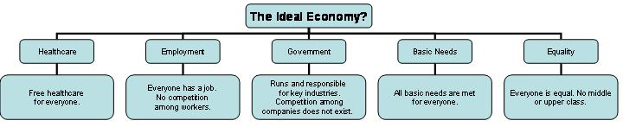
Economic Systems

1. What is the most appealing aspect of this economy to you? Why?

2. Do you believe a perfect economy really exists? Name one example?

3. Do you believe there can really be a classless society?

4. What are three key industries that the government would be responsible for?

a. ____________________ b. ____________________ c. ____________________

5. Do you think it is good or bad that medical care is free in this economy? Explain your answer.

6. Explain one drawback of an economy that has a classless society?

7. Would people be motivated to work hard if there is no competition?

8. Which is this? (circle one) capitalism socialism communism

9. This economy sounds great on paper. Write a paragraph about why it might not work well.
(use the back of this paper)

10. How is the U.S. economy different or alike from the economy described above? Explain your answer on the back of this page. Be sure to distinguish each of these areas:
Healthcare, Employment, Government, Basic Needs, and Equality.

