Name:______________________ Date:_______
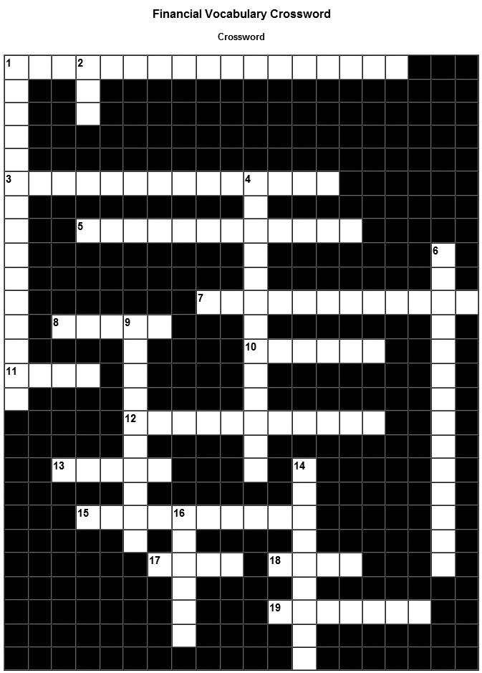
Across:

1 The long-term process of managing your finances so you can achieve your goals and dreams.
3 Licensed institutions which specialize in investing.
5 Something for which a set amount of money must be paid regularly.
7 Financial ___________: Businesses that offer multiple services in banking and finance.
8 Something you must have for survival, such as food and water.
10 A plan for the use or management of money.
11 Provides insurance for savings & loans associations and is a branch of FDIC.
12 A record of how much you spend, when, and on what.
13 Something that you would like to have, but it is not necessary, and you could do without it.
15 An amount the bank charges for use of the checking account.
17 Provides insurance protections for credit unions.
18 A federal government agency which insures federally chartered commercial banks against loss.
19 Money that is set aside for future use especially in a bank where interest is earned.

Down:

1 An expense that varies in amount and does not occur on a regular basis.
2 Annual Percentage Rate; the annual rate of interest charged for credit.
4 A purchase made quickly without much thought.
6 The minimum amount of money required in your account. Having an amount less than the minimum balance may result in extra service charges or reduced privileges.
9 ___________ Institution: A financial institution that offers banking service and loans to individuals and business.
14 To write a check for more money than what is in the account.
16 The amount of money a person receives for doing a job.

