Name: ___________________________________ Date: ____________

Unit 7: Fraud

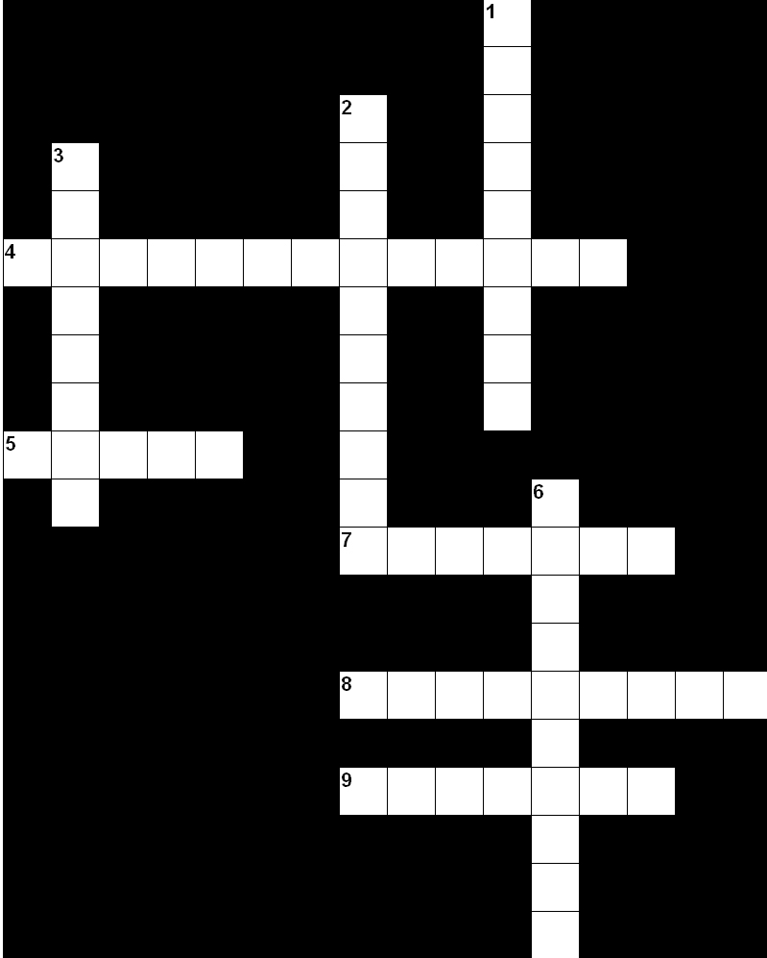

Across: | Down:
4. A sales practice in which a retailer advertises a product at a bargain price and does not intend to sell a customer that item but to persuade the customer to buy another item at a higher price. | 1. A material representation, omission, or practice that is likely to mislead a reasonable consumer to the consumer's detriment.
5. The deliberate deception of another for some gain. | 2. An item in a store priced below cost in order to draw in business.
7. A remedy or compensation for a wrong or grievance. | 3. A type of fraud that plays on human emotions and fears.
8. A marketing practice of convincing a customer to buy a higher-priced item than the customer originally intended to purchase. | 6. Something done unintentionally.
9. The use of claims or descriptions to exaggerate a product's reputation or appeal.

Fraud and Deception
Answer Key

