Oral Health – Handout B
Unit 8 – 4a part2
Name _________________________ Date _______________________

Bone - the hard supportive tissue in which the tooth's root is anchored.  Crown - the visible part of a tooth.  Dentin - the hard but porous tissue located under both the enamel (and cementum) of the tooth. Dentin is harder than bone.  Enamel - the tough, shiny, white outer surface of the tooth.  Gum - the soft tissue that surrounds the base of the teeth. | Nerves and Blood Vessels - nerves transmit signals, and blood vessels carry nutrients to the tooth - they run through the tooth's root within the pulp.  Pulp - the soft center of the tooth. The pulp contains blood vessels and nerves; it nourishes the dentin.  Root - the anchor of a tooth that extends into the bone of the jaw. The number of human tooth roots ranges from one to four.

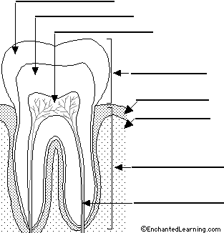

http://www.enchantedlearning.com/subjects/anatomy/titlepage.shtml

