Human Growth and Development
You will be required to keep this signed copy in your classroom notebook. A copy will also be kept on file.

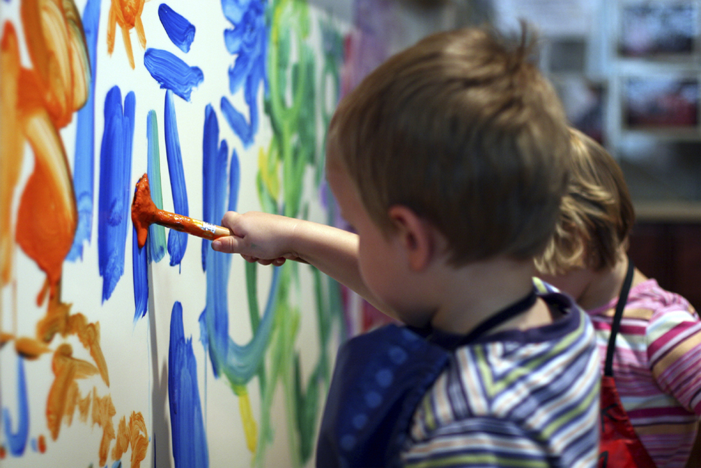
High School

Family & Consumer Sciences Department

Grade Level: 9th-12th

Teacher:
Texts: Working with Young Children, Goodheart-Wilcox
The Child Care Professional, Glencoe-McGraw Hill
The Developing Child, Goodheart-Wilcox

Course Description: Human Growth and Development for Early Childhood addresses the knowledge, skills, attitudes, and behaviors associated with supporting and promoting optimal growth and development of infants and children. Topics that may be addressed include principles of physical, emotional, social, cognitive, and moral development; human needs across the ages and stages of childhood; impacts of family and societal crisis on the development of the child; and career decisions. Mastery of standards through project based learning, technical skills practice, and leadership development activities of the career and technical student organizations will provide students with a competitive edge for either entry into the education global marketplace and/or the post-secondary institution of their choice to continue their education and training. Because Family, Career and Community Leaders of America (FCCLA) is co-curricular with this class, students are encouraged to join and be active participants.

Course Objectives:
HGD-2 Students will make informed career decisions that reflect personal, family, and career goals.
HGD-3 Students will explore the growth, development, and care of the newborn.
HGD-4 Students will analyze the growth, development, and care of the infant.
HGD-5 Students will investigate the growth and development of the toddler.
HGD-6 Students will examine the growth and development of the preschool child.
HGD-7 Students will acquire techniques for observing and assessing behavior and development of children.
HGD-8 Students will identify characteristics of appropriate curriculum.
HGD-9 Students will describe a well organized environment conducive to student learning.
HGD-10 Students will identify appropriate materials and equipment for a child care center.
HGD-11 Students will analyze ways to encourage and guide the creative development of children ages birth to fives years of age.
HGD-12 Students will describe an appropriate daily routine.
HGD-13 Students will identify developmentally appropriate guidance techniques.
HGD-14 Students will be introduced to children with special needs.

Program Requirements:
1. Complete all daily work, tests, projects, and labs by assigned due date. Late assignments (not due to excused absences) will lose 20 points per day and will not be accepted after 2 late days. An assignment not being turned in immediately upon teacher’s request is considered late.
2. Complete all make-up work within 2 days of an excused absence. An additional day may be allowed for each consecutive excused absence thereafter. You will not be allowed to make up work from unexcused absences.
3. Provide one 1” clear-cover notebooks & dividers to accommodate classroom assignments.
4. Be prompt to assigned classroom and be prepared for planned lessons. Tardies are unacceptable.
5. Some class and home projects may require purchased materials.
6. All work is to be done in blue or black ink, pencil, or word processing document.
7. Student’s name and date should be written on upper right corner of every assignment. 5 points may be taken from any paper, (that can be identified), without necessary information.
9. Students are required to join the student affiliation of PAGE (Professional Association of Georgia Educators). $7.
10. Students are strongly encouraged and expected to join FCCLA (Family, Career, and Community Leaders of America). $20.00 includes local, state, and national affiliation and t-shirt.

Materials Needed: Students are to provide one 1” notebook, notebook paper, dividers for notebook, blue or black ink pens, pencils and project supplies (i.e. report folders, poster boards, and markers).

Student Activities:
Text book reading Unit and lesson planning
Independent work Observations

Grading Criteria:

A. Brain Warmups 5%
B. Projects, Tests, Labs 50%
C. Daily work 30%
D. Final Exam 15%

Assignments never stop; you’ll always have one. Free time does not exist in the Early Childhood Education department. If you are faster than other students, hooray! You will have more opportunity to apply your knowledge preparing activities for children.

Journal Entries:
We will be doing Brain Warmups each day and the student is responsible for completing these in their journal. Journals will be taken up without notice and a grade will be assigned for completing the journal entry.

Other Classes you may want to take are: Teaching as A Profession; Art; Nutrition & Wellness; Psychology; Sociology; Introduction to Early Childhood Education; Health, Safety, and Nutrition for the Young Child

Careers related to Early Childhood Education are bountiful:
Teachers, Paraprofessionals, Child care directors, Parent Educator, Child care resource and referral specialist, child
development consultant, Lawyers who specialize in child care law, Architects who specialize in designing child care center buildings, Dietician or Nutritionist, Pediatrician, Play therapist, Nanny, Author of children’s books, Social worker, Counselor, School psychologist, Music teacher or therapist, ect… (These are only a few, the list is long).

In addition, parenthood is not necessarily thought of as a career, but it is the most important responsibility one can ever be given in life. The ECE class offers multitudes of opportunity to learn the principles needed for successful parenting.

Photos/Videos: On occasion, pictures and/or videos will be taken of students and their participation in activities and projects. Parents must contact me if this is not acceptable for their child. Signing this syllabus signifies parental acceptance of student possibly being captured on film for scrapbook or program marketing purposes.

Teacher Information:

Email:
Planning Period is th block
Phone:
Website:

I know you are all eager to begin. With everyone’s help and determination we will have a successful year learning about children and working in the preschool. If you or your parents have questions regarding the course expectations please do not hesitate to ask. By signing this syllabus, you are signifying that student and parent/guardian have read the syllabus and accept the responsibilities and requirements of the Early Childhood Education program.

_____________________________________ ______________________________________
Student Signature Parent/Guardian Signature

