The Value of Play
A WebQuest for Child Development and Early Childhood Education students
Designed by
Landis Hicks
lhicks@habersham.k12.ga.us
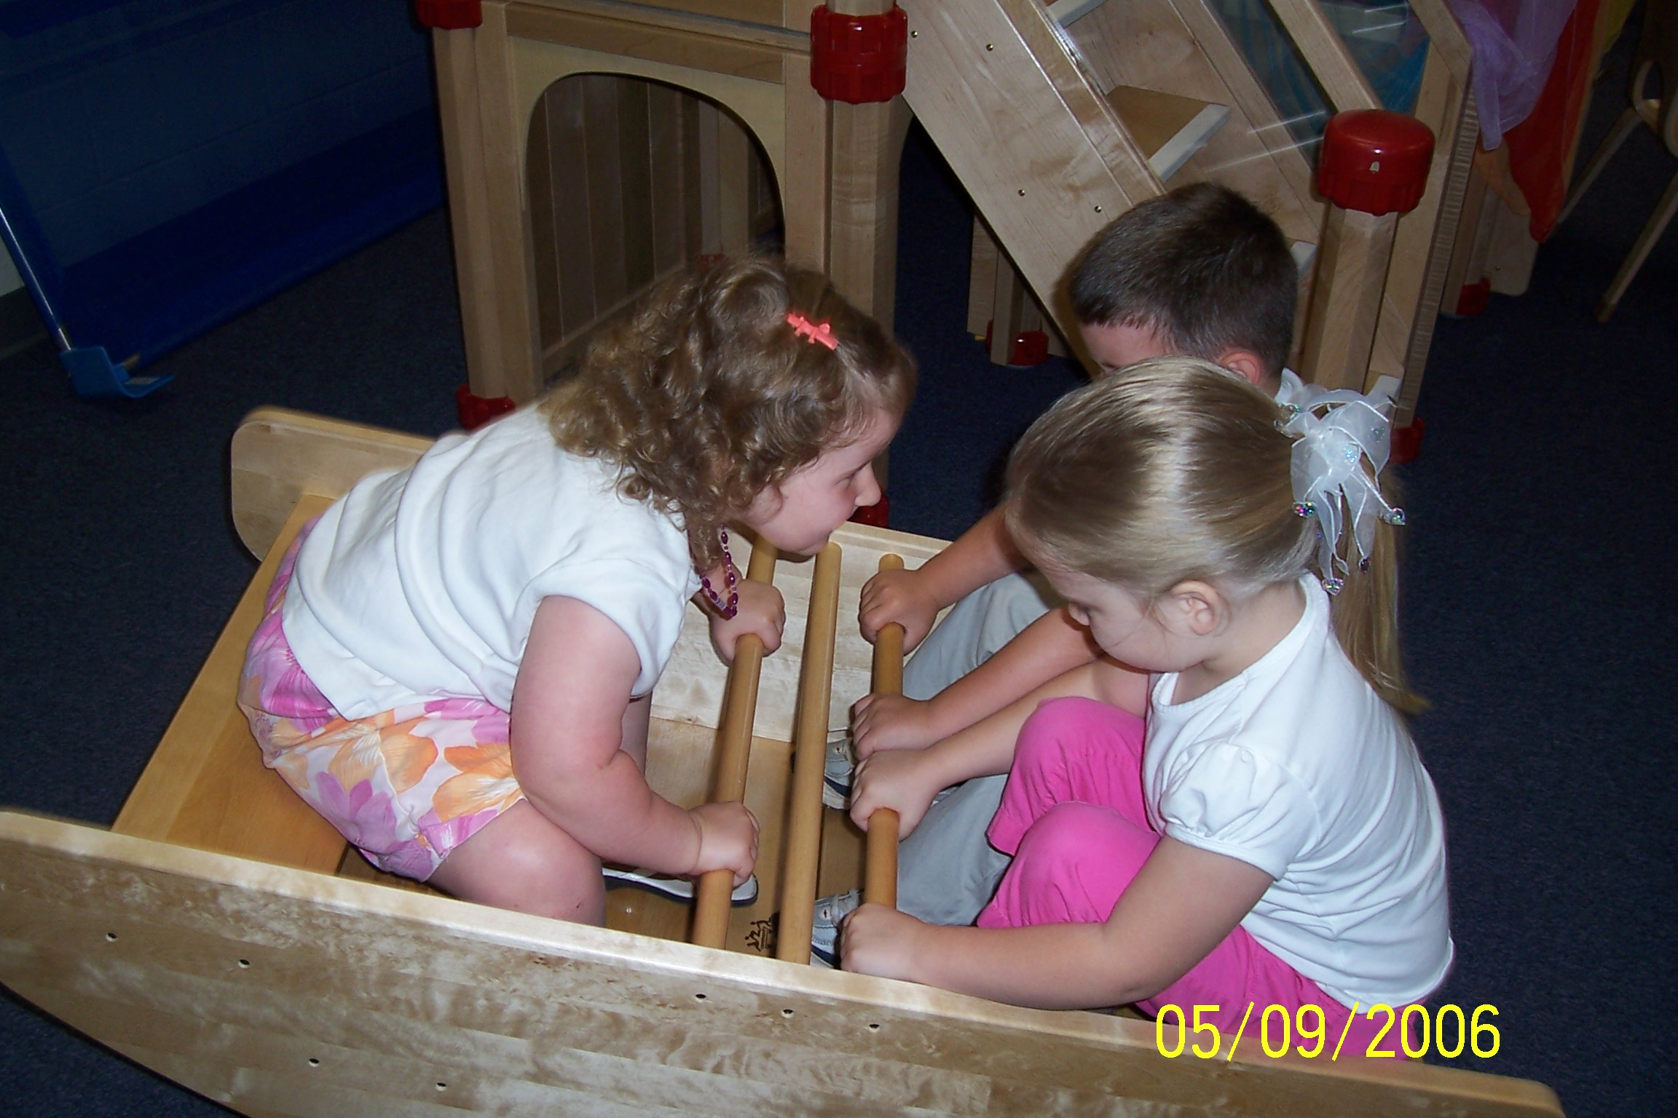
Introduction | Task | Process | Evaluation | Conclusion | Credits | Teacher Page
Introduction
- What is play?
- What are the stages of play?
- What are the stages of materials used in play?
- What is the teacher’s role in play with children?
- What are the benefits of dramatic play?
- What are the influences of play on the developmental stages of children?
Play is the foundation that supports higher learning. Playing is necessary to the social, physical, cognitive and spiritual development of all children. Unfortunately there is a cry for more academic preschools and higher test scores. This is forcing play out of the picture in many early childhood environments. After researching this topic, the ultimate answer will show what you can do about it!

The Task

Learning activities will include:
- Collaborative groups.
- Research the value of play and answer questions.
- Create a brochure in Microsoft publisher.
- Assemble a tri-board visual.
- Prepare and practice an oral presentation.
- Deliver oral presentations to class.

The Process
- First you'll be assigned to a team of 4 students and assigned a job responsibility.
- Each team will be given a guideline form for the group activity and a copy of questions to be completed. Research and answer the questions.
- Answers are to be turned in and evaluated before proceeding to next step.
- Each team will be given an assessment rubric and directions for preparing flyers on Microsoft Publisher for their tri-boards.
- Create and print flyers.
- Work in teams and assemble tri-boards.
- Prepare and practice 5-8 minute oral presentations.
- Students will present oral presentations to the class.
Attachments
Title: Guidelines for Group Activity File Name: Value of Play Activity Guidelines.doc
Description: Guides the students through the team project
Title: Questions on Play File Name: Questions on Play.doc
Description: Questions covering the primary and secondary objectives of the lesson. They will be answered as a team and assessed as a team.
Title: Value of Play Project Rubric File Name: Play Assessment Rubric.doc
Web Resources for Step 2
URL: http://laika.ed.csuohio.edu/SUM00/ETE565/Everett/Stages_of_Play.html
Annotation: Gives a basic definition of play and the stages of play.
URL: http://www.ipausa.org/
Annotation: The American Association for the child’s right to play
URL: http://www.naturalearning.org/
Annotation: The purpose of the Natural Learning Initiative is to promote the importance of the natural environment in the daily experience of all children, through environmental design, action research, education, and dissemination of information.
URL: http://www.geocities.com/recessplease/
Annotation: This web site is dedicated to exploring the TRUTH about elementary school recess.
URL: www.ooeygooey.com
Annotation: The Learning Through Adventure Company. They support the creation of child-centered environments where children are actively engaged in real, meaningful experiences, not "cute" fluffy time fillers.
URL: www.fcclainc.org
Annotation: Go to the national FCCLA web site and click on link for logos. Then click on FCCLA Planning process for a guideline to plan Play Day project.

Evaluation
CATEGORY | Needs Improvement  0 - 1 | Satisfactory  2 | Good  3 | Excellent  4 | Score
Visual | The brochures and presentation board use images and captions that have been arranged or mounted carelessly.  Incorrect spelling or grammar.  Poor lettering. | The brochures and presentation board use some images and captions that have been arranged or mounted carefully.  Incorrect spelling or grammar on one or two items.  Poor lettering. | The brochures and presentation board use images and captions that have been arranged and mounted carefully.  Correct grammar and spelling.  Lettering is big enough to see. | The brochures and presentation board use images and captions that have been arranged and mounted precisely and neatly.  Correct grammar and spelling. Lettering is neat and attractive.
Creativity | Little creative energy used during this project; was bland, predictable, and lacked “zip.” | Added a few original touches to enhance the project but did not incorporate it throughout. | Was clever at times, thoughtfully and uniquely presented | Was extremely clever and presented with originality; a unique approach that truly enhanced the project.
Pride | Work reflects very little effort on the part of this student. | Work reflects some effort from this student. | Work reflects a strong effort from this student. | Work reflects this student's best efforts.
Focus on the task | Rarely focuses on the task and what needs to be done. Lets others do the work. | Focuses on the task and what needs to be done some of the time. Other group members must sometimes nag, prod, and remind to keep this person on-task. | Focuses on the task and what needs to be done most of the time. Other group members can count on this person. | Consistently stays focused on the task and what needs to be done. Very self-directed.
Attitude | Often is publicly critical of the project or the work of other members of the group. Often has a positive attitude about the task(s). | Occasionally is publicly critical of the project or the work of other members of the group. Usually has a positive attitude about the task(s). | Rarely is publicly critical of the project or the work of others. Often has a positive attitude about the task(s). | Never is publicly critical of the project or the work of others. Always has a positive attitude about the task(s).
Problem-solving | Does not try to solve problems or help others solve problems. Lets others do the work. | Does not suggest or refine solutions, but is willing to try out solutions suggested by others. | Refines solutions suggested by others. | Actively looks for and suggests solutions to problems.
Quality of Work | Provides work that usually needs to be checked/re-done by others to ensure quality.  Did not utilize resources effectively; did little or no fact gathering on the topic. | Provides work that occasionally needs to be checked/re-done by other group members to ensure quality.  Used the material provided in an acceptable manner | Provides high quality work.  Did a good job researching and providing accurate information. | Provides work of the highest quality.  Went above and beyond to research information.
Contributions | Rarely provides useful ideas when participating in the group and in classroom discussion. May refuse to participate. | Sometimes provides useful ideas when participating in the group and in classroom discussion. A satisfactory group member who does what is required. | Usually provides useful ideas when participating in the group and in classroom discussion. A strong group member who tries hard! | Routinely provides useful ideas when participating in the group and in classroom discussion. A definite leader who contributes a lot of effort.

Conclusion
Open any research data base on the topic of “play” and you will find the evidence our heads so desperately need in order to support what our hearts have known for years – play is the foundation for future school success. If children attend play based preschool programs with an emphasis on social and emotional development as opposed to those that use worksheets and drill, they WILL get ready for kindergarten. The ultimate questions remains, what will you do about it?

Credits & References
Murphy, L. (2003). Play…The foundation that supports the house of higher learning. San Diego: The Learning Through Adventure Company.

Last updated on August 15, 1999. Based on a template from The WebQuest Page

