555 Integrated Circuit Basics

Worksheet

The 555 integrated circuit is normally constructed in an 8 pin configuration. Identify the specific function of each of the 8 pins of the integrated circuit. Note: The diagram shown also contains the 556 integrated circuit. The 556 is a 14 pin configuration that is actually two 555 integrated circuits on the same chip.

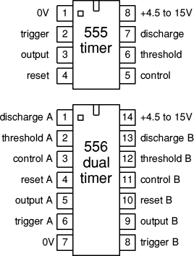
Pin 1 - _____________________________________________________________________________________________________________________________________________

Pin 2 –
_____________________________________________________________________________________________________________________________________________

Pin 3 –
_____________________________________________________________________________________________________________________________________________

Pin 4 –
_____________________________________________________________________________________________________________________________________________

Pin 5 –
__________________________________________________________________________________________________________________________________________________________________________

Pin 6 –
__________________________________________________________________________________________________________________________________________________________________________

Pin 7 –
__________________________________________________________________________________________________________________________________________________________________________

Pin 8 –
__________________________________________________________________________________________________________________________________________________________________________

