741 Op-Amp Amplifiers
In this activity you will be assembling and testing two different 741 Op-Amp circuits. A high impedance voltmeter should be used to measure output voltage during testing of the amplifiers. A dual 9 VDC power supply is necessary to power the circuit. DO NOT connect an input signal before connection of your power supply to the integrated circuit. If the circuit fails to work, remove the input signal FIRST then disconnect power before checking wiring. Fresh batteries or an adequate dual power supply should be used to power the circuits.

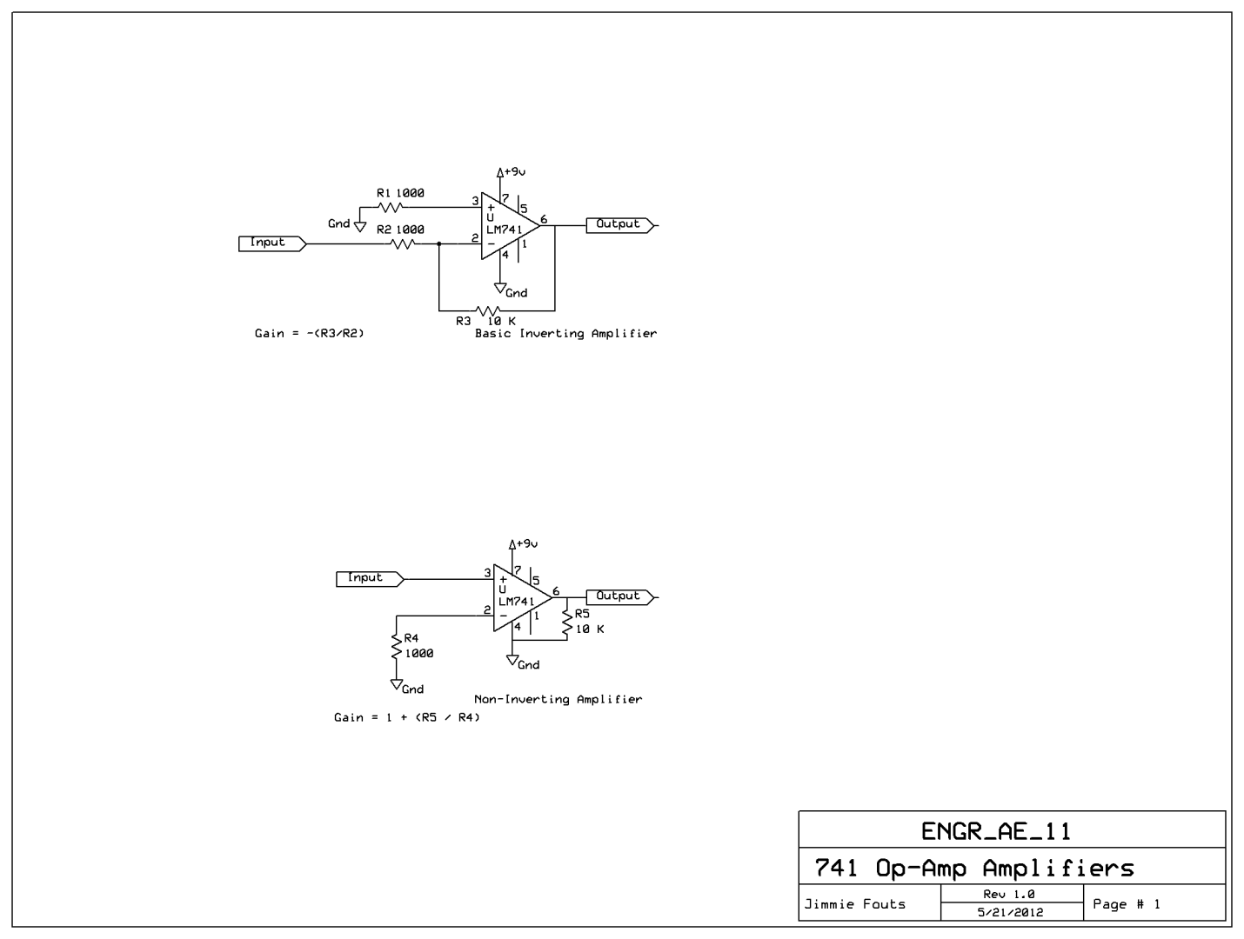

- Construct each circuit using a breadboard.
- Test each circuit by applying source voltage then an ac input of 1 volt at 1 KHz.
- Verify amplifier operation by recording the output voltage level.
- Compare output signal phase to input signal phase.
- Record results in your engineering notebook.
- Try changing the resistor values. What change is seen in the output signal as changes are made?

