Culminating Activity

Students will construct a basic RC Oscillator using the following schematic. The circuit can be constructed with most any general purpose NPN and PNP transistor. Components with the values given are very common and inexpensive. Resistor R2 controls the rate of charge and discharge for capacitor C2. This in turn controls the conduction activity of Q1 and Q2. This is directly related to the blinking of the LED. The LED indicates operation of the oscillator circuit. The following procedure applies:
- Students construct the following circuit on a breadboard.
- When completed, verify proper circuit operation. When properly constructed the LED should continually turn on and off. If it does not “blink”, carefully check all of your connections including the proper polarization of the LED and capacitor C2.
- After ensuring the circuit operation, answer the following questions:
  - Does your circuit operate properly?
  - What is the actual frequency of operation? (Count the number of “blinks” over a one-minute period of time and divide this number by 60)
  - Use a different resistor or add a variable potentiometer in series, to increase the value at the position of R2. What is the result in the frequency output?
  - What would you expect to happen if capacitor C2 decreased in value?
  - What would you expect to occur in the circuit if resistor R3 were to open?
  - How might you decrease the intensity of the LED flash?
  - If the supply voltage is decreased, what effect would there be on the circuit operation?
  - Would the circuit continue to operate if the leads of the LED are reversed? Why or why not?
Required Materials:
Q1 – Transistor PNP (2N3904 or equiv)
Q2 – Transistor NPN (2N3906 or equiv)
R1 – Resistor 470Ω, ¼ or ½ watt
R2 – Resistor 470KΩ, ¼ or ½ watt
R3 – Resistor 1 KΩ, ¼ or ½ watt
C1 – Capacitor .01µf Ceramic
C2 – Capacitor 10pf Electrolytic
LED – Light Emitting Diode, Any color or size
Various resistors or a 1MΩ potentiometer
Power supply or battery
Breadboard
Solid connecting wire

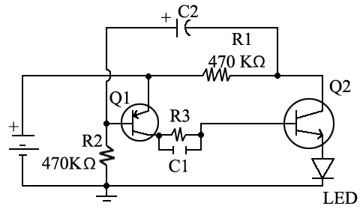
Figure 1. ENGR AE 5 Culminating Activity – RC Oscillator

