Wien Bridge Oscillator

ENGR AE 3.B
ENGR AE 3.D
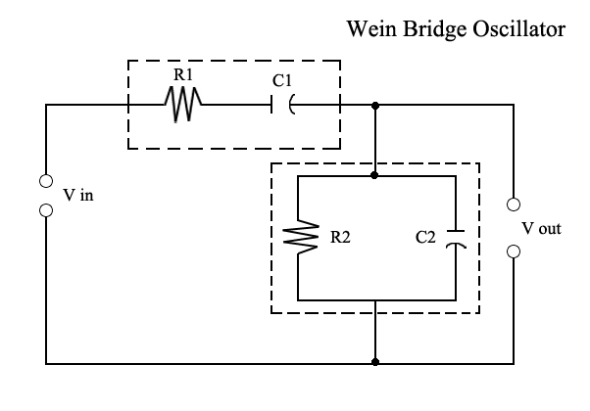
The Wien Bridge oscillator takes advantage of two RC circuits, one in parallel and the other in series. The circuit shown is often called a lead-lag network and shows maximum output and zero phase shift at one frequency. This frequency is called the resonant frequency f_{r.} The resonant frequency can be found using the equation:
f_{r =}
The series and shunt values of R and C are equal.
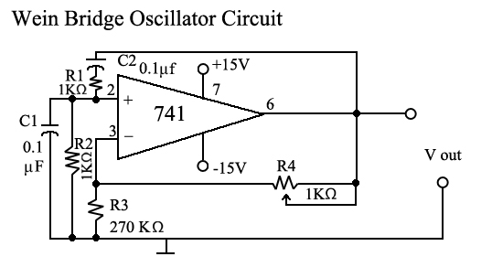
This is a typical Wien Bridge Oscillator. The lead-lag network consists of resistor R1 and capacitor C1 plus resistor R2 and capacitor C2. They form one leg of the bridge and resistors R3 and R4 form the other leg. Oscillation begins due to positive feedback through the lead-lag network. Resistors R3 and R4 form a voltage divider. As the voltage applied to the OP Amp increases at the inverting input, negative feedback will decrease the gain of the amplifier. When potentiometer R4 is correctly adjusted, the gain will decrease to a value that prevents clipping but is still large enough to sustain oscillation.
The Wien-Bridge circuit satisfies the basic demands of all oscillator circuits:
- The gain is adequate to overcome the loss in the feedback circuit and,
- The feedback is in phase.
At the moment of powering on, the gain of the OP Amp is high and ensures rapid start-up of the oscillator. The gain then decreases based upon the voltage divider network values. This eliminates clipping of the output. Wien Bridge Oscillators are known for their low-distortion sinusoidal output.

The following components are required for circuit construction:
Operational Amplifier (OP Amp) IC 741
1 KΩ Potentiometer
Capacitors 0.1µf (X 2)
Resistors 1 KΩ (X 2)
Resistors 3.3 KΩ (X2)
Resistor 270 KΩ

Assignment:

- Calculate the resonant frequency (f_{r}) of the oscillator.
- Construct the circuit.
- If available, observe the output with an oscilloscope and adjust the potentiometer for a stable output.
- Using the oscilloscope perform the following operations:
  - Observe and sketch the output waveform
  - Is the output sinusoidal, rectangular, or sawtooth?
  - Measure the peak-to-peak voltage of the waveform using the oscilloscope.
  - What determines the amplitude of the output signal?
  - Measure the period of the output signal.
  - Calculate the actual frequency output of the oscillator based upon the measured period. f ₌ 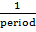
  - How does this value compare to the original fr calculated value?
  - Why is there a difference in your calculated fr value and the measured f value (actual)?
- Change the resistors at R1 and R2 to 3.3KΩ.
- Use the oscilloscope to adjust the potentiometer for a stable output.
- Has the period of the output signal increased or decreased?
- What is the new operating frequency of the oscillator?
Troubleshooting:
- If the oscillator exhibits no output, what is the most likely cause (assuming proper operation prior to oscillator failure)? Why?
- If the value of C decreased, what would you expect to be the resulting oscillator output?
- Verify your conclusions by changing a capacitor or placing another capacitor in series with C1. Explain your results.

