Building an Electronic Keyboard

Background Information:
An electronic organ is an electronic keyboard instrument which was derived from the harmonium, pipe organ and theatre organ. Originally, it was designed to imitate the sound of pipe organs, theatre organs, band sounds, or orchestral sounds.
The harmonium was a reed type organ in which air was forced through the reed using a bellows arrangement. Cahill's gargantuan and controversial instrument, the Telharmonium, which began piping music to New York City establishments over the telephone system in 1897, predated the advent of electronics, yet was the first instrument to demonstrate the use of the combination of many different pure electrical waveforms to synthesize real-world instrument sounds.
Electronic organs were once popular home instruments, comparable in price to pianos and frequently sold in department stores. After their début in the 1930s, they captured the public imagination, primarily through the film performances of Hammond organist Ethel Smith. Early electric organ products released in 1930s/1940s were already implemented on frequency divider technology with vacuum tubes.
With the development of the transistor, electronic organs that used no mechanical parts to generate the waveforms became practical. An early model was the frequency divider organ, the first of which used twelve oscillators to produce one octave of chromatic scale and frequency dividers to produce other notes. These were even cheaper and more portable than the Hammond. Later developments made it possible to run an organ from a single radio frequency oscillator. Frequency divider organs were built by many companies, and were offered in kit form to be built by hobbyists.
A synthesizer is an electronic instrument capable of producing a wide range of sounds, which may either imitate other instruments or generate new tones. Synthesizers are often controlled with a piano-style keyboard, leading such instruments to be referred to simply as "keyboards".
The piano keyboard generates different tones when a hammer strikes series of strings within the piano itself when keys are pressed by the person playing the instrument. The amplitude of the output waveform generally diminishes with time. A typical electronic keyboard maintains the signal output amplitude as long as a key is depressed. The functional sounds of the piano can be created using the basic oscillators that you have been studying. The typical piano keyboard and assigned frequency of the notes is contained in Figure (1) below:
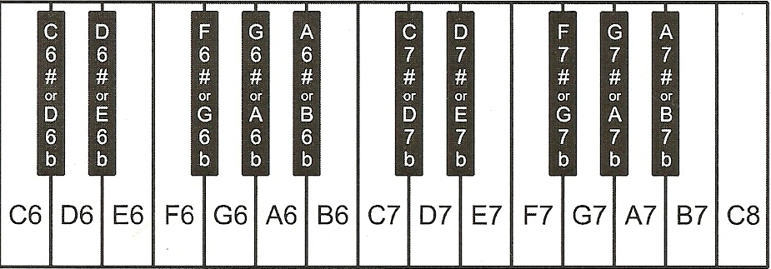
NOTE | FREQUENCY | NOTE | FREQUENCY | NOTE | FREQUENCY
C6 | 1046.5 | D6 | 1174.7 | E6 | 1318.5
F6 | 1396.9 | G6 | 1568.0 | A6 | 1760.0
B6 | 1975.5 | C7 | 2093 | D7 | 2349.3
Sharp (#) and flat (b) notes are middle frequency between the adjoining full notes
Figure 1. Piano Keyboard
Assignment:
Using the Engineering Design Model , design, construct, develop, and troubleshoot until successful a working electronic synthesizer. Your end product should be capable of playing 5 individual notes (for example: C6, D6, E6, F6, G6. Each note will be played by depressing an individual single pole pushbutton switch.
Select one of the oscillator designs that you have studied in this unit and make necessary changes to the circuit to accommodate a speaker output (i.e. Isolate dc current flow through the speaker through the use of a capacitor in series with one of the speaker leads).
Be prepared to demonstrate and describe your engineering process to the class. Keep records of your calculations and brainstorming sessions in your Engineering Notebook.

