The Six Step Troubleshooting Process
The following diagram shows the sequencing of the Six Step Troubleshooting process.
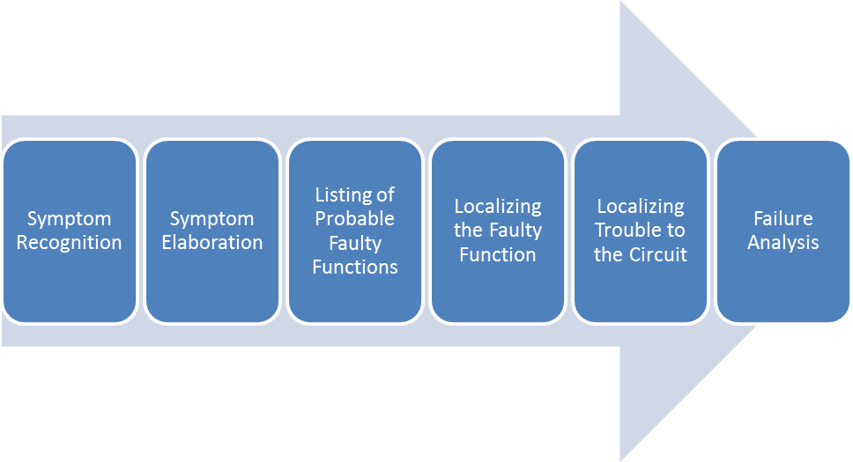
Assignment: Expand this sequencing flow map to include the major actions involved in the performance of each of the steps. Actions might include knowledge, operational controls, notes, thinking, equipment diagrams, schematics, testing devices, eyes, ears, equipment indicators, etc. For example:
System Recognition
