Typical Digital Oscillator

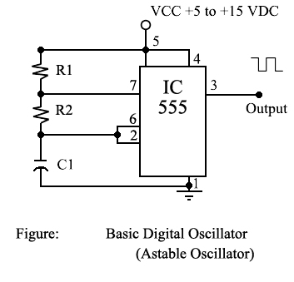

This diagram represents a typical digital oscillator. Technically, the IC555 is known as a timer-integrated circuit. Markings on the circuit “chip” may vary depending on the manufacturer, but the basic operation is the same. The circuit is sometimes identified with LC555, LM555, SN72555, MC1455, etc.

This circuit consists of the following components:

Resistors: 100KΩ (X2)
Capacitor: 0.1 µf
Integrated Circuit 555
The supply voltage is direct current (DC) and should be steady but may be a value of 5 to 15 volts. The amplitude of the DC supplied will determine the amplitude of the output signal.
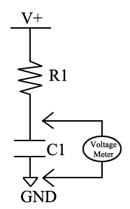
Basic Operation of the Circuit

A capacitor holds charge and a resistor limits current flow, so if you place a resistor and
capacitor in series and apply power, the capacitor at first appears like a direct short to
ground, and a measurement of the voltage across the capacitor shows 0 volts.
Because the resistor, R1, limits the current, it takes time for the capacitor to fully charge, as shown in the following plot of voltage across the capacitor C versus time. The plot shows a charging cycle followed by a discharge cycle through the same resistance.

The RC circuit has a time constant, defined as the time required for the voltage across the capacitor to reach 63 percent of its maximum value. As seen in the plot, it takes about five time constant periods for the capacitor to fully charge. At that time, the capacitor is fully charged and no additional current will flow in the circuit.
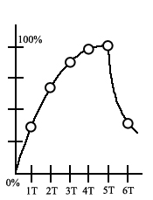
Because there is no longer any current flow in the circuit, the voltage drop across the resistor is essentially 0. Thus, the voltage across the capacitor is equal to the supply voltage.
The time constant for a series RC circuit can be calculated using the following formula.
Time (seconds) = resistance (ohms) X capacitance (farads)
Thus for a resistance of 100KΩ and a capacitance of 0.1 µf;
Time = 100,000 Ω X 0.000001 farads
Time = 0.1 seconds
So the capacitor will reach about 63% capacity in 0.1 seconds and become fully charged to 100% after 0.5 seconds in our example.
A 555 timer integrated circuit (IC) takes advantage of this type of charge-discharge
cycle to create a series of timed pulses. The trigger input at pin 2 (TRIG) on the 555 timer IC monitors the voltage across the capacitor as it charges. When this voltage reaches 2/3 of the supply voltage, the timer circuit switches the discharge connection at pin 7 (DISCHG) to ground, which starts to discharge the capacitor, but only through resistor RB. Now, when the 555 detects the capacitor has discharged to 1/3 of the supply voltage, it disconnects the DISCHRG pin from ground so the capacitor can charge again through RA and RB to 2/3 the supply voltage. This charge-discharge cycle repeats as long as you power the 555 IC. Remember, a
typical 555-timer IC can operate with a supply voltage between 5 and 15 volts.
The circuit will provide an output at pin 3 (OUT) that can be used to feed additional circuitry. By using some simple math, the ON and OFF times for a given circuit can be determined. You can even choose components to ensure a specific output frequency is obtained!
In our example, resistors R1 and R2 determine the charging time of capacitor C1. Because of this we can determine the charging time as follows:
Charging time = T1 = 0.693 X (R1 + R2) X C1
T1 = 0.2 seconds
Resistor R2 determines the discharge time, so discharge time is calculated as:
Discharge time = T2 = 0.693 X R2 X C1
T2 = 0.1 seconds
The total time required to complete one cycle will be equal to T1 plus T2. Thus, T total = T1 + T2
T total = 0.3 seconds
The frequency of the circuit would be equal to = = 3.33 CPS or 3.33 Hz
Assignment:
- Construct the circuit in Figure 1.
- Using an oscilloscope, determine the time interval occupied by one cycle of output signal during operation.
- How does this value compare to your calculated value?
- Why are they not exactly the same?
- Calculate the frequency of the output signal.
- Change the value of C1 to 0.047 µf.
- Calculate the expected output signal frequency.
- Measure the duration of the time interval occupied by one cycle of the output signal during operation.
- Calculate the actual frequency output of the circuit.
- How does the value of the frequency output obtained in question 9 compare to the value obtained in question 5?
- What would happen if you increased the voltage of the supply voltage from +5 volts to +10 volts? Would the timing change? Why/why not?
- If you have a variable power supply, adjust it and look at the result using the oscilloscope. Observe both the amplitude and frequency of the output signal obtained at Pin 3 of the 555.

