FE 10 Series, Parallel, and Combination Circuit Unit Exam
- According to Kirchoff’s Current Law, currents sum to zero at circuit __b___.
  - Branches
  - Nodes
  - Sources
  - Loops
- When using Kirchoff’s Current Law (KCL), if a calculated current turns out to be negative, this indicates that the current is ___a____.
  - Reversed from the assumed direction
  - Changing frequency
  - Producing energy
  - Violating KCL
- For the following circuit, calculate the requested information: 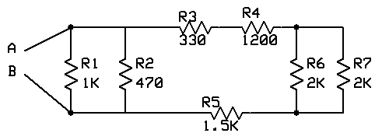
  - What is the equivalent resistance of the R3 and R4 portion of the circuit? 1530Ω

  - What is the equivalent resistance of the R6 and R7 portion of the circuit? 1000Ω

  - What is the equivalent circuit resistance of the circuit when measured between point A and point B? 296Ω

  - If 12 vdc is applied to the circuit between points A and B, What is the current through R1? 12ma

  - If 12 vdc is applied to the circuit between points A and B, What is the current through R3? 3ma

  - If 12 vdc is applied to the circuit between points A and B, What is the current through R7? 1.5ma

  - If 12 vdc is applied to the circuit between points A and B, What is the voltage drop through R6? 3v

