Using 5Spice Software Activity Sheet
5Spice is a general-purpose electronic circuit simulation program with a full graphical user interface. It wraps around a traditional Spice simulation engine, presenting a single application to the user. 5Spice provides Spice specific schematic entry, the ability to define and save an unlimited number of analyses and graph setups, and integrated graphing of simulation results.
The program is intended to provide the analysis and documentation capabilities needed by experienced circuit designers while remaining easy to use - a step up from student oriented Spice programs. The focus is on analog circuit analysis and circuit design at the component level.
Try the operations using the Demo1 schematic (see program's main menu FILE and select "Open Demo Schematic"). The schematic's NOTES page has more information. The NOTES page can be opened by left clicking on the NOTES tab after opening the Demo Schematic. You will see that the presented Demo1 schematic is a simple OP-Amp amplifier circuit. The schematic has already been provided for you so now it is time for a little analysis of the circuit! While at the MAIN tab, press the function key F8 to open the Analysis Dialog window. There are a number of operations that we can perform but for now we will look at circuit DC Bias. Select “DC Bias” in the “Select Analysis” window, then, select “Apply and Run” at the bottom of the Analysis window.
You will note that a new tab labeled “DC Bias” has been added. If you left click your mouse on this tab you can see the DC bias levels within the circuit. If you move your mouse pointer around the circuit and rest it at various points within the circuit, you will note that it also provides you with the voltage level that should be present at that particular location.
Again depress function key F8 to open the “Analysis Window”. We will look at the ability of the circuit to amplify various signal frequencies. Select “AC-High Frequency” for the analysis and Vs1 as the frequency generator source. We can change the frequencies for the test but for this example we will look at frequencies from 10KHz to 10MHz. Click the “Apply and Run” button. You should see a new tab and a graph that reflects the gain of this amplifier for the frequency range of the test. Note from the graph that this particular circuit would do well at providing a linear amplification of an input signal to about 2 MHz. After 2MHz the signal gain begins to fall off rather sharply.

It Is Your Turn!

Begin a new schematic by clicking on the “File” menu and then selecting “New Schematic”. When the Main drawing screen opens, double click on the Title Box in the lower right corner of the drawing. This will open the Title Box and allow you to input a name for your schematic and your name plus any other details that your instructor might desire.

Schematic
The first step is to create a schematic of the circuit you want to simulate. This schematic will probably be different from a production circuit schematic. It is best to start with a simple schematic and get the DC Bias analysis running before adding complexity. For practice, you will be drawing the circuit shown here:
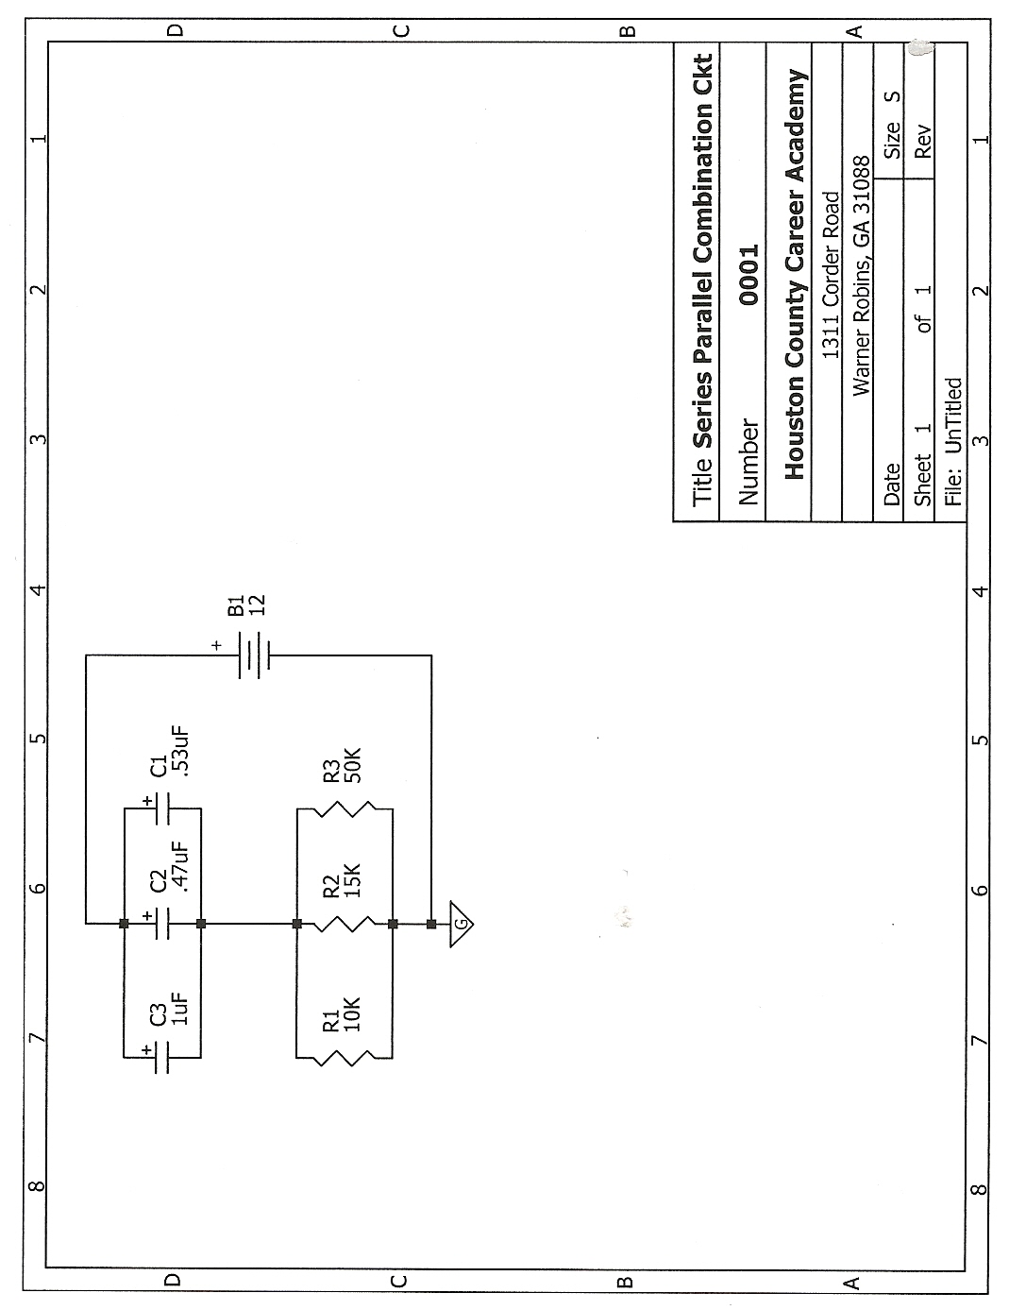
Avoid a common mistake: If the circuit you draw will not work in the real world, Spice is likely to be confused. You may get simulation failure or an error message that doesn't make sense. If so, review your schematic to be sure it is a valid circuit. This particular circuit is of little value by itself but will allow you to practice using the program. If you feel comfortable with basic drawing and analysis of DC Bias, try replacing the battery with a signal generator and you will be able to analyze AC characteristics of the circuit!
Drawing
Drawing the schematic is done with tools located in the vertical toolbar at the right of the screen. The toolbar buttons have familiar images. Move the mouse over a button to pop up a group of related buttons. Hold the mouse still over a button in the group to see a description of the part/tool. Click the button to select the part/tool.
Parts
Click the button with the part you want. Next left click the schematic where you want to place a copy of the part. Click again to place another part. To end placing parts, click the right mouse button or press the ESC key.
Before clicking on the schematic, you may use the shortcut keys “R” and “M” to rotate and mirror the symbol.
Lines/Wires/Junctions
Wires and junctions connect parts electrically; lines (drawn in blue) do not. Junctions are used to indicate a common connection where wires and/or part pins intersect in a T or cross at right angles.
Select which style the mouse will draw with. The cursor changes to a pencil. Click the left mouse button over the schematic to start drawing and to turn corners. Click the right mouse button to end drawing the current wire/line. To end drawing, click the right button or press the ESC key while not drawing a wire/line.
Editing
Parts - To edit a part’s parameters, double click on the part. For other editing, right click on the part to bring up a pop-up menu of choices.
Schematic - right click in an open area to bring up a menu of choices.
Move/Drag items
Drag: Click and hold the left mouse button over a part or wire and then move the mouse. If there is room, the part will move while the wires stay connected and change length.
Move: Hold the Shift key down - the cursor changes to a hand. Click the mouse over a part or wire and then move the mouse. Only the selected part will move.
5Spice uses the Signal Source component in the way you use a function generator in the lab. Most schematics need a Signal Source to supply an input signal to the circuit (not necessary for DC Bias analysis).
5Spice uses the Test Point component like a test point in a circuit breadboard. Wire a TestPoint to each circuit point you want to appear in a graph or table (not necessary for DC Bias analysis).
Every schematic must have at least one ground symbol.
Connect everything
When you try to run an analysis, the program first checks that all parts and wires connect. It flags unconnected ends and overlapped wires with error circles in the schematic. After correcting errors you can press the keyboard’s space bar to redraw the schematic to clear the error circles.
If you want to leave a part pin or wire unconnected, place a No Connection (looks like an X) on the end. This part is found with the wire and junction tool buttons.
Important Items to Remember
Resistor Values: To avoid errors when you run an analysis, keep the values you assign to resistors in a range of .001 Ω to 1,000,000,000 Ω..
Keep things simple until you become familiar with the software operation of 5Spice.
Analysis
It is good practice to start by running the DC Bias analysis (circuit’s DC operating point). Spice finds most errors here. Spice automatically runs this analysis prior to AC and Transient analysis so operating point errors cause these analyses to fail also.
DC Bias voltages show in a table and also as pop up text in the schematic when you hold the mouse still over a wire. If you change the schematic, the voltages are no longer valid and do not show in the schematic.
DC Bias does not require setup - just hit the Apply and Run button. If you want, you can enter a different circuit operating temperature. Or you can sweep/step the temperature or sweep/step the values of one or two components. If you sweep, you get multiple values for each circuit node in the results Table - they do not show in the schematic.
AC and Transient Analysis
These analyses change the output of the circuit’s input Signal Source:
AC: sine wave swept over frequency
Transient: selected waveform changes over time.
Enter the starting frequency or time in the From box, the ending point in the To box.
Failure Messages
Simulation doesn’t always succeed. When it doesn’t, the Simulation Failure box appears. Read the error message and then click the box’s Help button for help on causes and fixes.
Enjoy using this valuable piece of software!

