Constructing DC Circuits
Using the schematic, breadboard and resistors provided, construct the following circuits. Using a digital multi-meter (DMM) or other assigned device, conduct the indicated measurements. Perform the appropriate mathematical calculations where applicable. It is suggested that a Variable Power Supply with voltage and current regulation be used as B1. If one if not available, the use of a battery is acceptable.

Materials Required:

Digital Multi-meter (or other appropriate measurement device)
Breadboard
Multiple Resistors
Connecting wire
Power Supply or Battery
Calculator

- Series Circuit

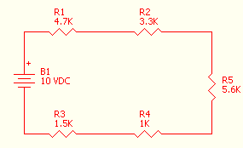
- Construct the circuit shown.
- Using the indicated resistor values, calculate the value of total resistance (Rt). Rt = ___________
- Remove the power source and measure the total resistance (Rt). Rt = _________________
- Connect your power source.
- Observe and record the following measurements: Vb1 = ___________________, Vr1=______________, Vr2=__________________, Vr3=________________, Vr4=_______________, Vr5=_______________
- Calculate the sum of the voltage drops across the resistors. Vrt= ________________ Is this value the same as Vb1? ________________ Why? ________________________
- Disconnect one lead of the power source. Connect the meter, set to measure the appropriate circuit current scale, in series with the circuit and the power source. Measure It. It =____________
- Since the total current in the circuit is ____________ and the supply voltage is ____________ , using Ohm’s Law the calculated value of Rt is: Rt = ____________________.
- Is the value calculated in h. above the same as that calculated in b. and measured in c. above?________
- Calculate the total power consumed in the circuit (P=EI). Pt = _________________

- Parallel Circuit

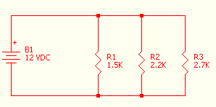

- Construct the circuit shown.
- Using the indicated resistor values, calculate the value of total resistance (Rt). Rt = ___________
- Remove the power source and measure the total resistance (Rt). Rt = _________________
- Connect your power source.
- Observe and record the following measurements: Vb1 = ___________________, Vr1=______________, Vr2=__________________, Vr3=________________
- Are the values observed in e. above equal to each other? ________________
Why? ________________________
- Disconnect one lead of the power source. Connect the meter, set to measure the appropriate circuit current scale, in series with the circuit and the power source. Measure It.
It =____________
- Since the total current in the circuit is ____________ and the supply voltage is ____________ , using Ohm’s Law the calculated value of Rt is: Rt = ____________________.
- Is the value calculated in h. above the same as that calculated in b. and measured in c. above?________
- Calculate the total power consumed in the circuit (P=EI). Pt = _________________

- Series-Parallel Combination Circuit

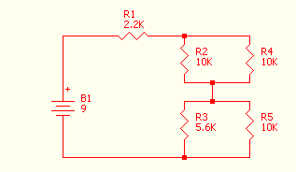
- Construct the circuit shown.
- Using the indicated resistor values, calculate the value of total resistance (Rt). Rt = ___________
- Remove the power source and measure the total resistance (Rt). Rt = _________________
- Connect your power source.
- Observe and record the following measurements: Vb1 = ___________________, Vr1=______________, Vr2= Vr4 =__________________, Vr3= Vr5 = ________________
- Calculate the sum of the voltage drops across resistors R1, R2, and R3. Vr1-3= ________________ Is this value the same as Vb1? ________________
Why? ________________________
- Disconnect one lead of the power source. Connect the meter, set to measure the appropriate circuit current scale, in series with the circuit and the power source. Measure It.
It =____________
- Since the total current in the circuit is ____________ and the supply voltage is ____________ , using Ohm’s Law the calculated value of Rt is: Rt = ____________________.
- Is the value calculated in h. above the same as that calculated in b. and measured in c. above?________
- Calculate the total power consumed in the circuit (P=EI). Pt = _________________

- Series-Parallel Combination Circuit

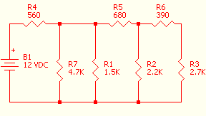

- Construct the circuit shown.
- Using the indicated resistor values, calculate the value of total resistance (Rt). Rt = ___________
- Remove the power source and measure the total resistance (Rt). Rt = _________________
- Connect your power source.
- Observe and record the following measurements: Vb1 = ___________________, Vr1=______________, Vr2=__________________, Vr3=________________, Vr4=______________, Vr5=__________________, Vr6=_________________, Vr7=______________
- Calculate the total voltage drop for the circuit. Vrt= ________________ Is this value the same as Vb1? ________________ Why? ________________________ [HINT: The circuit consists of multiple series and parallel. Separate the circuit into individual branches and calculate the total based on the result from each of the branches.]
- Disconnect one lead of the power source. Connect the meter, set to measure the appropriate circuit current scale, in series with the circuit and the power source. Measure It.
It =____________
- Since the total current in the circuit is ____________ and the supply voltage is ____________ , using Ohm’s Law the calculated value of Rt is: Rt = ____________________.
- Is the value calculated in h. above the same as that calculated in b. and measured in c. above?________
- Calculate the total power consumed in the circuit (P=EI). Pt = _________________

