Slow Speed Flasher Circuit

A Culminating Activity

Construct the following circuit following the schematic provided and the available parts:

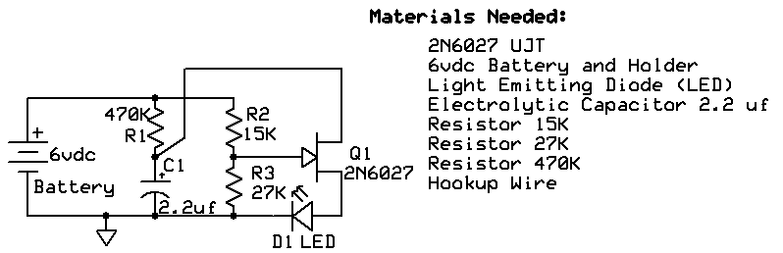

Does the circuit flash the LED? ____________ What is the rate of flashing? _______________RPM

The flash rate is dependent upon the time it takes for the capacitor C1 to reach its threshold value (99% charge). This value can be calculated with the following formula: Time = 5 X R1 X C1. What is the calculated time for this circuit? _______________ The frequency of operation can be calculated by the following formula: f = 1/time. What is the calculated frequency of operation for this circuit? _________.

If you desired to double the current rate of flashing, about what resistor value would you need to use to replace R1? _____________________

What is the calculated value of voltage at the junction of R2 and R3 with reference to ground? _________

What is the calculated voltage at the junction of D1 and R3 with reference to ground? ________

