What To Expect? A Design Challenge!

- Challenge One: Room Light from Two Locations
  - Materials Provided:
    - Battery pack with batteries (3 VDC)
    - 2 SPDT switches
    - 1 Light Emitting Diode (LED)
    - 1 Resistor (220 Ω or 470 Ω)
    - Hookup wire (about 1 foot should be adequate)
  - The challenge is for students to design a circuit to turn the LED on or off using either switch. A similar circuit is used in most homes so that individuals may turn on the room light at one entrance and turn the same light off as they exit another entry point! In other words, the LED can be turned on by flipping either switch and once on can be turned off from either switch. Note: The resistor should serve as a current limiter for the LED when in operation.
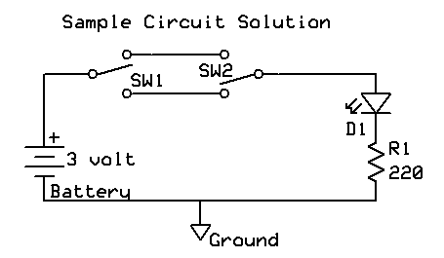
- Challenge Two: Simple Battery Tester
  - Materials Provided:
    - Battery holder (size determined by battery to be tested)
    - 1 DPDT switch
    - 1 lamp holder
    - 1 lamp (1.5 volt to fit holder)
    - Hookup wire (about 1 foot should be adequate)
  - The challenge is for students to construct a simple battery tester. The purpose of the tester is to determine a go/no-go condition of the battery. Note: The lamp and lamp holder may be replaced with LEDs and appropriate resistors if desired. You may also substitute a small 1.5 volt dc motor. You will hear the motor speed changes based upon the battery being tested. Using a voltmeter across the load will give a exacting level of voltage although that is not necessary just to test the go/no-go state of the battery. It is important that the battery be under load when conducting the voltmeter test. Make students aware that just measuring the voltage of a battery with a voltmeter is not sufficient for the testing of battery condition. The battery must be under a proper load condition.

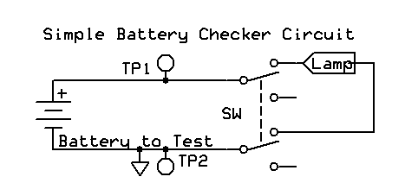

Sample Battery Test Circuit

