Name_____________

Class _____________

Electronic Components Test

Write the letter of each symbol next to the name of the component it represents.
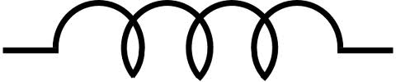
Resistor ____ A

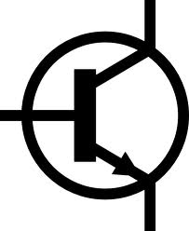
Capacitor ____ B

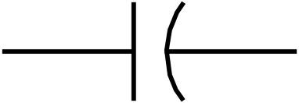
Inductor ____ C

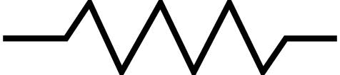
Diode ____ D

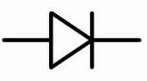
Transistor ____ E

Draw an arrow to show which direction current would flow through this element.

Fill in the table:
 | Does current flow through? | Is there a voltage difference?
Steady-state capacitor
Steady-state inductor
Capacitor just as power is applied
Inductor just as power is applied

If a resistor has a value of 50 MΩ and a tolerance of ±5%, what is the lowest resistance the resistor might have?

________________________________________________________________________

You are using a voltmeter to identify the terminals of a transistor. You know that for this voltmeter, the red lead is positive and the black lead is negative. You set the voltmeter to measure resistances and take the following readings from the transistor:

Red lead on terminal 1, black lead on terminal 2: 1.2 MΩ
Red lead on terminal 1, black lead on terminal 3: 5 mΩ
Red lead on terminal 2, black lead on terminal 3: 5 mΩ

Is this transistor an NPN transistor or a PNP transistor?

________________________________________________________________________

You now set the voltmeter to its diode test function and take the following readings:

Red lead on terminal 1, black lead on terminal 3: .32V
Red lead on terminal 2, black lead on terminal 3: .37V

Identify which terminals are the base, emitter and collector.

Terminal 1:_________

Terminal 2:_________

Terminal 3:_________

