Human Electrons Activity

In this activity, students will navigate a large-scale simulated circuit en masse to create interest and reinforce the properties of circuit components. This activity can be done in a large classroom, an empty hallway, a gymnasium, or outside.

Lay out the following circuit using tape, rope, ribbon, or any other such material. An appropriate size is about 50 long; adjust to class size and available space.

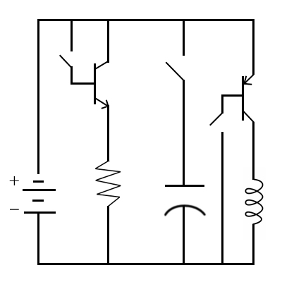

The rules for the circuit are as follows:

The battery is the entry point for all students. Students file into the circuit through the battery and exit through the battery. You may have students pass through the battery during the activity.

Once students enter the circuit, their objective is to get to the negative terminal of the battery or to the positive plate of the capacitor. They should avoid dead ends that do not lead to one of these. If a student goes down a dead end, they may turn around and rejoin the flow.

Students cannot cross open switches; the teacher must close them before they can be crossed. Students who go down dead ends may turn around and resume to flow. In addition to not keeping them stuck in one place, this is not entirely contrary to actual charge carrier behavior.

At the NPN transistor, students can only cross from the collector to the emitter if a student crosses from the base to the emitter. For every student that crosses from the base to the emitter, three can cross from the collector to the emitter.

At the resistor, students must [absurd action of your choice] as they cross. This can be hopping, stepping from side to side, turning in circles; anything that will slow them down. Be as silly as you desire and your students will tolerate.

At the capacitor, students cannot cross and should naturally bunch up at the positive plate. This is natural and makes the point. Allow the students to evacuate before closing the switch.

At the PNP transistor, students cannot cross from the collector to the emitter unless a student crosses from the emitter to the base. When a student crosses from the emitter to the base, three students may cross from the collector to the emitter.

At the inductor, leave a large gap and set a number of carpet squares or sheets of cardboard to one side. Students can only cross on these materials. Encourage them to build a sparse path and then fill in the gaps as more students cross. This is to simulate inductors’ high initial resistance that decreases with time. Additionally, make sure the last students to cross pick up the bridge; inductors slow both when the circuit is turned on and when it is turned off.

To conduct the activity, throw each of the switches in order and guide students through the element exposed. Remind them of the properties of the element and how that determines the way it affects their path. After all elements have been explored, throw all the switches closed and let the entire circuit run for a while.

After completing the activity, remind students that electrons actually move in the direction opposite conventional electrical current; this is because electrical current conventions were set before it was known that the negatively charged particle is the charge carrier.

