Identifying Transistors
The collector, emitter and base terminals on transistors are usually not labeled. Additionally, putting a transistor into a circuit in the wrong orientation can cause the circuit to not function or permanently damage the transistor. For these reasons, it is important that you be able to identify the terminals of a transistor. To do this, however, you must first identify whether the transistor is PNP or NPN.
Transistors can be thought of as containing two diodes:

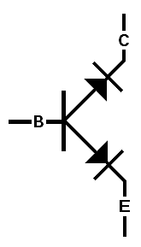
In an NPN transistor, the diodes both point away from the base:

In a PNP transistor, the diodes point towards the base:
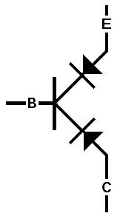

Current can only flow from the positive to the negative end of a diode; the way the arrow points in the diode symbol. When probing the terminals with a voltmeter, the only time a low resistance will be read is when one lead is on the base and the other is on either the collector or the emitter. When you can hold a probe on one terminal and move the other between the remaining two terminals, reading a low resistance for both paths, the stationary probe is on the base. If the probe on the base is negative, current is flowing towards the base, as shown in the PNP transistor diagram; the transistor is PNP. If the probe on the base is positive, current is flowing away from the base, so the transistor is NPN.
Now that we know which pin is the base, we need to find out which is the emitter and which the collector. We will do this by measuring its forward voltage; the voltage drop across a resistor when it is forward-biased. The forward voltage of the emitter will always be larger than that of the collector, because the material of the emitter is more heavily doped that than of the collector (This difference in doping concentration is why transistors only allow current from collector to emitter and not from emitter to collector). Using the diode check function of a voltmeter will show the forward voltage of the two diodes. Keeping the appropriate probe on the base, read the voltage drop from the base to the other two pins. The pin with the larger voltage reading is the emitter, and the pin with the lower reading is the collector.
EXAMPLE:
With the voltmeter set to its diode check function, the following readings are taken from a transistor (O/L means no reading could be taken or that the reading was too high to measure):
Positive probe | Negative probe | Reading
Terminal 1 | Terminal 2 | .54 V
Terminal 1 | Terminal 3 | .51 V
Terminal 2 | Terminal 1 | O/L
Terminal 2 | Terminal 3 | O/L
Terminal 3 | Terminal 1 | O/L
Terminal 3 | Terminal 2 | O/L

Looking at the two readings that returned a value, we see that they were from terminal 1 to terminal 2 and from terminal 1 to terminal 3. Since terminal 1 is the terminal in common for both of these readings, we know it is the base terminal. Since the positive probe is on the base for both of these readings, we know the transistor is NPN. Lastly, since the voltage drop from the base to terminal 2 is larger than the drop from the base to terminal 3, we can identify terminal 2 as the emitter and terminal 3 as the collector.
It is important to remember that while thinking of the transistor as having two diodes is useful for identifying the terminals, it is not how transistors are actually constructed. Placing two diodes back-to-back or front-to-front does not make a transistor. The properties of a transistor have to do with the interaction of its N and P regions on an atomic and subatomic level; two diodes do not have these interactions and will not behave the same way.

