Kirchhoff’s Current Law
“The sum of all currents flowing into a node and all currents flowing out of a node is equal to zero.”

Circuits are composed of nodes and branches. A node is any point in the circuit at which current can divide between conducting paths. A branch is any unique conducting path between nodes. A series of branches that make a complete current path is called a loop. As an example:

Iin1 + Iin2 + Iin3 =
InodeA + InodeB +InodeC = I total
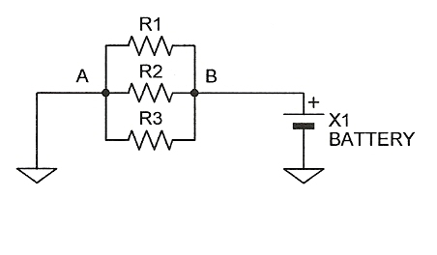
According to Kirchoff’s Current Law, the sum of all currents flowing into a node must balance the sum of all currents flowing out of a node. Thus, the current flowing into node A must equal the current flowing out of node B. One way to demonstrate this is to assign values to the circuit components and, using Ohm’s Law, calculate the results. Thus, if the battery is equal to 100 volts, R1 equals 5 kΩ, R2 equals 50 kΩ, and R3 equals 100 kΩ, the same voltage would exist on all of the resistors. We can calculate Ir1:
Ir1 = 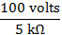 = 20 ma
We can also calculate Ir2 as: Ir2 = 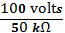 = 2 ma. Ir3 would be calculated in the same manner:
Ir3 = 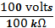 = 1 ma. Note that the branch currents are inversely proportional to the resistances. According to Kirchhoff, the circuit current at node A = circuit current at node B =
20ma + 2ma+1ma = 23ma. The equivalent resistance of the circuit would be as follows:
Requiv = 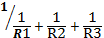 = 4.35 kΩ

Using this equivalent resistance and Ohm’s Law we can calculate and validate the earlier calculated current as follows:
Itotal = 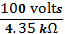 = 23 ma.

Resistors connected together in parallel are often referred to as a resistive current divider. For any number of resistors connected in parallel, the current through one of the resistors, R#, is equal to the sum of all resistor currents multiplied by the ratio of the sum of all resistors except R# to the sum of all resistors. For example:
In a circuit with three parallel resistors; R1, R2, and R3, the current through R1 would be equal to I1 = I total * . Note: I total is equal to the sum of all the total currents flowing through all resistors in the circuit.

Work Session/ Lab

Using the resistors and power source provided by your instructor, construct parallel circuits using the resistance values provided by your instructor. Using Ohm’s Law, calculate the approximate current expected through the circuit when the power source is placed across the parallel circuit. Measure the voltage drop across your resistors (Normally this should be the same as the source voltage, but if a battery is used, the load current may cause a decrease in the voltage when connected into the circuit. This is caused by the internal resistance present within the battery). Using Ohm’s Law, calculate the current through each resistor. Calculate the total current in the circuit by adding the individual branch currents. Calculate the circuit resistance using Ohm’s Law.

Circuit 1:
Values per your Instructor:

Source Voltage: __________________

R1: ______Ω, R2: ______Ω, R3: ______Ω

Measure Values:

Vr1 :______, Vr2: ______, Vr3: _______

Calculate the following values:

Rt : __________ Ω, = ( = 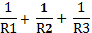 )

Ir1: __________ma, = ( )

Ir2: __________ ma,

Ir3: __________ ma,

I total: ________ma, = ( Ir1 + Ir2 + Ir3)

R total: ________ Ω = ( )

If a meter is available, disconnect the circuit between Node B and the battery. Insert an ampere meter (or DMM set to the ampere scale) with the positive lead on the battery and negative lead at Node B. Measure the circuit current. It should be close to the calculated value of I total. You may also measure the current in each leg as directed by your instructor.

Circuit 2:
Values per your Instructor:

Source Voltage: __________________

R1: ______Ω, R2: ______Ω, R3: ______Ω

Measure Values:

Vr1 :______, Vr2: ______, Vr3: _______

Calculate the following values:

Rt: _________ Ω

Ir1: __________ma,

Ir2: __________ ma,

Ir3: __________ ma,

I total: ________ma,

R total: ________ Ω

If a meter is available, disconnect the circuit between Node B and the battery. Insert an ampere meter (or DMM set to the ampere scale) with the positive lead on the battery and negative lead at Node B. Measure the circuit current. It should be close to the calculated value of I total. You may also measure the current in each leg as directed by your instructor.

Circuit 3:
Values per your Instructor:

Source Voltage: __________________

R1: ______Ω, R2: ______Ω, R3: ______Ω

Measure Values:

Vr1 :______, Vr2: ______, Vr3: _______

Calculate the following values:

Rt: ________ Ω

Ir1: __________ma,

Ir2: __________ ma,

Ir3: __________ ma,

I total: ________ma,

R total: ________ Ω

If a meter is available, disconnect the circuit between Node B and the battery. Insert an ampere meter (or DMM set to the ampere scale) with the positive lead on the battery and negative lead at Node B. Measure the circuit current. It should be close to the calculated value of I total. You may also measure the current in each leg as directed by your instructor.

