Simple Resistive Circuits Worksheet
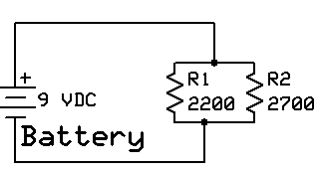

- Connect the circuit shown above. Apply the indicated voltage and observe the following:
  - Voltage across the battery: _________________
  - Vr1 _________________________
  - Vr2 _________________________
  - We can conclude, based upon the measurements, that the voltage across the resistors in a parallel circuit is _____________________.
  - Open the circuit and measure the current in the circuit (CAUTION: The ammeter must be in series with the circuit!). It = ________________________
  - In a similar manner, measure the current flow through R1: __________________
  - In a similar manner, measure the current flow through R2: __________________
  - According to Kirchoff’s Law, the total current of the parallel circuit should equal the sum it branch currents. Based on your measurements, is this correct? __________________
  - Based upon Ohm’s Law, what is the combined total resistance of the 2 parallel resistors? _______________
  - What is the calculated resistance of the parallel circuit? ____________________
  - Are the values obtained in f. and g. above the same? _____________ Why or Why Not? _____________________________________________________________________
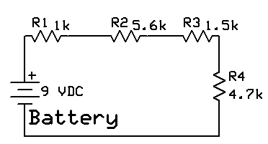

- Connect the circuit shown above. Apply the indicated voltage and observe the following:
  - Voltage across the battery: _____________________
  - Vr1: ______________________
  - Vr2: ______________________
  - Vr3: ______________________
  - Vr4: ______________________
  - According to Kirchoff’s Voltage Law, the sum of the resistor voltages should equal the supply voltage. Is it correct? ______________________
  - Disconnect the battery and connect the ammeter, in series, between the battery and R1. Connect the battery and measure the circuit current. ________________________
  - Again disconnect the battery and connect the ammeter between R2 and R3. Connect the battery and measure the circuit current. ______________________
  - Is the value of current measured in g. the same as that measured in h.? __________
  - Using Ohm’s Law, what is the calculated total circuit resistance? _______________
  - Calculate the sum of the individual resistances. Does it equal the calculated value in question j. above? _________
  - Remove power from the circuit! Using the meter, measure the total resistance of the series resistor network. Rt = ___________________. Is the measured value close to that identified in k. above? _______________

