Simple Resistive Circuits Worksheet
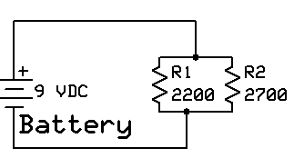
Note: Observed values will vary based upon battery condition and component tolerances

- Connect the circuit shown above. Apply the indicated voltage and observe the following:
  - Voltage across the battery: _____9VDC____________
  - Vr1 ______9 VDC___________________
  - Vr2 ________9VDC_________________
  - We can conclude, based upon the measurements, that the voltage across the resistors in a parallel circuit is _______Equal______________.
  - Open the circuit and measure the current in the circuit (CAUTION: The ammeter must be in series with the circuit!). It = _____7 ma___________________
  - In a similar manner, measure the current flow through R1: _____4 ma_____________
  - In a similar manner, measure the current flow through R2: ___3 ma_______________
  - According to Kirchoff’s Law, the total current of the parallel circuit should equal the sum it branch currents. Based on your measurements, is this correct? ___Yes_____________
  - Based upon Ohm’s Law, what is the combined total resistance of the 2 parallel resistors? 1212 Ω
  - What is the calculated resistance of the parallel circuit? ______1212 Ω______________
  - Are the values obtained in f. and g. above the same? __Probably Not___________ Why or Why Not? _Resistance tolerances will result in a difference in the calculated and actual measured values of current through the resistors__________________
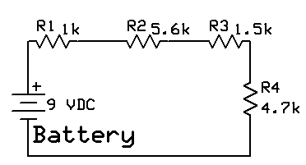

- Connect the circuit shown above. Apply the indicated voltage and observe the following:
  - Voltage across the battery: ______9 VDC_______________
  - Vr1: _____.7 VDC_________________
  - Vr2: _____3.9 VDC_________________
  - Vr3: ______1.0 VDC________________
  - Vr4: ______3.3 VDC________________
  - According to Kirchoff’s Voltage Law, the sum of the resistor voltages should equal the supply voltage. Is it correct? ____YES__________________
  - Disconnect the battery and connect the ammeter, in series, between the battery and R1. Connect the battery and measure the circuit current. __0.7 ma__________________
  - Again disconnect the battery and connect the ammeter between R2 and R3. Connect the battery and measure the circuit current. ___________0.7 ma___________
  - Is the value of current measured in g. the same as that measured in h.? ____YES______
  - Using Ohm’s Law, what is the calculated total circuit resistance? ___12.8 KΩ_____
  - Calculate the sum of the individual resistances. Does it equal the calculated value in question j. above? _12.8 kΩ________
  - Remove power from the circuit! Using the meter, measure the total resistance of the series resistor network. Rt = ___12.8 kΩ________________. Is the measured value close to that identified in . above? ___YES____________

