FE8 Unit Review Test
Answer each of the following questions with the one best answer:

- The unit of energy is the :
  - Watt
  - Volt
  - Ampere
  - Joule
- The unit of force is the:
  - Power
  - Newton
  - Current
  - Square feet
- Four resistors are connected in series. The total resistance of the circuit is 150Ω. The resistor values are as follows: 10Ω, 40Ω, 42Ω and an unknown resistor, R4. What is the value of R4?
  - 82Ω
  - 58Ω
  - 68Ω
  - 92Ω
- Three resistors are connected in parallel. The resistor values are: 20Ω, 60Ω, and 100Ω. What is the combined resistance of the circuit?
  - 8.8Ω
  - 12.8Ω
  - 18 Ω
  - 22 Ω
- Calculate the following for the circuit shown:

R total: _____________________

I total: ______________________ (Battery Voltage = 10 volts)

Vr4: ________________________

P total: ______________________
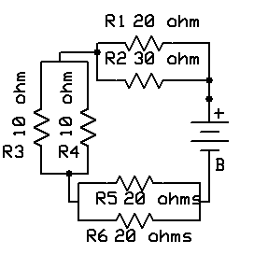
- Calculate the following for the circuit shown:

Rt: ____________

Ir1: ____________

Ir3: ____________

It: _____________

Er2: ____________

Er4: ____________

P total: __________

Pr1: _____________

Pr4: _____________

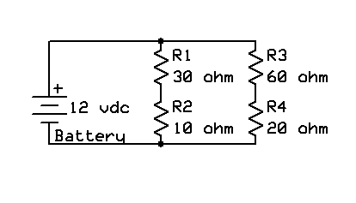

- What would the voltage you would expect to measure at the following points during normal operation? (All voltages with reference to ground)

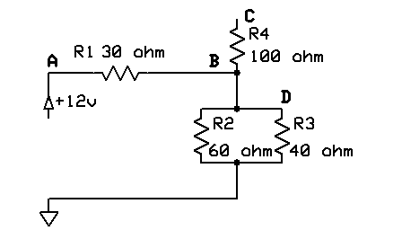
Point A: _________________

Point B: _________________

Point C: _________________

Point D: _________________

- Troubleshooting: Using the above circuit, R2 has become open. What voltage would you expect to measure at the following points?

Point A: ________________

Point B: _________________

Point C: _________________

Point D: _________________

- Troubleshooting: Using the circuit in Problem 7, The following measurements are taken:

Point A: _________________

Point B: _________________

Point C: _________________

Point D: _________________

Voltage Input: 12 vdc

The faulty component is most likely to be:

- R1
- R2
- R3
- R4

- In your own words, explain Kirchoff’s Current Law:

