FE8 Unit Review Test
Answer each of the following questions with the one best answer:

- The unit of energy is the : D
  - Watt
  - Volt
  - Ampere
  - Joule
- The unit of force is the: B
  - Power
  - Newton
  - Current
  - Square feet
- Four resistors are connected in series. The total resistance of the circuit is 150Ω. The resistor values are as follows: 10Ω, 40Ω, 42Ω and an unknown resistor, R4. What is the value of R4? B
  - 82Ω
  - 58Ω
  - 68Ω
  - 92Ω
- Three resistors are connected in parallel. The resistor values are: 20Ω, 60Ω, and 100Ω. What is the combined resistance of the circuit? B
  - 8.8Ω
  - 13 Ω
  - 18 Ω
  - 22 Ω
- Calculate the following for the circuit shown:

R total: _________28 Ω____________

I total: __________0.5 amps____________ (Battery Voltage = 14 volts)

Vr4: ___________0.25 amps_____________

P total: _________7 watts_____________
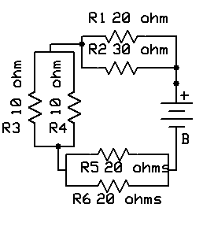
- Calculate the following for the circuit shown:

Rt: ____26.7 Ω________

Ir1: ___0.3 amp_________

Ir3: ___0.15 amp______

It: ____0.45 amp_________

Er2: ___3 volts_________

Er4: ___3 volts_________

P total: __5.4 watts________

Pr1: ____2.7 watts_________

Pr4: ____2.7 watts_________

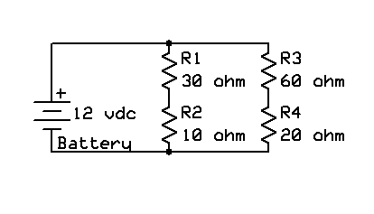

- What would the voltage you would expect to measure at the following points during normal operation? (All voltages with reference to ground)

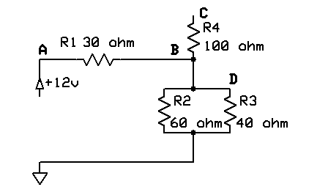
Point A: ____12 vdc_____________

Point B: _____5.3 vdc____________

Point C: _____5.3 vdc____________

Point D: _____5.3 vdc____________

- Troubleshooting: Using the above circuit, R2 has become open. What voltage would you expect to measure at the following points?

Point A: ___12 vdc_____________

Point B: ____6.85 vdc_____________

Point C: ____6.85 vdc_____________

Point D: ____6.85 vdc_____________

- Troubleshooting: Using the circuit in Problem 7, The following measurements are taken:

Point A: 12 vdc

Point B: 8.5 vdc

Point C: 8.5 vdc

Point D: 8.5 vdc

Voltage Input: 12 vdc

The faulty component is most likely to be: A

- R1
- R2
- R3
- R4

- In your own words, explain Kirchoff’s Current Law:

According to Kirchoff’s Law, all currents into a circuit node equal all currents out of that node. You can’t just lose electrons as they flow around a circuit. The law may also be written as ∑ In = ∑ Iout.

