FE 8 Culminating Activity

What Does the Circuit Tell Us?

Materials Needed:

Power Supply (10 volts) or substitute a 9 volt battery
Breadboard
Connecting wire, Solid, 20 or 22 gauge Copper
Resistors, Carbon ½ or ¼ watt
100 Ω, 220 Ω, 470 Ω, 1000 Ω, 2.1 kΩ, 10 kΩ

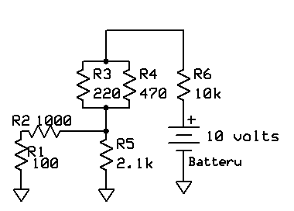

Construct the circuit as shown above.

Calculate the expected voltage and current for each resistor while the circuit is in operation.

Resistor | Voltage | Current
R1
R2
R3
R4
R5
R6

Measure the voltage and current for each resistor while the circuit is in operation. Note: For current measurement, the meter must be placed in series with the applicable resistor.

Resistor | Voltage | Current
R1
R2
R3
R4
R5
R6

Are the values measured the same as those calculated? Why/Why Not?

Resistor | Same (Yes/No) | Why/Why Not?
R1
R2
R3
R4
R5
R6

Does this validate Kirchoff’s Current and Voltage Laws?

