FE 8 Culminating Activity

What Does the Circuit Tell Us?

Materials Needed:

Power Supply (10 volts) or substitute a 9 volt battery
Breadboard
Connecting wire, Solid, 20 or 22 gauge Copper
Resistors, Carbon ½ or ¼ watt
100 Ω, 220 Ω, 470 Ω, 1000 Ω, 2.1 kΩ, 10 kΩ

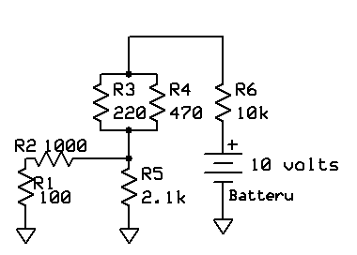

Construct the circuit as shown above.

Calculate the expected voltage and current for each resistor while the circuit is in operation.

Resistor | Voltage | Current
R1 | 610 mv | 610 µa
R2 | 610 mv | 610 µa
R3 | 138 mv | .000627
R4 | 138 mv | .000294
R5 | 664 mv | .000316
R6 | 9.2 v | .000920

Measure the voltage and current for each resistor while the circuit is in operation. Note: For current measurement, the meter must be placed in series with the applicable resistor.

Resistor | Voltage | Current
R1 | 60 mv | 610 µa
R2 | 60 mv | 610 µa
R3 | 140 mv | 600 µa
R4 | 140 mv | 300 µa
R5 | 660 mv | 300 µa
R6 | 9 v | .9 ma

Are the values measured the same as those calculated? Why/Why Not?

Resistor | Same (Yes/No) | Why/Why Not?
R1 | NO | Differences in actual and calculated circuit component values
R2 | NO | Differences in actual and calculated circuit component values
R3 | NO | Differences in actual and calculated circuit component values
R4 | NO | Differences in actual and calculated circuit component values
R5 | NO | Differences in actual and calculated circuit component values
R6 | NO | Differences in actual and calculated circuit component values

Does this validate Kirchoff’s Current and Voltage Laws? YES

