SUPERPOSITION ANALYSIS
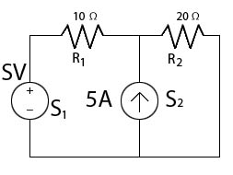
Let us say that we need to know the voltage across the resistor R₁ in the above circuit. How would we go about analyzing the circuit to find that? With both a voltage source and a current source, finding the net effect on the resistor is not simple. Fortunately, there is a method for simplifying such circuits: Applying the Superposition Theorem. The Superposition Theorem states that a circuit with more than one source is equivalent to the sum of multiple circuits, each with just one source. Put another way, the net effect on an element by multiple sources is the sum of the effects of each source. Knowing this, we can break our circuit down into two circuits, each with just one source:
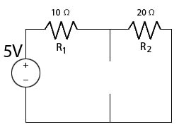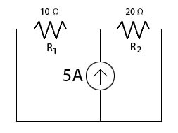
In the left circuit, the current source has been eliminated by replacing it with a break; no current can flow across a break. On the right, the voltage source has been replaced with wire, since wire has no voltage across it in an ideal circuit. If we solve for the voltage across R₁ in each of these circuits, we can add the answers to get the net voltage across R₁.
First, the circuit with the voltage source: since all elements are on the same line, we know that the same current I flows through all of them. Now, using Kirchhoff’s Voltage Law we get the following equation:
-5V + V_{R1} + V_{R2} = 0
Now we can use Ohm’s Law, V=IR, to define the voltages across the two resistors.
-5V + I*R₁ + I*R₂ = 0
Rearranging to solve for I, we get:
I = 5V/(R₁+R₂) = 1/6 A
Now we can use this current, again with Ohm’s Law, to find the voltage drop across each resistor.
V_{R1} = I*R₁ = 10/6 V
V_{R2} = I*R₂ = 20/6 V.
It is important to remember that the voltages are positive in the direction of current flow in our decomposed circuit; the net current flow after superimposing our two circuits may be in the opposite direction. This will have to be taken into account when the two circuits are recombined.
Now, the current source circuit:
First, we can see from applying Kirchhoff’s Voltage Law that the voltage across the two resistors must be the same, but opposite in direction. By taking the outside loop and listing the elements clockwise, we get: V_{R1} + V_{R2} = 0, or V_{R1} = -V_{R2}. Now we can apply Kirchhoff’s Current Law at the top node.
[DIAGRAM: current source circuit with currents I₁, I₂, I₃]
Notice that although we could expect currents I₂ and I₃ to flow in opposite directions just from looking at the circuit, we have them flowing in the same direction as when we used KVL on the voltage source circuit. This is to maintain consistency across equations and avoid problems with signs later. The currents flowing into this node must equal the currents flowing out: I₁ +I₂ = I₃. The current source mandates that I₁ = 5A. We can use Ohm’s Law to define the currents I₂ and I₃ through the two resistors in terms of the voltage across them; I = V/R. This gives us:
5A + V_{R1}/10Ω = V_{R2}/20Ω
Lastly, we use our equation V_{R1} = -V_{R2} to set the equation in terms of V_{R2} and solve.
5A -V_{R2}/10Ω = V_{R2}/20Ω → V_{R2} = 100/3 V
We can substitute this into our previous equation V_{R1} = -V_{R2} to find that V_{R1} = -100/3V. Remember: the sign of the voltage drop shows the relation of the drop to the direction of current chosen. The net current at the end of the problem may not be in the direction we have chosen; in fact, the negative sign of the voltage implies that this may be the case.
Now that we have solutions for the decomposed circuits, we can recombine (or superimpose) them for the final answer:
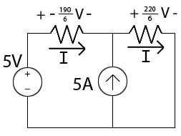
Note that we are able to sum the voltages without changing their signs because we set the same direction for current for both decomposed circuits.
For the direction of current shown, the total voltage drop across resistor R₁ is -190/6 V. This shows that the current through the resistor is in the opposite direction from what we chose. Though the current solution is valid, we can BOTH change the sign of the voltage drop AND reverse the direction of current flow to get a diagram that shows current flow through the circuit more clearly:
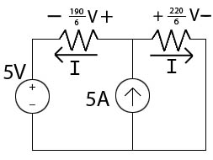
We can now see that current in the left loop flows from the positive to the negative terminal of the voltage source. This is unusual for many circuits, and illustrates a sometimes overlooked aspect of ideal voltage sources: they show a voltage gap; they do NOT mandate the direction of current flow. In a circuit with only one voltage source, current will almost always flow from the positive to the negative terminal, but in a circuit with multiple sources, this is not always the case.

