Pizza Box Solar Oven
There are many versions of solar ovens. Pizza box solar ovens can reach temperatures up to 275 degrees Fahrenheit (135 degrees Celsius). That is hot enough to cook food and kill any pathogens in water. To get the best result, food should be put in the oven early in the day and forget about overcooking. Solar cooking can be done six months out of the year in northern climates and longer in climates the closer they are to the equator. Cooking time should approximately double in solar cooking compared to conventional cooking. The solar ovens take about half an hour to pre-heat.

Needed materials for making your own Pizza Box Solar Oven:
- Pizza box (can be a recycled/used box if clean)
- Black construction paper
- Aluminum foil
- Clear plastic (heavy plastic laminate will give the best results)
- Non-toxic glue, scissors, ruler, marker, tape
- Wooden dowel or sturdy straw

How to make your own oven:
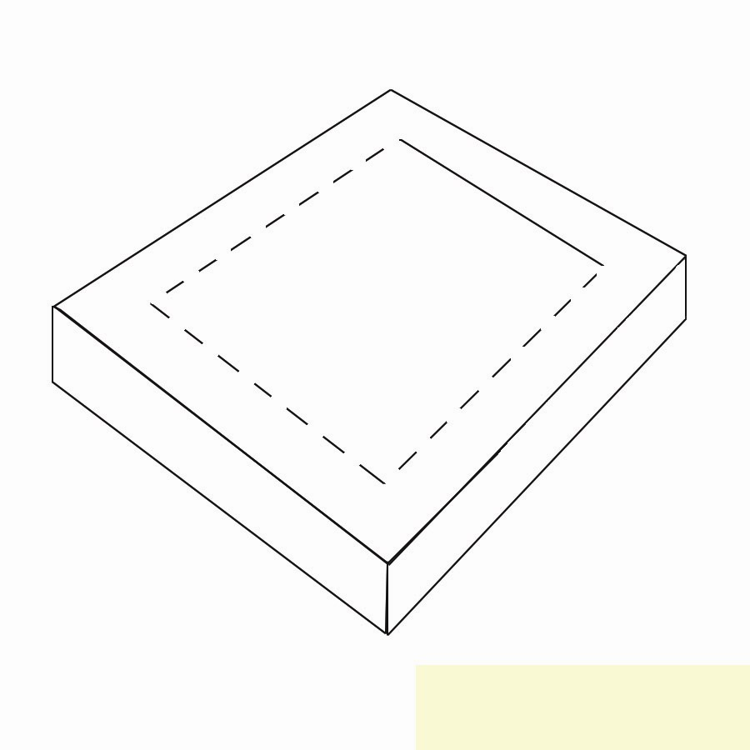
Taking the marker, draw a one inch border on all sides of the top of the box. Leave the line along the fold of the box and cut the remaining three sides.

Carefully fold back along the uncut line, forming a crease. This will create a flap. Fit a sheet of aluminum foil to fit the inside of the flap; smooth out any wrinkles and glue in place. Next, cover the opening created by forming the flap with clear plastic. Make sure the plastic is cut large enough to tape to the underside of the box top. The plastic should be tightly sealed so the air cannot escape from the interior.
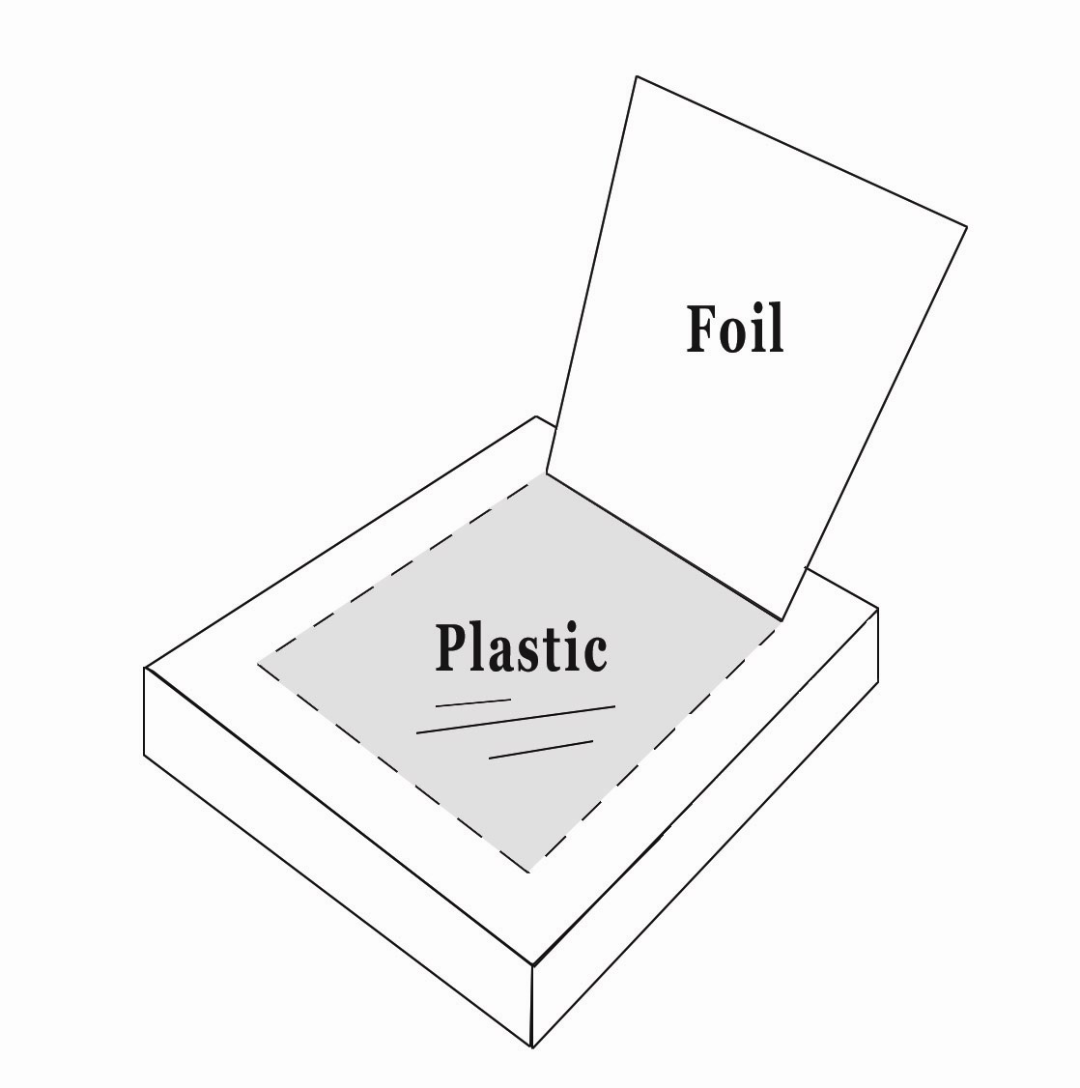

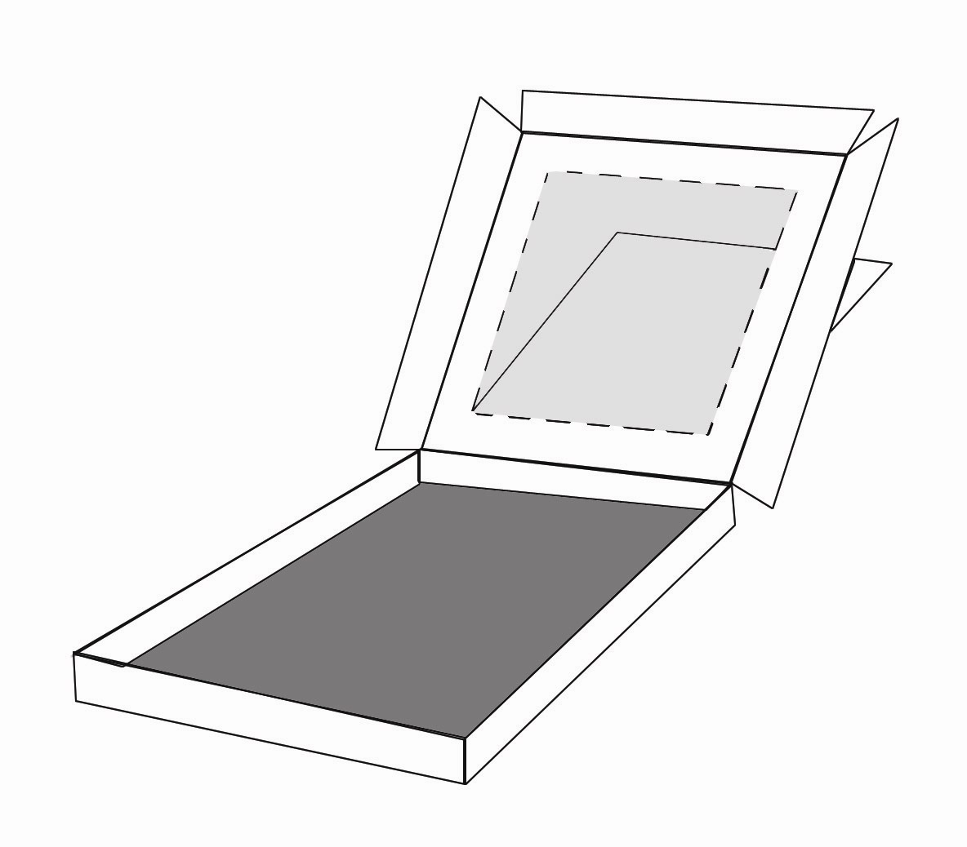
Cut another sheet of aluminum foil to line the bottom of box and glue into place. After it is glued, lay a piece of black construction paper on the aluminum foil and tape into place.

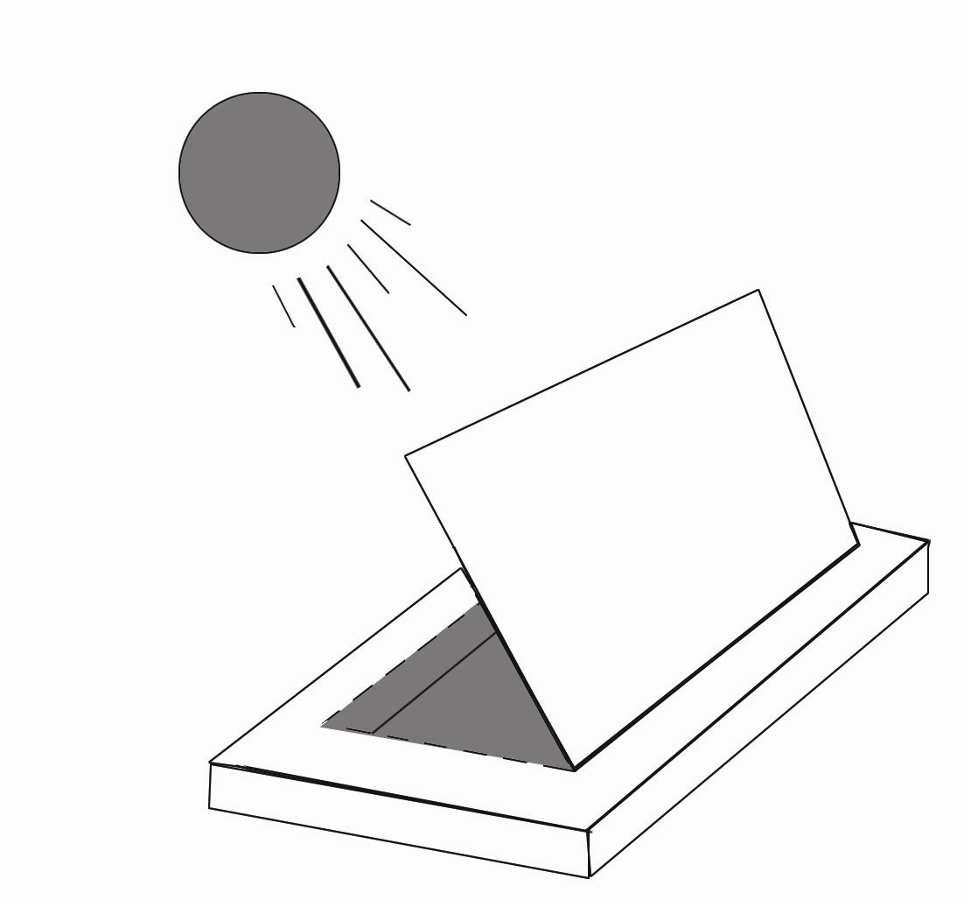
Now that you’ve assembled the oven, prop the flap of the box with the wooden dowel/sturdy straw and face oven towards the sun. Adjust until the aluminum reflects the maximum sunlight through the window into the oven interior.

When you find the maximum sunlight, you’re ready to start cooking!

