Using a Geiger Counter
How radioactive are different materials?

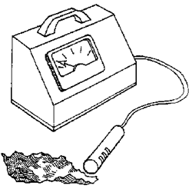
Materials:
Geiger counter
Radioactive sources such as:
• cloisonne jewelry
• commercially available source from a science supply house
• luminescent clock face
Shielding materials such as:
• paper
• aluminum foil
• brick
• jar of water
• piece of wood
• glass pane
• sheet of lead

Directions: Follow the instructions and answer the questions below.

One at a time, test each item that is a source of radioactivity by placing the source 2 inches from the Geiger counter probe.
- Which item has the highest reading?______________________
The lowest?__________________________

Place the radioactive source that had the highest reading 2 inches from the
Geiger counter probe. One at a time, test each of your shielding materials by
placing them between the source and the counter.
- Do you think the density of the shield is important?______________________________
Why?_________________________________________

- Why do we measure radiation exposure?

- When you use a Geiger counter to survey a radioactive substance, why is it important to know what the background radiation level is?

