Solar Cell Technology: Teacher Reading

Solar Cells Convert Light Energy into Electricity
A solar cell is an energy conversion device. It converts energy from sunlight into electrical energy.
A solar cell is an energy conversion device that converts light energy into electrical energy. Through a multi-step process, a solar cell takes sunlight as an input and generates electrical energy (in the form of a current) as an output. A common misconception is that solar cells produce or create electricity. It is more accurate to say that a solar cell is a device that “converts” light energy from the sun into electrical energy [1][2]. Other examples of energy conversion devices are batteries (conversion of chemical energy to electrical energy), wind and water-powered generators (conversion of mechanical energy to electrical energy), and gasoline engines (conversion of chemical energy to mechanical energy).

How Solar Cells Work
Understanding how a solar cell works means understanding the process by which a solar cell converts light into electricity. There are four important steps to the energy conversion process in a solar cell:
- Sunlight Shines on the Solar Cell
- Energy is Absorbed to Liberate Electrons
- Electrons are Transported
4. Circuit is Completed
Below are general explanations of these steps for two specific types of solar cells: newer, nano-influenced dye-sensitized solar cells (Figure 1a), and more traditional, single-crystal silicon solar cells (Figure 1b).
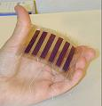 | 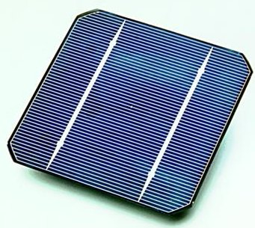
Figure 1a. Dye-sensitized “nano” solar cell [3] | Figure 1b. Single-crystal silicon solar cell [4]

Step 1: Sunlight Shines on the Solar Cell
The solar cell can only absorb energy from the sunlight that shines directly on it. It is also important that the sunlight strikes the solar cell as close to perpendicular as possible, in order to achieve maximum transference light energy to the solar cell. The greater the angle between the sun and the solar cell, the greater the area that the light is spread over. This reduces the energy per unit area. (Note: this angle of incidence phenomenon can be demonstrated in class with a flashlight and beach ball by shining the flashlight onto the ball at different angles and observing the change in area that the light shines on.)

Step 2: Energy is Absorbed to Liberate Electrons
After the light shines on the surface of the solar cell, the light energy needs to be captured by the solar cell so it can be converted into electrical energy. Here the energy from the light is transferred to electrons in the material that makes up the solar panel. In both the dye-sensitized solar cells and traditional single-crystal silicon solar cells, there are minimum energies that the light has to have to be able to excite the electrons into a higher energy state.
Dye-Sensitized Solar Cell (DSSC) | Single-Crystal Silicon Solar Cell
In the dye-sensitized solar cell, electrons are liberated from an organic dye material that acts as a “photosensitizer.” Ruthenium (Ru) complexes are some of the more promising photosensitizers being used because of their ability to absorb a wide range of visible light (from 400 to 800 or 900 nm [5]).  The dye molecules are responsible for absorbing the incident light. However, the light has to have enough energy to promote an electron from an occupied molecular orbital to a higher energy unoccupied molecular orbital. The energy gap of relevance here is that between the highest occupied molecular orbital (HOMO) and the lowest unoccupied molecular orbital (LUMO).  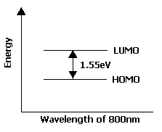  Figure 2. Energy vs. wavelength (800nm)  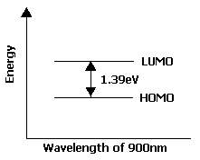  Figure 3. Energy vs. wavelength (900nm)  For typical dyes the energy gap is 1.55eV or 1.38eV (corresponding to 800nm or 900nm, respectively). | In the single-crystal silicon solar cell, electrons have to have a minimum “band gap” energy before they can be released. Band gap is the energy difference between the top energy level of the valence band and the bottom energy level of the conduction band. The valence band and the conduction band are overlaps of several Si atomic orbitals. For the electrons to jump between the valence band and the conduction band, the valence band has to be partially empty and the conduction band has to be partially full.  Electrons can jump from anywhere in the valence band to anywhere in the conduction band, so incident light with an energy equal to or greater than the band gap energy can be used to excite the electrons. In the case of crystalline silicon, the band gap energy of silicon (Si) is about 1.1 eV [6].  band gap ∆E  conduction band  valence band  Figure 4. Band gap between conduction band and valence band

Step 3: Electrons are Transported
Now that we have excited electrons, we need a way to “corral” them so they can do work. The goal at this point is to organize the electrons so they form a current, which can be used outside of the cell to drive a motor or light a light bulb.
Dye-Sensitized Solar Cell (DSSC) | Single-Crystal Silicon Solar Cell
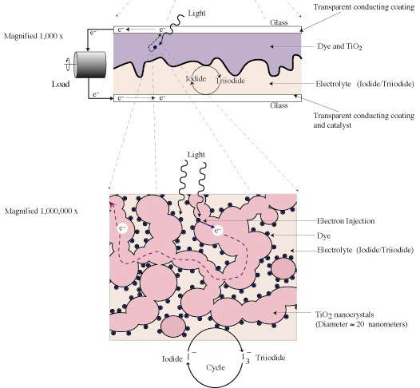  In the DSSC, the light-absorbing dye molecules are coated onto very small, dispersed TiO₂ particles. The TiO₂ particles form “layers” that are more spherical than flat (see figures below) – basically stacks of nano-sized particles covered with dye.  Figure 5. Dye-sensitized solar cell diagrams [7]  The TiO₂ particles range in size from 10nm-30nm, giving them high surface to volume ratios. In the range where the dye molecules convert a significant fraction of incident light into electron energy (400nm-900nm), the TiO₂ is transparent to light. The large surface area of the TiO₂ creates a large surface area for absorption for the dye molecules that coat them. Since the TiO₂ is transparent to light in this energy range, light that isn’t absorbed by the dye molecules coated onto a particular TiO₂ particle will pass through and be available to be absorbed by the next dye-coated TiO₂ particle that the light strikes.  Figure 5 above shows the construction of a dye-sensitized solar cell. The top figure depicts the dye and TiO₂ situated in the top portion of the cell. The light enters through the top glass plate and excites electrons in the dye. Electrons with enough energy are absorbed into the conduction band of the TiO₂ and are transported to the conductive coating on the top glass plate. The TiO₂ acts as a conduit between the dye molecules (where the electrons originate) and the top contact, and channels the flow of electrons out of the cell. The bottom figure is an expanded view of the dye/ TiO₂ layer. Note that the dye molecules sit on top of the TiO₂ nanocrystals, and that there are various “layers” of the dye/ TiO₂.  Again, since the nano-sized TiO₂ particles do not scatter light in this wavelength range, the light can penetrate into the DSSC and contact multiple layers of dye-coated TiO₂. If the TiO₂ were all larger particles, the light would be scattered out of the cell without penetrating many dye layers, and hence not much of the incident light would be absorbed.  The idea of using nano-sized particles to eliminate scattering is similar in principle to the use of TiO₂ in making “clear” sunscreens. All TiO₂ is good at absorbing UV rays, but thick layers of TiO₂ scatter visible light. Much of this scattered light is reflected back to our eyes, making the sunscreen appear white (because the whole spectrum of visible light together appears white). When nano-sized TiO₂ particles are used instead, absorption of the UV rays still occur, but the smaller particles don’t scatter the visible light. The visible light can pass through the TiO₂ particles and reach the skin when the blue/green wavelengths are absorbed and the red/yellow wavelengths are reflected. The person’s normal skin color shows through and the sunscreen appears clear. | In the single-crystal silicon solar cell, crystalline silicon is used. The outer shell of each silicon atom has four electrons, which creates the crystalline structure when the atoms are bonded together––each silicon atom shares an electron on each side with a neighboring silicon atom. Because pure silicon is a poor conductor, other atoms are added (“doped”) to the silicon to increase conductivity. By adding phosphorus (P) atoms, an additional electron is added since phosphorus has five electrons in its outer shell. By adding in boron (B) atoms, an empty spot, or “hole” is available (see figure below.)  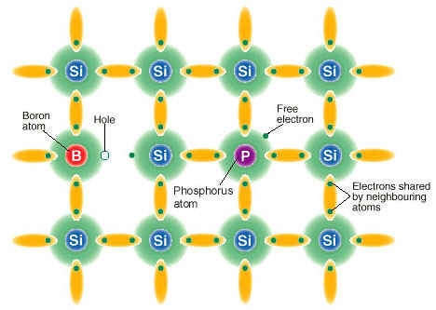  Figure 6. “Doped” silicon crystalline lattice [8]  In the single-crystal silicon cell, the added phosphorus and boron atoms are split between two layers. The layer with phosphorus atoms added is called the n-type silicon layer (“n” because of the added negative electrons).  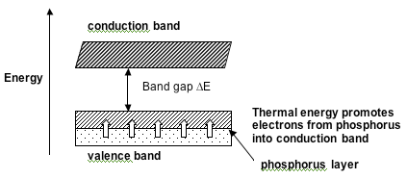  Figure 7. Phosphorus layer in conduction band  The layer with boron atoms added is called the p-type silicon layer (“p” for the added positive holes). It is important to note that the positive holes effectively move around just like the electrons do, so it is safe to think of them as mobile positive charges.  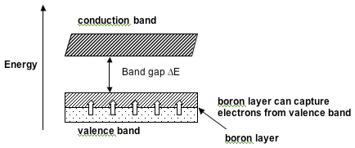  Figure 8. Boron layer in conduction band  When the n-layer and the p-layer are brought into contact with each other, an electric field is set up. This electric field directs the flow of excited electrons that were liberated from the interaction with the sunlight. The electric field allows the flow of electrons in one direction only – from the “p” side to the “n” side. As such, when the sunlight strikes the solar cell, electron-hole pairs are freed, and, due to the electric field, they are separated. It is this separation (and ultimately the recombination) of electron-hole pairs that generates a current.  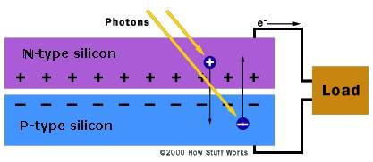  Figure 9. Silicon solar cell schematic [9]

Step 4: Circuit is Completed
For the excited electrons to actually move in a controlled fashion and do work, there needs to be a complete path for their flow.
Dye-Sensitized Solar Cell (DSSC) | Single-Crystal Silicon Solar Cell
In the dye-sensitized solar cell, the flow of excited electrons from the dye molecules into the TiO₂, and then through the TiO₂ to the top conducting plate of the cell, sets up a potential difference (i.e. voltage). Once the electrons re-enter the solar cell they need a way to move from the bottom contact back up to the TiO₂ and dye molecules at the top. An ionic iodide solution is used to make this “last mile” happen – the solution acts as a transportation path for moving the electrons back to where they started. Once the electrons reach the dye, they fill in the positive holes that were created when they left. Again, it is the charge separation––the excess negative charge from the electrons moving out of the top of the solar cell, and the positive holes left behind––that sets up the potential difference in the cell and influences the electrons to move in the completed circuit. | In the silicon solar cell, to make the electrons move the electric field set up within the silicon creates a potential difference (a “voltage”) between where the electrons leave the solar cell and where they re-enter the solar cell. This voltage can be thought of as acting like a pump, pushing the electrons out the top of the solar cell and back to the bottom of the solar cell.

A Note on Efficiency
In general, silicon-based solar cells tend to be more efficient at generating electricity from light energy than dye-sensitized solar cells. However, it is important to note that dye-sensitized solar cells (DSSCs) have several advantages over silicon-based solar cells. First, DSSCs are more effective at picking up light earlier in the morning and later in the evening. This allows the DSSCs to operate for a longer portion of the day than silicon-based solar cells. Second, DSSCs are less affected by temperature––they can operate as efficiently in hot climates at they can in cold [10]. Standard silicon-based solar cells are more sensitive to temperature, with their efficiency dropping under particularly hot and cold conditions. Given these two advantages, when real-life operation is considered, the overall efficiency of DSSCs comes close to that of silicon-based solar cells. DSSCs tend to be about 10% efficient [11], with silicon-based solar cells being slightly more efficient (approximately 12%-15% efficient.)

In Summary
These are the four basic steps of the process in a solar cell. Even though single-crystal silicon and dye-sensitized solar cells differ in the materials they are made of, there are many similarities in the energy conversion process between the two. One final similarity is that in both cases optimization is important in each part of the system, so as to increase the efficiency of the solar cell. By improving the efficiency of the various components, the overall efficiency of the solar cell improves [12].

References
[1] See http://www.howstuffworks.com/light1.htm for a general description of the dual nature of light.
[2] For a more detailed description of light see http://en.wikipedia.org/wiki/Light#Particle_theory
[3] Source: http://www.elp.uji.es/juan_home/images/solar_cell/flex1.JPG
[4] Source: http://www.wisconsun.org/images/siemen_cell.jpg
[5] Hara, K., and Arakawa, H. (2003). Dye-sensitized solar cells. In the Handbook of Photovoltaic Science and Technology, Luque, A., and Hegedus, S. (Eds.) John Wiley and Sons. Hoboken, N.J.
[6] For a more detailed discussion on band gap and energy losses in solar cells, see http://science.howstuffworks.com/solar-cell4.htm
[7] Source: http://www.solideas.com/images/diagram.jpg
[8] Source: http://www.corrosion-doctors.org/Solar/images/silicon.jpg
[9] Source: http://science.howstuffworks.com/solar-cell3.htm
[10] See www.technologyreview.com/Energy/17490/. Retrieved 10-02-07.
[11] Dye Sensitized Solar Cells (DYSC) based on Nanocrystalline Oxide Semiconductor Films. Laboratory for Photonics and Interfaces, Swiss Federal Institute of Technology, CH-1015 Lausanne, Switzerland. Printed from lpi.epfl.ch/solarcellE.html on 05-16-07.
[12] For an even more detailed description of the full process of how a solar cell works, a good description is provided at http://science.howstuffworks.com/solar-cell.htm

