How to Create a Potato Clock

  - Materials:
- Cut potatoes
- Plates
- Three 8-inch pieces of insulated copper wire with 2 inches stripped off of one end
- Two galvanized nails
- Two pennies
- Digital clock with attachments for wires
  - Can also substitute the digital clock for a small lamp and lamp socket

- Directions:
- Wrap the end of one piece of wire around a galvanized nail and wrap the end of a second piece of wire around a penny.

- Stick the nail and penny into one half of the potato so that they're not touching each other.

- Next, wrap the third piece of wire around the other penny and put it into the other half of the potato. Put the other nail into the second half of the potato, but this nail should not have wire wrapped around it.

- Connect the wire from the penny on the first half of the potato to the nail that has no wire on it in the second half of the potato.

- Finally, touch the free ends of the wires to the wires coming out of the digital clock.

- If it is not successful on the first attempt, try connecting the wires to the clock in different ways to get the energy to flow through the clock in the right direction.
  - Like putting batteries into a clock; they have to go in the right way.
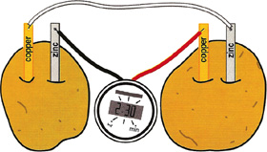

COPYRIGHT

