Pulley Lab

Purpose: To explore the mechanical advantage provided by different pulley systems.
Materials: ring stand, pulleys, string, spring scale, weight, meter stick
You will be examining different pulley configurations to help you understand the concept of Mechanical Advantage (MA). Simply put, the ideal or theoretical MA of a pulley system is the number of ropes pulling up on the object being lifted.
You will then determine the observed mechanical advantage by comparing the force required to lift and object to the weight of the object.
Observed MA = (weight of the object)/(measured force required to lift the object)
Procedure:
- Record all data on the data sheet provided.
- Calibrate your spring scales.
- For each configuration, you will be measuring the force required to lift the weight. You will also record the height you lift the object and the how far the string pulled during the same lift. Record all of this information on the data sheet.
- Weigh your weight using a spring scale. You will use this same weight throughout the entire lab.
Weight = ___________ Newtons

For each of the following five configurations, answer the following questions on the data sheet:
- Based on your class notes, what is the theoretical MA of this system?
- Measure the force required to lift the weight.
- Determine the observed MA of this system.
- Measure the height the object is lifted
- Measure how far the string was pulled to lift the object.
- Calculate the ratio of the length of string pulled to the height the object is lifted.
- Explain why someone would want to use this type of pulley system.

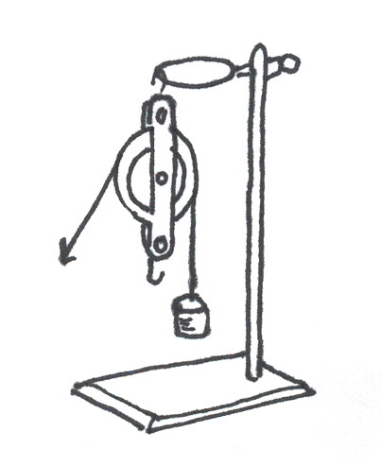
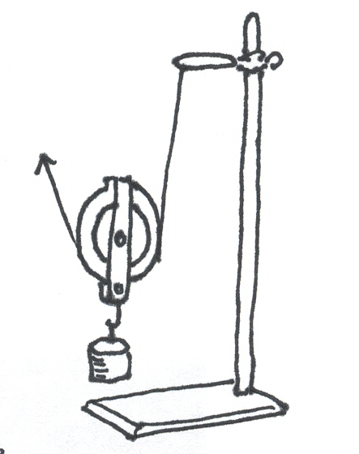
#1: Single Fix Pulley #2: Single Moveable Pulley

#3: Single Fixed, Single Moveable
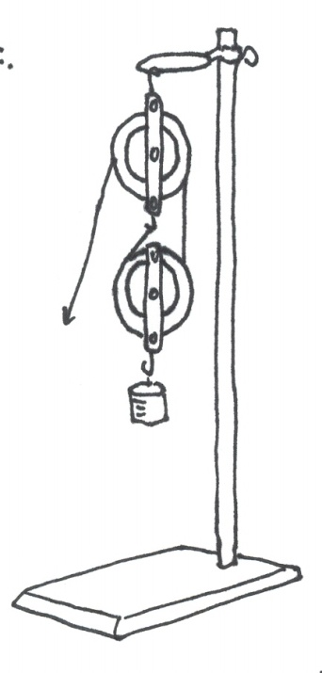

#4: Double Fixed, Single Moveable
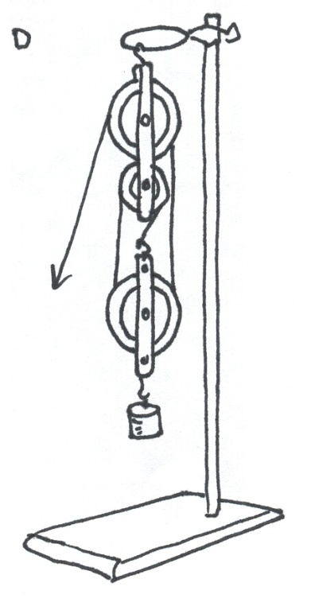

#5 Double Fixed, Double Moveable
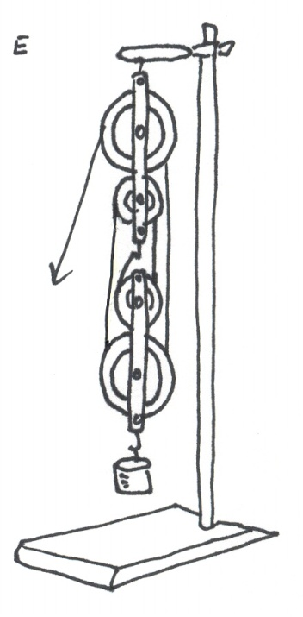

Summary
- Explain why the number of supporting ropes determines the mechanical advantage? Why can you count a section of rope you are pulling up on, but not a section you are pulling down on?
- When using a simple machine, you use less force. What do you have to do more of in exchange?

Extra Credit
- Look carefully at the string pattern around the pulleys. Find the relationship between the pattern and the Mechanical Advantage. Using only the two double pulleys, experiment with an arrangement of pulleys that has an MA of 5. Draw that arrangement on the back of your data sheet.

