Pneumatics and Hydraulics Lab Name:

Connect two syringes of the same size and a short length of tubing. Have both plungers all the way in.

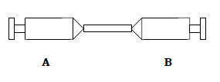
- What do you think will happen when you try to pull either plunger out?

- Try it. Were you right?

- Why do you think this happened?

This time make sure one plunger is out and the other is in, as in the diagram.
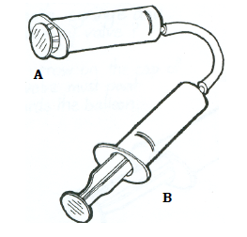
- Try pushing in plunger B. What happened?

- Now try pulling out the plunger that is all the way in. What happened?

- When you pushed one plunger in, the other plunger moved in the opposite direction. T or F?

Take off one syringe and fill it with 5 ml of air. Push the other plunger all the way in and connect the two syringes with tubing. Now push the 5 ml of air out of the syringe into the other syringe. How much air goes into the other syringe? Explain your answer
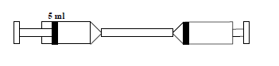

This time connect a medium and a small syringe together using a short length of tubing. Have the small syringe fully open and the large syringe closed.
Push in the small syringe plunger.
- Is the amount of air that goes into the large syringe the same amount that was in the small one? Yes or No ?
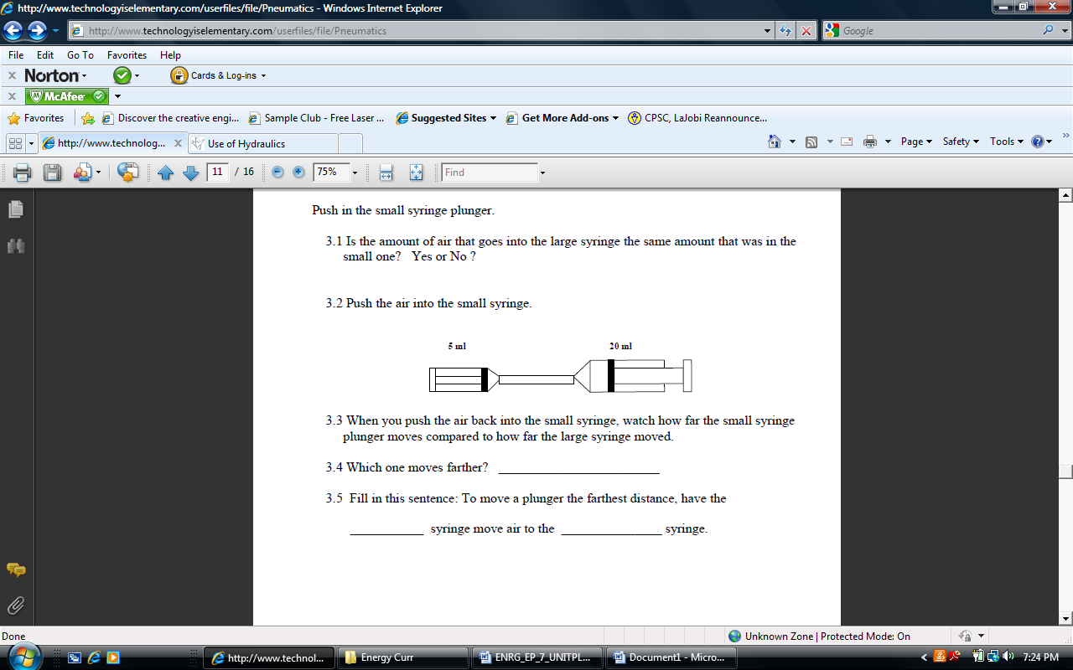

Push the air into the small syringe.
When you push the air back into the small syringe, watch how far the small syringe plunger moves compared to how far the large syringe moved.
- Which one moves farther?

- Fill in this sentence: To move a plunger the farthest distance, have the ___________ syringe move air to the _______________ syringe.

Have the air in the small syringe. Hold your thumb over the top of the large syringe plunger See if you can keep the large plunger all the way down easily as you push the air out of the small syringe.
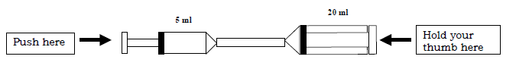

Now push the air out of the large syringe as you hold your thumb over the small syringe.

- Which way seemed to have more force: When you pushed the air from the _____________ syringe into the ______________syringe.
- When you want to increase the amount of force , have the _______________ syringe move air into the ___________ syringe.
- How does the answer to the question above compare to the question about which one moves farther?

You have just completed pneumatic tests. Repeat the same steps above but fill your syringes with water rather than air. This will represent hydraulic systems.



Pneumatics and Hydraulics Lab

This time connect two syringes of the same size together using a short length of tubing and a three-way valve. Have the three-way valve lever point toward syringe A.
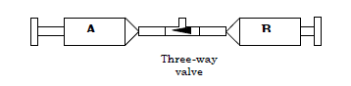
- Try pressing in plunger “A”. What happens?

- Pull out plunger B. Does it fill with air? Yes or no?

- Did syringe A lose air when you pulled out plunger B? Yes or no?

- Push plunger B in. Where did the air go?

Technical Note:
Direction of lever indicates that air will not flow in that direction.

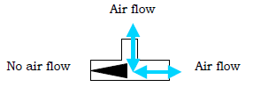

Can you inflate a balloon using a syringe and a three-way valve? In order to pump up the balloon, it will be necessary to continually change the position the valve.

- Draw the valve position so the syringe can blow air into the balloon.

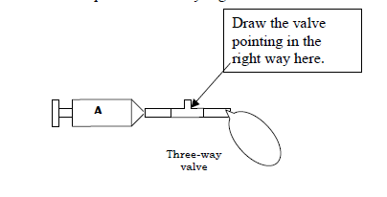
- Experiment with various valves to make the balloon continue to inflate without deflating. Draw a diagram below.

- Explain what is happening in the diagram.

