ATLAS

Support Research

Jacob Miller
Ringgold High School
29 Tiger Trail
Ringgold, GA 30736
Acknowledgments
While I may have been attempting this work as an individual, much of the success of this project is dependent upon the support and encouragement of family, friends & peers. Their unflagging faith in me, while almost certainly misplaced, was instrumental to any success resulting from this work. This task to design a space colony, while of unparalleled interest and relevance, was also equally challenging and demanded the full utilization of my creative faculties and determination. Indeed, I had doubts that I would be able to properly address the project, entering late into the competition cold in an entirely new school with no one to look to but myself and my will to achieve the fullness of my potential.
I would like to recognize Catherine Turner, my sponsor, for providing me with a challenging project that would demand every ounce of my imagination and ability. It was due to her interest in the welfare of her students and an expectation of the very best of you that led to the undertaking of this project and for that any success obtained from this project is due to her dedication to her students and to her role as a teacher but also as a friend.
I would also like to thank NASA for taking an interest in the opinions of my generation and for upholding the pursuit of science and technology in the interest of the betterment of mankind.

Introduction

ATLAS is named after the Greek Titan Atlas, who is often portrayed as carrying the weight of the globe on his massive shoulders. This perception is incorrect: in ancient Greek mythology, Atlas stands on the easternmost edge of the world, where his task is to forever hold the heavens above the Earth. The symbolism is appropriate, for the ATLAS Colony bears a marked resemblance to the spherical globe that is Atlas burden. Incidentally, the astronomical symbol for the Earth is almost identical to the frontal profile of the colony and means ‘sphere’.

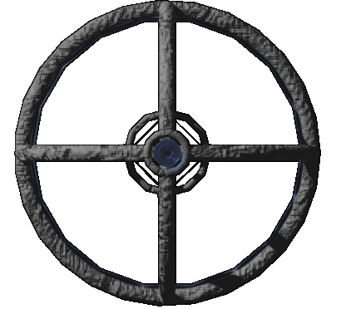

It is also fitting that the Titan Atlas is a child of Gaia (essentially Mother Earth) just as the ATLAS orbital colony will be the product of the cooperation of humans from all over the globe, much like the existing International Space Colony. Atlas is also an acronym of its defining attributes:

Automated

Telluric

Large

Astral

Settlement

Structure and Design

Three Tori

The main components of the design for ATLAS are the three perpendicular tori that form much of the habitable area in the space colony. This design was chosen for the reason that it facilitates the creation of artificial gravity by means of uniform circular motion. This principle is an extension of Newton’s third law of motion, concerning that “For every action, there is an equal and opposite reaction.” If the tori on ATLAS were to be rotated, the forces inscribed on them result in a motion that can be described as a vector sum of a horizontal force tangent to the torus restricted by a centripetal force manifested by the pull of the central axis. Because the horizontal motion of the colony is limited by its attachment to the central axis, it moves at a constant velocity with continuous change in direction of the velocity, producing continuous acceleration. The axis of the colony exerts a continuous centripetal force in keeping the rest of the torus from flying off in a straight line, this creates a pseudo-force known as centrifugal force that opposes the centripetal force and pulls objects towards the outside of the torus, creating a sense of gravity. The effect is similar to riding in a vehicle continually turning in a circle; the passenger would feel a pull towards the outside of the vehicle as a result of their inertia resisting the constant acceleration.

To create the perception of Earth normal gravity:

1g = 9.8 m/s² = centripetal Acceleration

Centripetal force = 9.8 x 90 kg = Centrifugal force of 882 N

Estimated mass of human = 90 kg

Force = Mass x Acceleration

Acceleration = Angular velocity (radians/ second) Ω

Centrifugal Force = mass x Ω x radius

882 n = 90 kg x Ω x 90 m

Ω = .11 rad/ s x (180°/π) =6.31˚/s x (60/60) =378.6˚/60s

1rpm = 360˚/60s, 378.6˚/360˚=1.05 rpm

Discrepancy due to varying weights among the population

Dimensions
Number of Tori | 3
Individual Torus Radius | 90 m
Inner Radius-r | 5 m
Combined Height- h | 10 m
Diameter- d | 180 m
Height of Living Space-Blue | 3 m
Height of Biological Sector-Green | 5 m
Height of service Area-Red | 2 m
Angular speed = .11 Ω or 6.31° per second which means that ATLAS would only need to make 1 rotation per minute to generate a sense of 1 g, a speed at which the Coriolis Effect to deflect objects is negated & centrifugal force dominates.

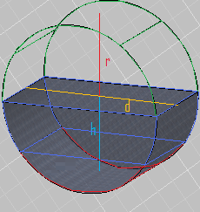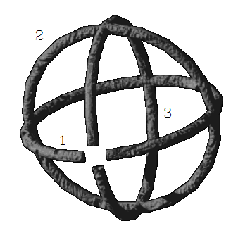

Continuum of Pseudo-gravity

To create this sense of gravity only one torus is needed; however, the inclusion of the two other tori perpendicular to the first creates a spherical shape that helps the mass of colony to remain balanced by keeping its center of gravity aligned with its center of mass. This helps mitigate gravitational perturbations caused by an unequal distribution of mass and thus reduces costly orbit corrections. Torus 2 is the only torus designed to harness the full effect because it houses the biological resources of the colony that would be impaired by the absence of gravity. Torus 1 and 3 will also experience areas of partial pseudo gravity at the intersections of the colony, with gravitational force weakening as one nears the central axis because of their alignment with the rotation of ATLAS. Thus, there is a continuum of gravity throughout the three tori aligned towards the exterior or ‘walls’ of the colony with an area of null or microgravity in the central axis.

In addition to contributing to a stable orbit, Torus 1 and 3 both function as a mineral repository, storage area and as a transportation route to six major intersections of the space colony. Torus 1 will house the majority of the mineral processing facilities and labs, while Torus 3 will house research labs related to space exploration and will house the quantum computer used to maintain the a favorable environment on ATLAS. Torus 2 is designed for the generation of biological necessities such as food, water and atmosphere and consequently will house the majority of the population.

Physiological and Psychological Effects

While the presence of a sense of gravity will be of paramount comfort and necessity on ATLAS There are certain factors that cannot be eliminated and that while posing no immediate harm might cause mild psychological distress in certain individuals. Such factors include a continuously curving horizon, which is very different from the human perspective of a flat horizon and may cause an individual to become disoriented due to misjudgments in balance by relying on optical input. Sufferers of this symptom will feel as if they are continually on the verge of falling due to the optical illusion generated by the curvature of the floor. This might create the perception that the floor is continually ‘rushing up’ to meet them, a sensation that is indeed the optical input associated with falling. While unfortunate, this sensation is relatively mild and can be adapted to through a reasonable period of training followed by adjustment. Subjects proving themselves psychologically unable to adjust to this aspect of ATLAS life will not be permitted on the colony.

The sense of gravity is imperative to the normal development of bone and muscular tissue and in the development of a sense of balance and coordination. The absence of gravity makes the importance of a strong muscular and skeletal system less important and long term gravity deprivation is known to cause osteoporosis and muscular atrophy, as well as causing damage through the distortion of blood pressure in the body, such as excess blood flow to brain tissue or a lack of blood flow, as is witnessed in ‘blackouts’ experienced by some fighter pilots during high- g maneuvers. To simulate the effect of excess blood flow to the brain, try hanging upside down for a period of time. The pressure exerted on the blood vessels in the brain can cause headaches or might cause the blood vessels to rupture; causing fatal hemorrhage in the brain. Some less serious side effect might include disorientation and the inability to readapt to the presence of gravity, which could mean that long term residents of ATLAS would be unable to return to Earth. Genuine gravity would require the mass of the colony to approximate the mass of the Earth, which would defeat the purpose of building a space colony as one might as well set out to build a planet. Instead, ATLAS will rely on the principles of uniform circular motion and centrifugal force to create an ‘illusion’ of gravity.

Central Axis

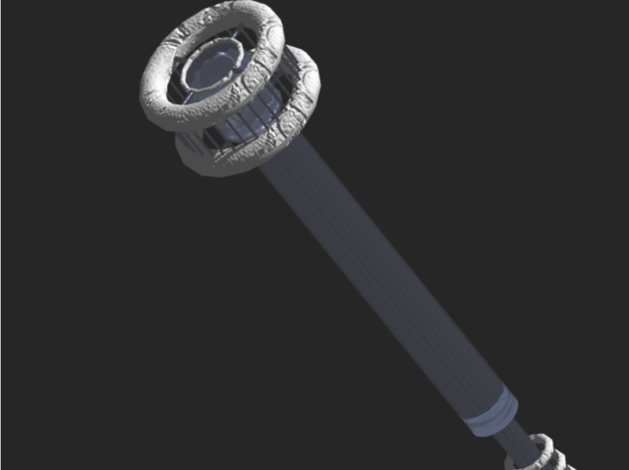

The central axis is important in that it functions as the spine of the colony by uniting the three tori; however, its main value is in its function as a conduit for the harvesting of solar energy for use in crop production, electrical energy, and in waste recycling. This process begins when pure solar radiation reaches the double convex lens at the entrance of the central shaft. Ultraviolet radiation and infrared radiation are immediately dispersed because the frequency of electron vibration in the clear plastic material approaches the frequency of the radiation and thus energy is dissipated as heat rather than retransmitted as light energy, reducing the amount of ultraviolet radiation and infrared radiation to comfortable levels necessary for warmth and UV stimulation of vitamin d production. The incident light rays of the sun will enter the lens virtually parallel to the normal causing the sunlight to disperse at an angle into the shaft through refraction of light as it propagates through the denser medium of the lens. The lens is denser at the edges rather than the middle light will be slowed more strongly near the edges than the middle, causing the light rays to diverge into the wall of the shaft instead of straight down the middle, which would cause most of the light to reflect straight out. The central optical shaft utilizes the property of total internal reflection of light to capture 100% of all light that enters the shaft. The shaft is designed as a glorified optical fiber, with the walls acting as cladding that reflects the light down a central optical fiber. Because there is a slight discrepancy between the index of refraction for the central core and the cladding, light will be internally reflected until it reaches a cylindrical right prism at the midpoint of the shaft. The cylindrical right prism will reflect the diminished light at a right angle in direct alignment with Torus 2.

Necessity of the Optical shaft

- reduction of the intensity of direct sunlight to levels of intensity optimal for photosynthesis and human tolerance
- Elimination of harmful Electromagnetic radiation through the use of reflection and refraction to deflect undesirable waves away from the colony and reduce incident waves to optimal levels.
- Channeling of thermal and solar energy from the sun in a method that allows for the protection of delicate solar arrays and biogas installations mounted within Torus 2.
- Increasing levels of visible light will initially raise the rate at which photosynthesis occurs, but at high levels of light intensity the rate of photosynthesis reaches a plateau and further exposure to light can actually damage the plants.
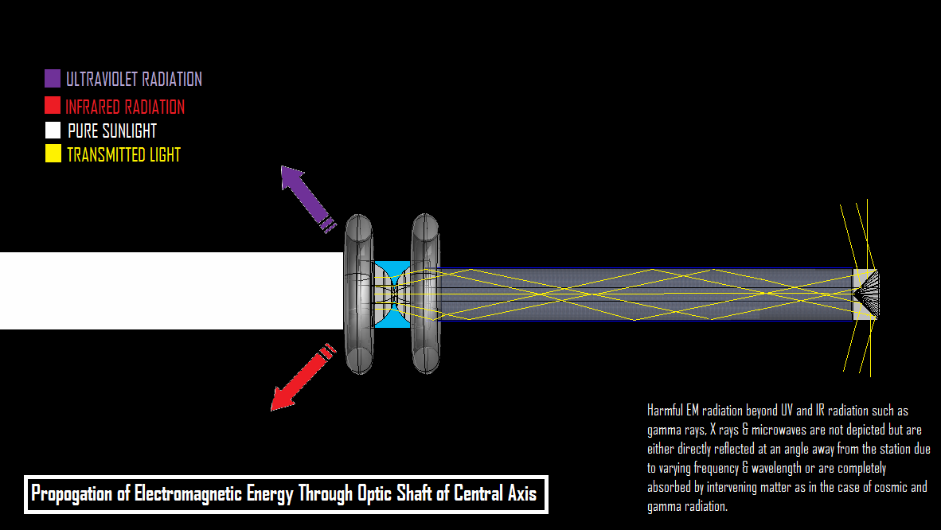

Mineral Resource Assembly, Communication Transmitter and Space Dock

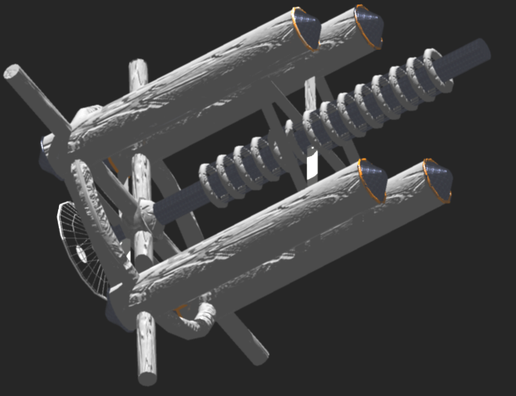

This sub assembly of the ATLAS colony is used to import material supply from lunar mines, earth and near earth asteroids. Other functions of the assembly include communication with Earth via EM waves and the mounting of circular storage facilities for microgravity materials or biological research along the central axis. Space craft will dock with one of the four docking ports and unload cargo. The resources will then be analyzed in the central docking hub and routed to different areas of the four resource towers for temporary storage, processing and distribution. Specialized scientific materials for research will be labeled for transportation to a certain department within torus 1, 2 or 3. Such examples of the diversity of resources include bulk construction materials and equipment for use in space exploration laboratories, replacement or updated scientific equipment such as EM telescopes and laser sensor packages, satellites for implementation or testing, additional space habitat modules for additional research facilities, etc. Because of the impact ATLAS will have on studying space the list of possible imports and exports are virtually limitless.

Location, Orbit & Construction

The location of Atlas is crucial to its operation. It must be located near enough to Earth to minimize costs of initial assembly and future trade, but far enough that it is completely free of the Van Allen radiation belts as well as drag caused by air resistance with the atmosphere, a distance that could extend up to 10 earth radii. Instead of trying to outdistance the Van Allen radiation belts, ATLAS will inhabit the space between them, a neutral zone between the inner and outer radiation belts, which occurs from the repulsion of the negatively charged electrons in the outer belt with the positively charged electrons of the inner belt. The range of this neutral area extends from the outermost extension of the inner Van Allen belt to the inner boundary of the outer belt, a distance between 1.5 and 3 earth radii.

ATLAS will move in a geosynchronous orbit that will allow it to remain at the same elevation and position relevant to the Earth. Not only will this facilitate logistics and communication it is necessary for residents of ATLAS to experience the same periods of night and day in order to maintain natural circadian biorhythms.

Construction

The majority of the ATLAS Space Colony is composed of torus rings. Each of these rings will actually be composed of thirty six smaller cylindrical segments, which can be stacked vertically aboard a conventional rocket and launched into space. Each cylindrical section would be preassembled on earth and loaded onto a concept of a modified version of a modern rockoon inspired by the work of Doctor Van Allen. The major strengths of a rockoon is that a balloon filled with a lighter than air gas is used to lift the rocket with no expenditure of fuel into the upper atmosphere, where the balloon detaches and the rocket then undergoes burn sequence and moves under its own power.

My proposition is to use the lighter in air gas doubly to reduce fuel costs and increase optimal propulsion of the rocket. The method involves sequestering a series of reinforced ‘pockets’ of a lighter than air gas within the containment of a standard rocket body. The rocket will then be both lighter than air and also fully maneuverable due to retaining the aerodynamic shape of the rocket. At takeoff, the rockoon would by virtue of its buoyancy rise hundreds of thousands of feet into the upper atmosphere with no loss of fuel whatsoever. At the limit of its maximum height from buoyant forces on the increasingly thin air, the combustible fuel mixture present in the buoyancy tanks would be ignited, producing explosive thrust that would allow the rocket to achieve escape velocity, which would be much reduced due to the elevation of the ignition sequence and thus necessary fuel consumption much reduced so that the rocket need not expend all off its fuel and can retain a considerable store for attitude and rotation adjustment for orbital maneuvering.

As a fuel source I propose a methane based hydrocarbon fuel source, both of which are highly combustible, lighter than air and are available in abundance. Methane can be obtained in a plethora of environmentally sound ways that involve recycling toxic waste products into viable rocket fuel. Methane can be produced by any process that involves fermentation of organic matter, which means that it can be found in landfills, organic wastes, natural gas deposits (which are themselves pockets of geologically decomposed organic matter), wetlands and marshes and even from exhalations from livestock, which already produce a significant portion of man made methane. I believe that this is the future of space exploration, as the fuel eliminates many of the pecuniary, environmental and technological obstacles to space colonization.

The benefits of a buoyant, Methane based hydrocarbon fuel source

- Available from a wide range of fuel sources
- Environmentally friendly
- 100% renewable resource
- environmentally green
- Economically sound harvesting & refinement
- Reusable

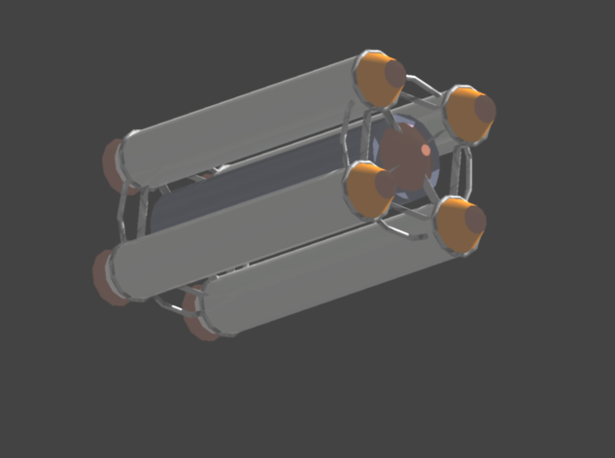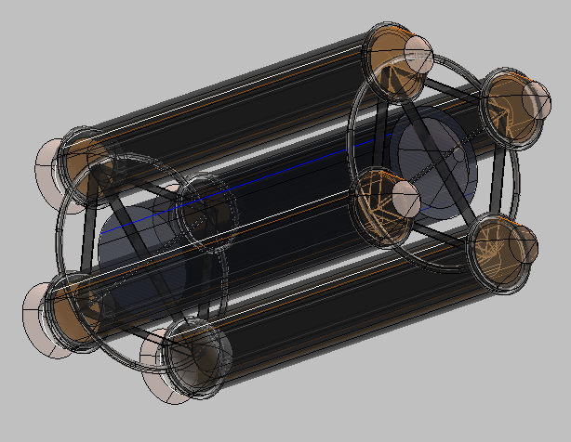

Four such rockoons could be synced to a central payload unit consisting of personnel space or cargo. Computer navigation systems can be incorporated into the nose cone of the craft, enabling remote operation or automated pilot configurations.

The spacecraft is designed to carry six sections of cylindrical hull each 16 m long and 10 m wide with an additional 200 m² of cargo space for building equipment, supplies, and personnel.

Each launch will deliver 6 sections of torus for a total of 36 hull sections per torus. This would mean a total of 18 launches to place all required torus sections into geosynchronous orbit. The cylindrical segments will be conjoined by segments of the flexible steel lattice extruding from hull sections that will later receive additional hull material to generate a continuous ring shape. Each extruding lattice segment is designed to link to subsequent hull sections and the whole structure needs only to be released from the rear of the rockoon to be fully assembled and ready for linkage.

Linkage of the hull sections will be accomplished by astronauts aboard the rockoon. The astronauts will use steel cable grappling hooks to capture segments in close proximity. Once linked, an electrical winch is used to reel in the segments to the point that the extruding lattice can be mated with the use of cables and physical docking points.

Once the 3 tori are assembled, hull material will be launched to strengthen the structure and cover the bare segments of lattice for an airtight and strong structure. The central axis will be assembled in a similar process of repeating cylindrical sections only that these sections will be hollow and contain plastic polymer optical lenses sheathed in hull section. Again, the cylindrical segments will be attached by extruding steel lattice and hull material used to cover the gaps.

The last launches will consist of the 4 mineral repositories, radio transmitter communication dish and space dock. Specimens of D. radiodurans and plant species will then be carefully transported along with enough organic nutrient supply to function long enough to produce breathable atmosphere and food supply. At this point human crew will be able to enter and the ATLAS space colony will be fully operational.

Life Support

NUTRITION

In order to be truly self sustaining ATLAS must be able to produce enough food to satisfy all of the nutritional and caloric requirements of its population. However, the vast amount of agricultural resources this would require would be quite unfeasible for a population of ten thousand people; mankind has yet to achieve total self sufficiency of a space colony of ten people, let alone ten thousand. However, I propose that in the future it might be possible to genetically modify the genome of bacteria such as D. radiodurans to produce all of the nutritive sources require for a human being. Such bacteria would be ideal because of their rate of DNA and protein synthesis would allow unprecedented amounts of organic material to be harvested, in theory enough to support a space colony. Another advantage of using bacteria to generate food sources is that it would eliminate the need to allow animals or plants to grow before consumption, vastly increasing the speed of the agricultural process. Also, the use of bacteria in a sterile space environment would allow for precise control of diet and nutritional content that would virtually eliminate illness and disease caused by pesticides, carcinogens & toxic environmental wastes. Yet another advantage to this system is the ability of the bacteria to thrive amidst organic waste, thus simultaneously helping safely dispose toxic matter while supporting the dietary needs of the population. Such a process would have to be highly regulated to avoid contamination from the bacteria’s proximity to waste products as well as genetic defects which might cause unforeseen illnesses and diseases, but the method represents an ideal management of precious resources and may be fully realized within the next half- century. It is this technology that ATLAS will use to support its population while in space and remain totally independent of Earth as far as food is concerned.

Traditional meals on earth typically consist of imbibing unrefined biomass in the form of direct tissue consumption, either through eating animal flesh or organic plant matter. The regulation of diet is thus very imprecise and requires a constant switching between certain types of food or another and this imbalance is manifested in all but the most health conscious of the world’s population in the form of obesity or severe nutrient deprivation. My method eliminates this crude means of nutrient utilization and instead tailors nutrient usage precisely to the exact needs of the body, which will result in a vast increase in physical fitness and longevity. Meals aboard atlas will consist of packaging of genetically regulated nutritive content into a variety of soft forms that can range from yogurt to pudding and ice cream that can be coated on a fiber bar or other form of cake. The nutritive paste is precisely regulated to maintain an optimal balance between dietary sources and will be embedded within a fiber bar in order to avoid gastrointestinal decline and further complications to the digestive system. Such ration will be issued at the regular times of breakfast, lunch, or dinner and combinations of artificial flavorings can be made to mimic as much variety of the palate as can be humanly desirable.

The basic components of the human diet that can be artificially reproduced are:

Essential Amino Acids- Components of protein that the human body cannot naturally produce on its own.

Essential Fatty Acids- Unsaturated fatty acids that cannot be manufactured by humans.

Micronutrients- Vitamins & Trace minerals

Fiber- Improves GI (gastrointestinal) mobility & aids in prevention of constipation.

Carbohydrates- Sugars broken down into monosaccharides such as glucose for use in cellular respiration

Fats- Used to store potential chemical energy in its molecular bonds and provides cushioning as adipose tissue against bodily injury.

Protein- Polypeptide sequences of amino acids used for tissue growth, maintenance & replacement.

Atmosphere

The generation of a pressurized, breathable atmosphere is the primary requirement of life support on ATLAS because it is so essential to the functioning of the human organism. Humans can survive weeks without food, days without water but only minutes without air. To generate a breathable atmosphere I propose using a unique growth technique in order to satisfy quantitative oxygen production. It involves direct assimilation of modified plants with a nutrient grid, by means of embedding stylets into the actual tissues of the plant itself. In this way there is absolutely no waste of nutrient material as 100% of nutrient content added will be received by the plant. This method also allows precise measurement of nutrient usage and requirements in order to produce a certain volume of oxygen, which enables an unprecedented level of resource management. This technique would also allow constant air pressure to be maintained merely by adjusting the nutritive content of the grid by a predetermined amount as can be shown from quantitative measurements of nutrient density to oxygen production ratios. The only other factor required for this process is natural sunlight, which is channeled directly at the plants by means of the optic shaft of the central axis. In order to maximize space needed for solar energy arrays and biogas plants I arranged the nutrient grid to be a suspended trellis with strongly adhering parasitic vines that would facilitate the process of nutrient assimilation by bonding to the grid network in much the same way as they would wrap around a tree or around a fence. The stimuli presented by photo and gravi-tropism would cause the plants to grow in a vertical manner like a forest of vines flanking a narrow path of solar arrays and biogas plants, which maximizes effective use of solar energy.

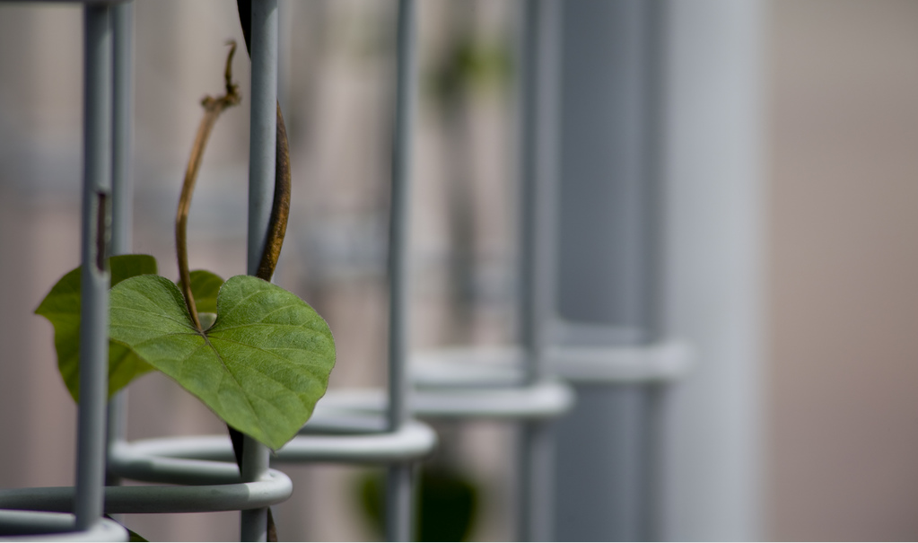

Administration

During the construction period of ATLAS all decisions concerning the design, assembly or nature of ATLAS will be decided by an international board (IB) of certified scientific specialists, e.g. Engineers, demographers, astronomers, physicists, etc. The only qualifications to this board are popular election by the host continent and peer review by other instated scientists of the board. Popular election consists of positions awarded based upon the total number of votes obtained, in order from the most received to least received, with 50 possible positions available per continent. Peer review by pre-instated members of the board will follow popular election and determines whether or not the candidate is fit to be a member of the board, based upon cognitive ability, scientific aptitude and moral fitness. Each nation is accorded a maximum of 50 positions; however, extenuating circumstances can be made at the discretion of the board to allow specialists to earn provisional membership as the situation requires. As mentioned before, the international board will have complete jurisdiction over all matters germane to the successful construction of ATLAS, including allocation of natural resources, personnel, funds and management. No nation will be forced to join the international board; however, those nations that do not contribute will not be allowed to colonize space independently. Successful colonization of outer space represents humanity’s best hope of long-term survival as a species, as such, all other political concerns have no place in the ATLAS project, and will not be tolerated.

After ATLAS has been successfully installed in orbit and is functional, the international board will be replaced by the earth advisory committee. The earth advisory committee will be comprised of an upper echelon (consisting of the first eighteen members of the international board) and a lower echelon comprised of fifty positions that will be selected by popular vote from each continent. The lower echelon will be compartmentalized into different departments pertaining to the continued operation of ATLAS, as directed by the upper echelon.

All members of both the international board and the earth advisory committee will serve terms based upon their performance, as determined by the host continent. The host continent can continue to supply new members of the board as long as they obtain a higher popular vote as well as board recognition. Formal elections will take place yearly with a ten day window to accept ballots. Voting will be conducted in a special kiosk designed to eliminate fraud by utilizing DNA identification. The voter will place the tip of his index finger into a slot beneath the name of his candidate of choice. A sterilized needle will then prick the skin to recover a small sample of blood. The individuals DNA will then be extracted and electronically submitted to a database for tallying and also to compare that vote against existing entries to eliminate fraud. The DNA will not be used for personal identification, so the anonymity of voters will be maintained.

Recreation

The unique vista of outer space has always been artistically inspiring even from the confines of the planets surface. Much of ancient mythology and romantic expression is concerned with the sublime and glorious nature of the heavens, a medium of artistic expression that is as wondrously vast as the universe itself. Residents of ATLAS will be in a unique and enviable position to observe the heavens and as a consequence the quality of artwork will reach new heights of mood and expression. Landscape paintings may seem inspiring to people on Earth, but how much more impressive will be a sky or space-scape, direct interpretation of vast areas of pristine and wondrous light?

For those not moved by such artistic pursuit there is fun enough. The position of ATLAS as an orbiting space colony makes it ideal for the serious and playful design of new spacecraft and space technology such intellectually stimulating sport will encompass the design of space suits for EVA races outside the colony, constructing satellites or even the annual design of spacecraft that meets new standards of efficiency and performance.

Such activity will provide more than enough mental and physical stimulation than is possible for anyone to want more, yet there is hope yet for even the most unmotivated of colonists in the form of a vast electronic library, with millions of volumes compressed into a space of a few shelves. Such reading will provide endless lifetimes of literary enjoyment and will even feature limited electronic requests of movies, games and novels to be beamed electronically to the colony for a fee amounting to the cost of the signal used and the media purchased or rented.

Electrical Power

ATLAS generates the majority of electrical power from the use of solar panels. The solar panels will be mounted inside the habitation Module on Torus 2 to protect them from bombardment from space debris and excess electromagnetic forces from the solar wind. The solar panels will be arranged in a circular array across the midline of the Habitation module in direct alignment with the maximum intensity of light reflected from the optical array on the central axis. This arrangement is much more efficient than arrays on Earth because the delicate solar panels are at once fully protected from harmful eroding elements and yet fully accessible to concentrated sunlight. The solar panels will be positioned directly above a major power line that circumnavigates Torus 2, which minimizes loss in electrical power due to great distances between power supply and grid utilization.

Because Atlas orbits has a geosynchronous orbit it will experience night in the same time as earth does and during these periods the solar panels will be useless. However, excess solar energy can be periodically shunted throughout the day to large capacitors and batteries, in this way providing backup energy for limited use at night time for powering the life support and environmental systems. This arrangement is further supplemented by the use of biogas plants, which will convert organic waste products aboard ATLAS into viable combustible energy products such as methane and hydrocarbon fuels for use in generating electrical energy. Such fuels cannot be used directly due to the fact that a single leak can pose simultaneous dangers from outgassing as well as explosion from accumulated airborne fuel particles igniting due to a minute electrical spark. The biogas will instead be shunted away from the interior to be used to power electrical generators and to be used as rocket fuel for preventative orbital maintenance.

Environmental Systems

The term polyextremophile is used to indicate an organism with a wide range of resistance to harsh conditions that would kill other organisms. Of particular interest is a type of bacteria that belongs to the family Deinococcaceae that is able to withstand 10,000 Gy (Gray = I kg matter absorbs 1 joule of radiation) of intense radiation, 2000 times the lethal dose for the average human at 5 Gy. Several species are also resistant to extreme dryness (desiccation), nutrient deprivation and extremes of temperature, making the microbes ideally suited for space adaptation. The species I am most considering for implementation in ATLAS is Deinoccocus radiodurans, which is known to be one of the most radiation resistant species of the family and is also extremely resistant to exposure to ultraviolet radiation, genotoxic substances (chemicals that damage DNA) extreme temperatures and desiccation. Incidentally, the genetic structure that makes it so resilient also makes it ideal for use in genetic experimentation and in generation of genetically encoded materials. It seems that D. radiodurans derives its extraordinary resilience from a combination of a tough 3 layer outer membrane and being able to rapidly replicate its DNA. D. radiodurans is unlike most bacteria in that it keeps four copies of its circular DNA as opposed to the single copy used by most bacteria during interphase. The complete genetic sequence of D. radiodurans has been known since 1999, making the genetic manipulation of the organism for mineral processing and toxic waste disposal much easier. Rapid and high yield DNA replication as well as knowledge of the genome makes this organism ideal for use in genetic research for material production and removal of toxic wastes. Key uses for this bacterium in ATLAS will be:

- Generation of the ATLAS endoskeleton by means of protein synthesis of metal elements excreted onto a framework intended to be formed into the outer structure of ATLAS.
- Research in biology and material science through gene manipulation to produce various chemicals and materials for use in ATLAS and for export
- Protection from UV and electromagnetic radiation by forming an absorbent layer of biomass.
- Organic waste disposal and recycling by using the organic debris generated by humans and plant matter as a source of nutrition.

Other environmental systems include the use of stylet assisted plant growth and microbe generation of food supply discussed in Life Support.

Defensive design

Thermal Protection and Regulation Systems

Exterior Thermal Protection

A thin reflective polymer film designed to reduce thermal absorption due to solar radiation and protection from damaging high energy electromagnetic radiation such as gamma rays, x- rays and microwaves. This film will reflect the thermal energy and electromagnetic waves back into space in the form of light and will keep the colony cool and safe from harmful radiation. Such films are already in use today in high- end aerospace projects and even as paint designed to keep office buildings cool, such as the materials provided by the Insultec Company that reflect up to 90% of thermal energy from solar radiation (on Earth). I propose using a layer of macerated quartz embedded in a flexible layer of reflective plastic fibers. The crushed quartz crystals would act as reflectors of incident solar radiation and would keep the colony cool while the material itself must be both flexible and elastic in order to withstand the collision with space debris without breaking.

Insulation

In lieu of the extreme heat of the Sun the importance of keeping the colony relatively warm is almost momentarily forgotten. yet ATLAS will experience 12 hours of complete isolation form the sun’s warmth and in space extreme temperatures range from the nuclear heat of the sun to the absolute cold of frigid space in its absence. ATLAS will remain warm because the flexible steel lattice making up the exterior portion of the ships hull will contain bladders of air that will isolate the colony from the cold of the outer hull. When combined with the use of circulating water pipes the colony will remain quite comfortable even in the temporary absence of the Sun’s radiation.

Interior Thermal regulation

A system of concentric water pipes embedded in the interior of the hull will help moderate temperature inside ATLAS by acting as a gigantic natural heat sink. Water is an ideal coolant because it has a very high specific heat, which means a great amount of energy is required to heat or cool it. This property arises from the relatively weak hydrogen bonds between water molecules. As water is heated, weak hydrogen bonds are broken and thermal energy is absorbed by the water from the environment. Conversely, when water is cooled, hydrogen bonds form, releasing stored thermal energy back into the environment. As water in the Hydrosphere absorbs ambient thermal energy the hydrogen bonds between water molecules are disrupted and allow the faster moving water molecules to become concentrated. This concentration exerts pressure on the water molecules, causing them to diffuse from the area of high heat and pressure to a cooler and less dense area within the liquid. In this way, thermal energy will be absorbed from the environment and then dissipated upon contact with cooler water, eliminating the widespread use of expensive and inefficient sources of artificial temperature regulation such as air conditioners or radiators. Warmer water could also be artificially shunted through the use of electric pumps to allow for limited temperature adjustment.

Structural Integrity against Exterior Physical forces

In addition to providing protection from radiation and extreme temperatures, the outer surface of ATLAS is unique in its ability to nullify impacts with high velocity micrometeoroids and space debris, thereby tremendously increasing the longevity and safety of the colony while simultaneously reducing costs of maintenance. This defense against high velocity space debris is accomplished through the use of a series of high end materials in a literal sandwich of a space colony hull. The next layer is crucial to the operation of the micrometeoroid shell and will be composed of a flexible steel lattice of high tensile strength and an organic derivative of a shape memory alloy (SMA) generated by a genetically engineered species of a polyextremophilic microbe population embedded within the steel lattice. The microbes will be embedded in a nutrient dense layer of the steel lattice and will gradually convert the elemental metals into a less dense but structurally stronger organic alloy that will display the shape memory effect. This organically polymerized SMA will form the basis of the micrometeoroid defense because SMA metal has the ability to regain its shape after being deformed by impact through a magnetic, thermal, or electrical stimulus. This property of SMA metals is achieved through molecular rearrangement of the metal in a solid- state phase change between two phases of the SMA called martensite and Austenite. The molecular composition of the two phases is the same, the only thing different about them is their molecular structure, which is not visibly recognized until martensite is deformed.

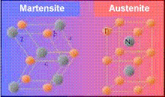

Martensite exists in the SMA at colder temperatures than Austenite and is the more easily deformed of the two phases, making it the default phase of the SMA material in ATLAS. When SMA becomes deformed it is possible to run an electrical current through it to heat it, a process called loading. The martensite will then utilize the energy to atomically rearrange its structure into the molecularly cubic austenite that retains the structure of the metal before the impact. As the austenite cools it naturally reforms back into martensite, enabling the process to happen over and over. Another added benefit of this material is that the rearranging atoms act as a sort of molecular shock absorber in and of itself which makes it doubly resistant to shear stresses that would cause dents or scratches.

The SMA material will remain effective because it is shielded from thermal and electromagnetic forces that might cause it to activate prematurely or to be in a state of continuous operation, which would cause the material to lose its unique properties. The process of micrometeoroid defense occurs as follows:

- A micrometeoroid moving at a high acceleration collides with the exterior of ATLAS
- The force of the collision is partially negated by the flexible steel lattice, but the force of the collision might be enough to cause deformation.
- Deformation of the hull will be electronically recognized and a signal will be sent to the central computer mainframe of the colony.
- The mainframe receives the signal and sends out an electrical impulse to the deformed metal, which will cause the SMA strands to regain their regular form and straighten the steel frame.

Transportation

The design of ATLAS is optimized to eliminate the need for internal transportation because of its relative size. The maximum distance obtained by traversing the entire circumference of the colony will be equal to near 565 meters, well within the limits of a healthy individual. Walking will also help combat some of the symptoms of latent gravity deprivation from spending a great deal of time in the areas of null gravity aboard the colony. Exercise is a key and integral part of maintaining a healthy lifestyle and this method is ideal for eliminating bulky and space wasting exercise machines.

EVA-

Operations outside the colony may sometimes be necessary for preventative maintenance and implementation of scientific modules as well as desirable for exercise and recreation. For that purpose I propose a new model of space suit designed to reduce muscular fatigue caused by resistance from a pressurized environment. Such a suit will consist of an elastic insulated compression undergarment custom fitted to an individual using laser scanning to eliminate chafing and provide basic protection against the low pressure environment of space. The next layer will consist of a network of ARACON fibers, which are a derivative of Kevlar material with the additional property of being able to conduct electricity. This fiber network will be used to amplify and retransmit the electrical signals made by neural impulses for locomotion to a mini-processor located in a back mounted life support system. These electrical signals will be interpreted by the processor and used as a feedback mechanism controlling a complex system of as yet to be developed SMA fabric designed to act as artificial muscle. For this structure, I propose using nanotechnology to engineer SMA fibers of extraordinary thinness and length. These fibers will then be conjoined to thousands of other fibers to create a lightweight mesh capable of responding to electrical impulses by contracting in unison. This will hinder the possibility of overloading the strand, because excess electrical current will be shunted from one fiber to the next due to the extreme smallness of each strand and the arrangement in series will diminish the effect of current overload. Furthermore, single strands of SMA material suffer from hysteresis (imprecise rates of contraction), but the linkage of a multitude of fibers ensures an average rate of contraction that eliminates hysteresis. Another advantage of this SMA technology is that individual strands suffer from a poor contraction length, usually only 10% of their total length. Arranging the micro strands in series will allow or a higher total ratio of contraction due to the sum of the total contraction rates of individual strands. This mesh will be mounted onto a hard layer of exoskeleton designed to correspond to the muscular-skeletal system of the human body and thus greatly enhance the strength of the individual within the suit to negate muscular fatigue due to fighting forces exerted by pressure and by assisting with compression itself. This suit will allow for unprecedented mobility and comfort in outer space, which will extend operational time constraints.

The back mounted life support system will attach onto the hard exoskeletal support system and will provide for the supply of pressurized oxygen directly into the helmet of the space suit. The helmet of the suit will be hermetically joined with the compression suit via a molecular adhesive that chemically bonds the two layers of fabric into a continuous unit, with a chemical dissolving agent being applied within the airlock in doffing the helmet.

The helmet will contain a polarized visor to protect the eyes from the intensity of the Sun, interior mounted communication headset with transmitter, water dispenser and ergonomic foam composite engineered to be comfortable even during long periods of EVA. To extend the supply of oxygen the helmet will contain a rebreather apparatus that converts exhaled carbon dioxide (co₂) into solid carbon and oxygen gas (o₂), which can be pumped back into the oxygen supply for reuse.

Financial & Technological Analysis

All of the technology used in this design is in direct accordance with the physical laws of the universe and some of the technology such as gene manipulation, biogas generation and solar panels are already in implementation or are on the verge of development within the next half century. Research costs alone will account for inestimable but vast sums of money, possibly in the trillions of dollars. The extensive use of specialized materials such as polymerized shape memory alloys, reflective anti- heat polymers & genetically modified microbes and plant specimens will also drive the costs up astronomically. However, the ATLAS station is designed to be completely self sustaining, which will reduce maintenance costs to almost nothing. The initial investment in ATLAS might be astronomical, but the construction of ATLAS can be spread out over a series of decades to reduce the costs to a more manageable level of investment. Also, because ATLAS is an international Endeavour costs can be divvied up so that the burden on each nation’s economy is at a tolerable level. Once fully operational, ATLAS will have full access to the mineral wealth of the moon, asteroids and eventually possibly even the gaseous environment of Venus. The enormous planetary wealth of these resources will vastly dwarf even the trillions of dollars involved in construction costs within years & the value of new materials and space technology research will be even more lucrative. Space tourism could also be a major supplement to income and will further aid in the establishment of ATLAS as an invaluable asset to the entire world. Despite its monumental significance if it were ever to be realized, ATLAS is only designed to serve as the first step towards the colonization of the universe. I envision space colonies spread across the solar system and even the galaxy in clusters as big as planets themselves in their own right, with humanity finally living in a state of true and perpetual freedom, liberated by space from overpopulation, global warming, resource depletion, poverty and violence.

References

- Understanding Physics. Dr. Isaac Asimov, 1966 Dorset press
- Oxford Dictionary of Space Exploration. Edited by Dr. E Julius dasch, 2005 Oxford university Press
- Inventions from Outer Space- Everyday uses for NASA Technology. David Baker, 2000 Random House, Inc/ Marshall Editions Developments Ltd.
- National Geographic Picture Atlas of Our universe. Roy A. gallant, 1980 National geographic society
- The Merck Manual-17th Edition. Edited by Keryn A. G. Lane, 1999 Merck & Co., Inc
- Elements of PHYSICS- 9th Edition. Alpheus W. Smith & John N. Cooper, 1979 McGraw- Hill, Inc.
- Inside modern technology- How it Works. Edited by Quentin Deane, 1982 Marshall Cavendish Limited
- The Handy Physics Answer Book. P. erik Gunderson, 2003 Visible Ink Press
- Utopia. Sir Thomas Moore, 2005 Barnes &Noble Books
- A Brief history of Time. Stephen W. Hawking, 1988 bantam books

Internet sites
- http://en.citizendium.org/wiki/Deinococcus_radiodurans
- http://www.usuhs.mil/pat/deinococcus/index_20.htm
- http://encarta.msn.com/encyclopedia_762505788/Gray_(radiation).html
- http://science.nasa.gov/newhome/headlines/ast14dec99_1.htm
- http://www.msnbc.msn.com/id/26742756/
- http://www.phy6.org/stargaze/Smotion.htm
- http://www.green-trust.org/2000/biofuel/methanedigestion3.htm
- http://www.cs.ualberta.ca/~database/MEMS/sma_mems/sma.html

