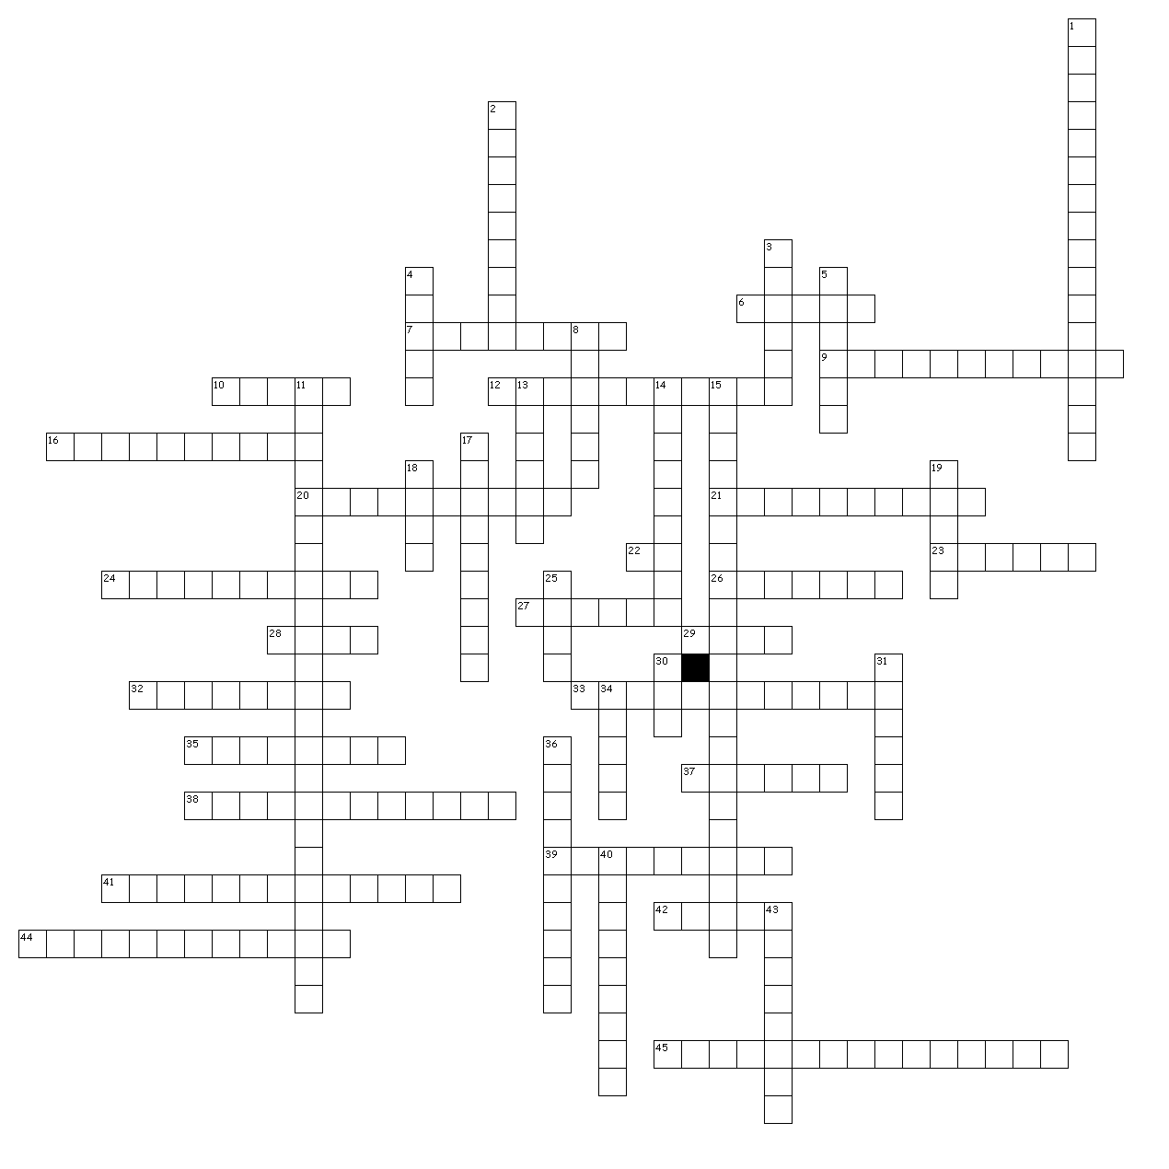
Space Settlement Crossword Puzzle


Across
6. Light Amplification by Stimulated Emission of Radiation.
7. A range of frequencies or wavelengths.
9. The mutual attraction of all masses in the universe.
10. Mass times Acceleration.
12. The angular distance of the orbital plane from the plane of the planet's equator, stated in degrees.
16. The process of modifying a radio frequency by shifting its phase, frequency, or amplitude to carry information.
20. The deflection or bending of electromagnetic waves when they pass from one kind of transparent medium into another.
21. The deflection or bouncing of electromagnetic waves when they encounter a surface.
22. The International System of Units (metric system).
23. the SI base unit of electric current.
24. 299,792 km per second, the constant c.
26. Mass per unit volume.
27. Small bodies composed of ice and rock in various orbits about the sun.
28. A fundamental property of an object comprising a numerical measure of its inertia; mass is the amount of matter in the object.
29. National Aeronautics and Space Administration.
32. the SI base unit of mass, based on the mass of a metal cylinder kept in France.
33. The phenomenon of emitting light upon absorbing radiation of an invisible wavelength.
35. A vector quantity whose magnitude is a body's speed and whose direction is the body's direction of motion.
37. the SI base unit of thermodynamic temperature.
38. Change in velocity
39. A measure of distance, the distance light travels in one year, about 63,197 AU.
41. Technique whereby a spacecraft takes angular momentum from a planet's solar orbit (or a satellite's orbit) to accelerate the spacecraft, or the reverse.
42. Nickel-cadmium rechargeable battery.
44. Materials that convert light into electric current.
45. A measurement of a rocket's relative performance. Expressed in seconds, the number of which a rocket can produce one pound of thrust from one pound of fuel. The higher the specific impulse, the less fuel required to produce a given amount of thrust.

Down
1. The outward-tending apparent force of a body revolving around another body that pushes outward (think a ball on a string that you swing).
2. Having uniform properties in all directions.
3. Downlink from a spacecraft that immediately indicates the state of the spacecraft as being one of several possible states by virtue of the presence and/or frequency of the subcarrier.
4. A microwave travelling wave tube amplifier named for its process of Microwave Amplification by Stimulated Emission of Radiation.
5. The gravitational force exerted on an object of a certain mass. The weight of mass m is mg Newtons, where g is the local acceleration due to a body's gravity.
8. Signal sent to a spacecraft.
11. The inward acceleration of a body revolving around another body.
13. the SI unit of force equal to that required to accelerate a 1-kg mass 1 m per second per second (1m/sec2). Compare with dyne.
14. Small bodies composed of rock and metal in orbit about the sun.

15. In a radio system, a selected processing frequency between RF (Radio Frequency) and the end product (e.g. audio frequency).
17. A small body which orbits a larger one. A natural or an artificial moon. Earth-orbiting spacecraft are called satellites. While deep-space vehicles are technically satellites of the sun or of another planet, or of the galactic center, they are generally called spacecraft instead of satellites.
18. A measure of electrical power equal to potential in volts times current in amps.
19. Wind -- Flow of lightweight ions and electrons (which together comprise plasma) thrown from the sun.
25. A small natural body which orbits a larger one. A natural satellite. Capitalized, the Earth's natural satellite.
30. A charged particle consisting of an atom stripped of one or more of its electrons.
31. The SI base unit of time.
34. Electromagnetic radiation in the neighborhood of 1 nanometer wavelength.
36. The distance that a wave from a single oscillation of electromagnetic radiation will propagate during the time required for one oscillation.
40. Electromagnetic radiation in the neighborhood of 100 femtometers wavelength.
43. Signal received from a spacecraft.

