Sinking Ships, Exploding Airships, and Collapsing Bridges: The Dumbest Engineering Disasters

http://io9.com/#!5700441/sinking-ships-exploding-airships-and-collapsing-bridges-historys-dumbest-engineering-disasters
Alasdair Wilkins — 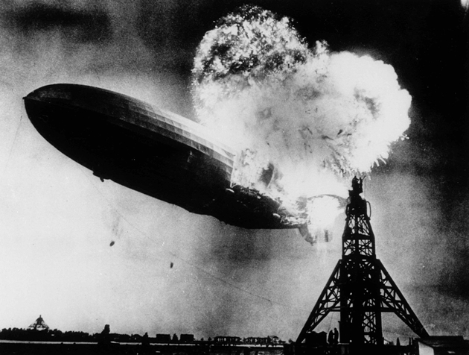Human ingenuity, our ceaseless drive to invent, create, and build, is one of our species's greatest strengths. But sometimes people just don't know what the heck they're doing. Here are the most ridiculous engineering disasters in human history.

Boats
We're talking about a lot of poorly engineered structures and vehicles, but very few disasters can quite measure up to the Vasa, pride of the Swedish navy for nearly an entire half-hour. Built in 1628, the ship was meant to be the crowning achievement of King Gustavus Adolphus, the greatest of Sweden's martial kings, and a harbinger of Sweden's coming glory in the Thirty Year's War.
That's what was meant to happen. In actual fact, the ship sank less than a mile into its maiden voyage when it ran into a wind slightly stronger than a slight breeze. The ship had been rushed into construction due to political pressure, and matters weren't helped when the king altered his requirements for the vessel midway through its construction. The finished Vasa was a top-heavy beast without sufficient ballast, setting the stage for total disaster the first time it tried to sail.
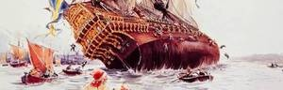
The ship was built at a time when scientific theories on how to build a ship properly didn't exist, and the shipbuilder had to hold all the proper design requirements in his head. It probably didn't help that the heads changed halfway through, as the first shipwright died and was replaced with his assistant. Even so, the Vasa might not have been a total disaster if Captain Söfring Hansson hadn't decided to sail with the lower gunports open, the better to show off the ship's incredible armaments. When the ship began to founder in open water, the open ports filled with water and the ship quickly sank, taking about 30 to 50 crew members with it. All was not entirely lost, though - the ship was ultimately salvaged in 1961 and is now one of the best best preserved repositories of the time period.
At least the builders of the Vasa had the excuse of operating in a time of relative ignorance. The people behind 1869's HMS Captain, Britain's six-month flagship of the Royal Navy, could only blame their own foolishness. Chief among them was Captain Cowper Phipps Coles, owner of one of the most British names in history and a veteran of the Crimean War.
During the war, Coles had helped break the siege of the Russian town Taganrog with a ship called the Lady Nancy, which was basically just a lashed together raft with a big cannon on it. Simple as it was, the Lady Nancy could move into shallow water and reach Russian supply stores that bigger ships couldn't. It was a fantastic bit of military improvisation, and Coles became convinced that it was the perfect basis for the Royal Navy's warships going forward.
After the war ended, Coles started designing ships, and he quickly hit upon two very good ideas that were completely opposed to each other. The first was to employ rotating turrets, which would see multiple guns moved around a port opening so that one would always be available for firing. The other was to keep the ship as low in the water as possible so that the enemy had less of a target to attack.
The problem is that a ship needs to be fairly high in the water so that it doesn't take on water during heavy storms and waves, particularly when a design requires added superstructure to support the extra guns of a rotating turret system. Coles was never a professional engineer and refused to accept this basic fact, and so all his designs called for his boats to sit dangerously low in the water.
The Royal Navy knew this and repeatedly refused to build Coles's ships, but the war hero proved skillful at gaining popular support for his ideas. Parliament ultimately ordered the Admiralty to build Coles's ship, dubbed the HMS Captain, and the naval brass relinquished - although they made it clear they wouldn't accept any responsibility for the ship's eventual failure. Naval Chief Constructor Edward James Reed emerged as the Captain's biggest critic. He repeatedly bashed the design, saying it was too heavy and the center of gravity wasn't low enough.
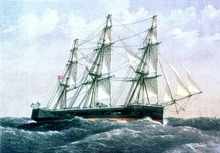
Still, the Captain performed exceedingly well during its trials, ably outperforming other British ships during tests and mock battles. Coles was briefly vindicated, and the Captain entered service in April of 1870. Just six months later on September 6, 1870, while sailing off the northern Spanish coast with eleven other ships, the Captain encountered a fierce storm.
At last, the ship's low decks and high center of gravity caught up to it, as water flooded the decks and, before evasive actions could be taken, the Captain capsized and sank. 480 sailors perished, including Captain Coles himself. A naval investigation into the disaster released some rather brazenly passive-aggressive findings, basically saying it was all Coles's fault for his poor design and that "the Captain was built in deference to public opinion expressed in Parliament and through other channels, and in opposition to views and opinions of the Controller and his Department."
Some boats weren't even meant to be particularly well-engineered. A tax loophole led Quebec timber merchant Charles Wood(s) to order the construction of two of the worst boats ever built, the Columbus and The Baron of Renfrew. In the mid-1820s, any timber transported across the Atlantic Ocean was taxed upon arrival, but any timber used to build the ships themselves was tax-free.
So merchants began building disposable ships, which could then be pulled apart and sold as tax-free timber upon arrival in France or Britain. Because these were intended as one-way cargo transports, little effort was put into making them seaworthy, and Wood(s)'s two efforts were particularly disastrous. The Baron of Renfrew left Quebec on August 23, 1825. It had only gone about 650 miles when it got waterlogged, with more than thirty feet of water lodged in the hold. The ship had to be towed the entire way from Quebec to Calais, and even then it never made it to London, running aground on the French coast.
The Columbus, to its credit, actually did make it to London in 1824. Charles Wood(s), apparently with no comprehension of how to quit when ahead, changed his mind at the last minute and told the crew to keep the ship intact, ordering only the cargo to be sold on. Instead, the ship was ordered back to Quebec for another tax-free dash, but its total lack of seaworthiness caught up to it off the coast of New Brunswick. The ship broke apart and sank, proving that, at least this once, tax cheats never prosper.

Airships
At least some wooden ships actually managed a decent tour of service. Airships, on the other hand, just seem like a mistake people had to keep making over and over again. It's not that rigid airships don't work, exactly, but apparently most engineers of the 1920s and 1930s weren't willing to put in the time to actually make them safe.
I'm pretty much required to start with the May 6, 1937 crash of the Hindenburg. The German airship caught fire as it was attempting to dock at New Jersey's Lakehurst Naval Station. The incident was neither the first nor the most deadly airship crash, but it represented a final shattering of global confidence in the safety of the craft. It's also one of the very few disasters to unfold live, as radio reporter Herbert Morrison's humdrum coverage of the Hindenburg's arrival quickly turned into the stuff of broadcasting legend. Here's his famous report, for those who can stomach it:
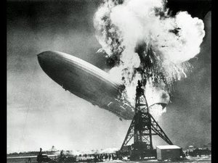
The exact cause of the Hindenburg fire isn't known. There have long been some rather fanciful theories of sabotage, but the evidence for that is at best circumstantial. The preferred explanation is the static spark theory, which holds that a buildup of static electricity on the skin of the airship ignited either the hydrogen gas inside or the materials on the outer skin.
The Hindenburg was attempting to make up a 12-hour delay as it crossed the Atlantic, and its crew had taken it through a weather front with high electrical charge, which could easily have caused the buildup of static. The airship's skin lacked the ability to redistribute the charge throughout the ship, leaving it vulnerable to a sudden massive spark. The combustible hydrogen gas that the airship used for buoyancy likely then fueled the growth of fire. Still, the precise causes of the Hindenburg disaster likely won't ever be known with certainty, and there are plenty of alternative theories with varying degrees of plausibility.
Now, if the Hindenburg had been an isolated incident, then maybe - maybe - you could argue it was simply a tragic accident and not evidence of a basic airship engineering flaw. But airships kept on crashing both before and after the Hindenburg, seldom putting in more than a couple years' service before taking the final plunge.
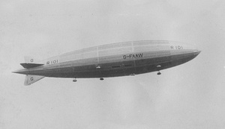
The R101 was basically the Titanic of airships - it was British, it was built too quickly and arguably too big, it crashed on its maiden voyage, and Doctor Who likes to set stories on it. It was meant to be the first part of a grand scheme to connect the furthest regions of the British Empire with a great fleet of airships, and the UK Air Ministry put in some of the most daring innovations in airship design ever seen into the R101.
That was part of the problem. To this day, the ship is alternately called the most elegantly designed airship ever and the worst piece of crap ever sent into the air (that's a paraphrase). The ship's innovative structure was a stressless design using stainless steel, but it also ultimately meant the ship didn't have nearly enough lifting gas. The gasbags were unstable because the wiring meant to hold them in place was extended beyond its capacity.
The valves, meant to adjust the amount of gas and crucial to the airship's successful operation, were far too sensitive, causing the ship to lose gas at the slightest provocation. The entire design of the ship revealed an engineering committee that was committed to building the most advanced airships ever - and yet had no idea about the basics of building airships.
The R101's government backers were desperate to make the airship's first scheduled run on time. As such, the ship was rushed through its trials and only tested in the most gentle way possible. Even so, the safety inspector refused to give a Certificate of Airworthiness to the R101, and it was more political intervention than anything else that ultimately got the certificate issued.
The ship left England on October 4, 1930 headed for Karachi, now the capital of Pakistan and then part of British India. The R101 hit a storm almost immediately, and witnesses on the ground in France later said the ship was flying dangerously low. They reported they could actually almost see passengers in the windows of the ship, and many feared the R101 was about to scrape rooftops.
Finally, the ship went into a dive at about 800 feet, smashing into the French countryside at about thirteen miles an hour. That might sound pretty slow, but 47 of the 55 passengers died instantly, and another crew member died later in hospital. The ship had caught fire, probably because the forward cover had ripped open and the gasbags had started to fail. An inquiry later concluded that the R101 was brought down by its basic instability, severe overloading, and its inability to stand up to the heavy rain, among other things. It was the end of the British airship program.
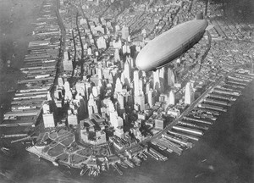
So that's the Germans and the Brits. What about the Americans? Although it's far less well-known than the Hindenburg or even the R101, the 1933 crash of the USS Akron was the worst airship disaster in history, killing 73 of the 76 people on board. The ship, along with its sister ship the Macon, was intended as a flying aircraft carrier, carrying a complement of biplanes inside its hull.
Compared to the R101, the Akron was fairly well-designed, but it proved horribly accident prone in its eighteen months of service. It managed to crash while still in its hangar, damaging its fins. An attempted landing at San Diego's Camp Kearny proved disastrous when the Sun's rays heated the airship's little remaining helium gas, making the ship nearly uncontrollable. The Akron started heading back up, but some of the inexperienced moorsmen on the ground held onto their lines, and two of them ultimately fell to their deaths. And then, just as it was beginning service as a flying aircraft carrier, it crashed in its hangar. Again.
The Akron met its final end on April 4, 1933. The ship encountered a huge storm off the coast of New England. At about 12:30 AM, the airship was struck almost simultaneously by an updraft and downdraft. The crew tried to release some ballast to right the ship, but this only caused the nose to rotate up and the tail to start falling down. Further downdrafts forced the ship to crash into the sea, claiming all but three of the ship's crew. The ship reached the end of its short, accident-prone life, a fate brought on by its commanding officer's foolhardy decision to fly into the storm.

Galloping Gertie and Collapsing Bridges
There's a long, long list of bridges that collapsed due to faulty engineering. There's the Dee Bridge disaster of 1847, in which the bridge's brittle cast iron girders collapsed as a train passed over, killing five passengers. There's the Broughton Suspension Bridge collapse of 1831, in which one of Europe's first suspension bridges was brought down, quite possibly due to a destructive mechanical resonance caused by soldiers marching over it in lockstep. There's the Quebec Bridge, which collapsed once in 1907 because it couldn't carry its own weight and again in 1916, which its engineers desperately hoped was the work of German saboteurs. (Unfortunately for them, it was just engineering incompetence once again.)
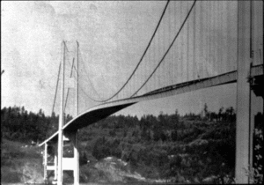
But the worst-built bridge of all time really has to be the infamous Tacoma Narrows Bridge. When it opened to traffic on July 1, 1940, it was the third longest suspension bridge in the world, and when it collapsed on November 7, 1940, it was the longest suspension bridge in the world that was twenty feet underwater. Construction workers nicknamed it Galloping Gertie because even mild winds caused the middle section of the bridge to shake up and down violently.
The basic problem with the Tacoma Narrows Bridge was that its girders were too shallow and too narrow to keep the bridge rigid. The bridge was nearly as long as the Golden Gate Bridge, but because the engineers expected far less traffic it only had two lanes, making it far narrower than any other suspension bridge of its length. The span of the bridge was only supported with eight-foot girders, far shallower than the more standard 25-foot girders originally proposed.
The bridge's engineer, Golden Gate designer Leon Moisseiff, had banked on the main cables of the bridge being strong enough to absorb most of the incoming wind pressure. He was spectacularly wrong, as you can see in the newsreel below:
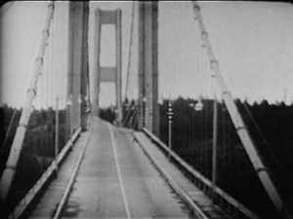
The bridge's collapse is often blamed on mechanical resonance, in which the bridge's wild motions were exacerbated by the right vibrational frequencies. Indeed, that's how a lot of high school physics students (myself included) first learn about the Tacoma Narrows Bridge, as a lesson in resonance. This, however, is an urban myth. The actual cause was aeroelastic flutter, a phenomenon where basically the unstable oscillation of the bridge caused by the wind creates a feedback loop of vibrational energy. The wind pumps more vibrational energy into the bridge's structure than it can lose through flexing, and if the wind doesn't die down in time the bridge will soon collapse.
Tacoma News Tribune editor Leonard Coatsworth was the last person to drive across the bridge. He later described the chaos as the bridge entered its death throes:
Just as I drove past the towers, the bridge began to sway violently from side to side. Before I realized it, the tilt became so violent that I lost control of the car...I jammed on the brakes and got out, only to be thrown onto my face against the curb...Around me I could hear concrete cracking...The car itself began to slide from side to side of the roadway.
On hands and knees most of the time, I crawled 500 yards (460 m) or more to the towers...My breath was coming in gasps; my knees were raw and bleeding, my hands bruised and swollen from gripping the concrete curb...Toward the last, I risked rising to my feet and running a few yards at a time...Safely back at the toll plaza, I saw the bridge in its final collapse and saw my car plunge into the Narrows.
Sadly, his dog Tubby was the only fatality of the bridge's collapse. He had been riding in the car with Coatsworth, and rescue workers were unable to coax the scared cocker spaniel out of the car. Today, the remains of the original Tacoma Narrows Bay sit at the bottom of the water as an artificial reef.

"Oh! ill-fated Bridge of the Silv'ry Tay!"
And then there's the disaster that befell Scotland's Tay Bridge. On December 28, 1879, a violent storm whipped across the more than two-mile-long Tay Bridge, causing the so-called "High Girders" at the center of the bridge to collapse as a train passed over it. Tragically, all of the roughly 75 crewmen and passengers on board were killed. There was one "survivor" - the locomotive itself was fished out of the water and served for another forty years, earning the grim nickname of "The Diver." It served for another forty years, although some engineers were perhaps understandably reluctant to take it back over the new Tay Bridge.
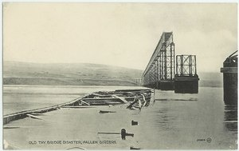
The Tay Bridge disaster destroyed the reputation of its builder, Sir Thomas Bouch, who had earned his knighthood for building the bridge in the first place. His incompetent and slipshod engineering was blamed for the disaster and the deaths, and this was only his most serious blunder. His entire rail line proved to be poorly built, with lots of engineering mistakes and poor quality materials used. He died shortly afterwards with the Tay Bridge inquiry's conclusions left to serve as a grim legacy: "badly designed, badly built, and badly maintained."

