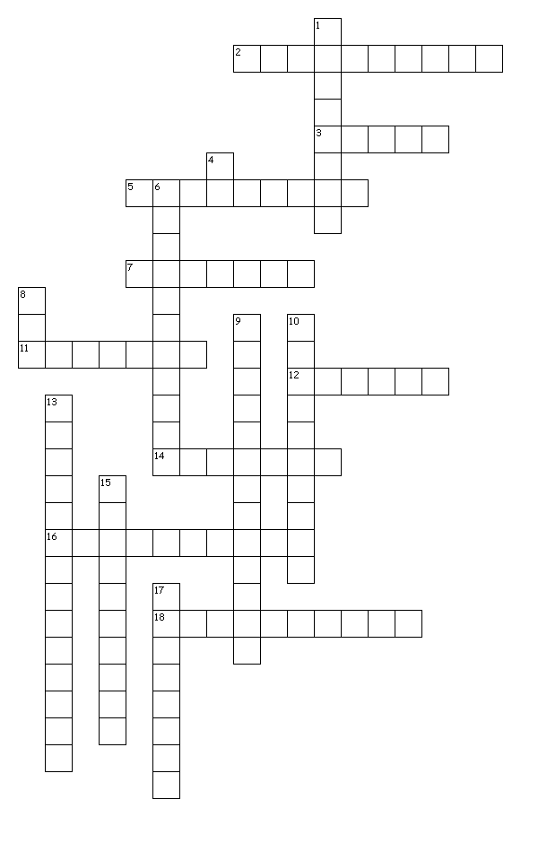


Across
2. Chronology is a form of presentation in which the order of events is fixed, for instance, an animation piece that shows the growth of a plant. Because animation takes a significant amount of time to photorealistic render each frame, it is recommended that students only photorealistic render one object with one frame for portfolios.
3. In rendering, adding artificial light highlights what the user wants to focus on when natural light is eliminated. Most programs default to sunlight so nighttime views have to have the sun ‘turned off’ in order to effectively show the artificial light. Some of the software have sun and locations located under geographic location. Others have it under the render commands. Note that the morning has longer shadows than at noon when the sun is overhead. The glow effect is an option available separately from light on a few of the software packages. Most will automatically ‘glow’ if the artificial light is turned on when setting up the rendering operation.
5. Images are rendered to make them appear more real in the digital world. Note that often objects are photographed and then rendered through a process called physically-based rendering. The engineering design student is mainly interested in the synthetically based rendering, one modeled first and then presented through rendering.
7. Digital means something that is electronic; binary; numerical, or anything computer based.
11. Shading is used in an artistic, aesthetic way, to show depth, texture or another characteristic of a surface.
12. Many programs allow the perspective of the viewer to be changed before rendering by setting the camera angle. It’s like pointing a spotlight at the object to highlight the particular desired view. The software may call this perspective instead of camera.
14. The surface material of object(s) in virtual reality like wood, metal, textiles is known as texture. Texture reflects light and can range from a bright, shiny, mirrored appearance to a dull, light-absorbent appearance.
16. In virtual reality, reflection is the photorealistic rendering of the interrelated effects of lighting on objects and surfaces.
18. This eliminates the need of transferring objects into triangles before rendering and significantly speeds the rendering process. Many software packages use ray tracing as an option to set variables like the coordinate systems, and textures alignment to the X-Y-Z axis system.

Down
1. Digitally creating a three-dimensional object or space, especially in computer animation and virtual reality defines modeling. Different software packages use different words for rendering effects. In modeling, most have a wireframe option that shows all the sides of an object, almost as if it were made of glass. Another option is the face where only the face of the object shown to the viewer is displayed, like a wireframe but all the lines behind the shown planes are not visible. Some software options include a grey scale where the object is shown in various shades of grey. Concept rendering shows an almost cartoon aspect of the textures and is more color driven without the textures. Realistic rendering is the best most modeling software can do to mimic photorealistic where textures and colors and background are rendered. The best photo rendering like those displayed in cinema (think Avatar) either use software that does both modeling and rendering or was modeled in one software package and exported and rendered in another program that was developed just to do photorealistic rendering.
4. Three-dimensional is a specific way of presenting a scene or an object. It is commonly used in computer animation, virtual reality, environment, etc. As most photorealistic renderings are attempting to create as realistic a presentation as possible, and the human eye sees in three dimensions (pictorial drawings), rendering is recommended in 3D.
6. A digitally created space environment is where the user can move objects around on a scene, much like in the physical environment (rotate, change coordinates). The environment can also be adjusted in most rendering software for changes in atmospheric (fog, dust, smoke). Some software calls the background “environment” in their programming. It is normally the last thing modified when photo-realistic rendering objects and scenes.
8. (World Coordinate System) The space where the objects reside is often called the WCS (called environment in some software packages). NOTE: You can change the vertical and horizontal positioning of texturing using the UV options on a lot of software. Some software will give you options on the planar mapping to change the alignment (X-axis, Y-axis, Z-axis) and the orientation (horizontal or vertical).
9. Compatibility is the transference of data from one program to another, for instance, modeling something and then moving it to another piece of software to photorealistic render the object. This is discussed in greater detail in the modeling section.
10. The background shows up behind the image in rendering. Many programs allow jpgs to be opened, adjusted or stretched to fit to form a background.
13. Ideally, the viewer would be unable to tell the difference between a real subject and a digitally generated object when object is photorealistic rendered.
15. Light bends as it travels through something (refraction). In rendering, refraction or index of refraction can be adjusted before rendering. When setting up rendering, sometimes under Ray Tracing, the ability to change the refraction is sometimes labeled IOR (Index of Refraction). The value of glass is 1.5 so if you are working to achieve a glass effect, use that value (1.5).
17. The physical work itself is an artifact; an essay, a test, a drawing, a plotted drawing. This is important because photorealistic drawings often find their way into formal presentations and student portfolios.

Answers:

Across

2. Chronology
3. Light
5. Rendering
7. Digital
11. Shading
12. Camera
14. Texture
16. Reflection
18. Ray Tracing
Down

- Modeling
4. 3D
6. Environment
8. WCS
9. Compatibility
10. Background
13. Photo rendering
15. Refraction
17. Artifact

