AutoCAD: How to Draw Good-Looking Bolts (From the Trenches Tutorial)
http://www.cadalyst.com/cad/autocad/how-draw-good-looking-bolts-from-trenches-tutorial-11188

Here are step-by-step instructions for drawing bolts and nuts for exploded assemblies. These instructions are designed to help you make an exploded assembly with bolts that look like threaded bolts. You will be drawing bolts rather than inserting them from an online catalog. It will explain how you can make a bolt's threads look like bolt threads, with evenly spaced sections. You will be drawing a bolt that is .25-10x1.
Set Snaps to at least 1/16 or 1/32. Draw a 1" long line and offset it 1/4".
Set PDMode to 3. Set Running Osnaps with Node on.
1. Divide the top line into 11 (gives 10 points).
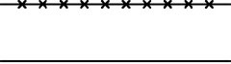
2. Make a circle from the rightmost node point to the one just to the left of it.
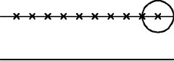
3. Draw a line from the center point down to the quadrant point of the circle.
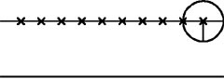
4. Use grips to move the end point up to the middle.
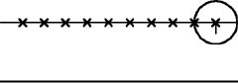
The last two steps will give you the "Root, which is one-half the distance between two crests" this is needed to make a proper looking tooth.
Erase the circle and the vertical line.
5. Copy the top lines node points to the end of the just created line.
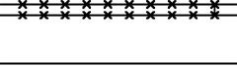
6. Move the bottom node points to the right one-half the distance between the two node points.
Use "Mid between Two Points" on Snaps to do this. Copy the leftmost node point to the left one-node spacing so that you have one more node point on the bottom line. You now have two sets of node points, with the bottom set one-half the distance to the right.
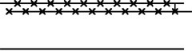
Use a pline to go from the upper-right line end and zigzag your way to the left end. You will now have the upper crest and root of the threads.
7. Now erase all the node points on both lines; the only thing left (on the top) is the zigzag pline.
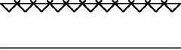
8. Mirror the pline to the bottom line. Notice that the plines' crests touch the same way on the upper and lower lines.
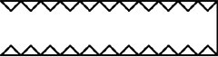
9. Erase the lines, leaving only the two plines. Move the bottom pline to the right one-half the distance between two points. Use "Mid between Two Points" to do this.
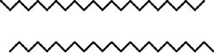
10. Now draw three lines:
The first one two crest lines in from the left
The second one from root to root just to the right of above
The third one from crest to crest just to the right of above
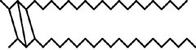
11. Now you can see that they are misshapen. We will now shape them correctly.
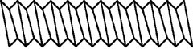
12. Delete the rightmost line, leaving one crest line and one root line. Draw a line from the left crest to the third crest over (three crests long) and draw a line from the left root to the next root.
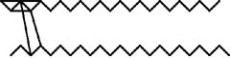
13. Use the grips to move the endpoint of the first line to the midpoint of the bottom root line.
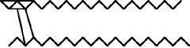
14. Extend this line to the top crest line. This shows that the crest points need to be moved to the left so that they will be in the middle of the root spacing.
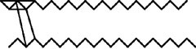
15. Stretch ALL of the crest points from the crest point just to the right of the extended line to the end of the extended line. Hint: Stretch all the points, then remove the vertical line so that it stays where it is.
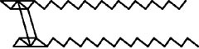
Perform the same sequence for the bottom section. Erase all the nonessential lines and copy all the vertical lines and fill in the blanks to make it look like bolt threads.
It is now necessary to adjust what we have just created.
16. Move the whole assembly from the left crest point to a snap to the right. If you don't, it will be off somewhat and will affect placement. Now draw a vertical pline from below the left bottom lines (dimensionally vertical to the top crest point) up past the top crest point, then to the right 1" and down past the whole assembly. This will help to readjust everything to 1" long.
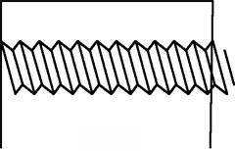
17. Copy the crest/root lines to fill in the blanks.
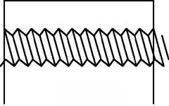
18. Trim all excess lines to the 1" long reference line. Now you should see properly spaced bolt threads.
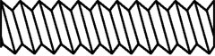
Once you create one and understand the concept, the process is really quick.
You can also use scale and reference to quickly make other sizes (with the same number of threads per inch).
Draw the Matching Nut
Now that you know how to make good-looking bolts, try this method to make the nuts to match.
A. Draw a circle of the correct height according to a bolt chart.
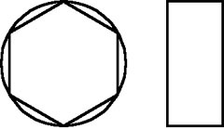
B. Make a six-sided polygon in the center of the circle and use Inscribed to go up to the quadrant of the circle. To the right of the polygon (and in line with the circle), draw a rectangle the same height as the circle and give it the correct width. Now draw lines from the two midpoints of the polygon across the rectangle. This creates the flat sides of the bolt head. Trim the rectangle out.
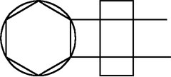
C. Offset the rectangle (in this example only) 1/32".
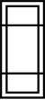
D. Draw an ARC on the left side, from the first intersection point on the inner rectangle and flat side of the bolt line, to the middle of the left line back to the bottom intersection point on the bottom rectangle and flat of the bolt line.
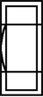
E. Copy the arc from one endpoint to the other. Then copy it from the other endpoint to the other end. One-half of the Arc will extend past the bolt head on each side.
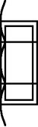
F. Trim the arcs back.
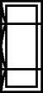
G. Erase the center rectangle, then TRIM the two Bolt "Flat" Lines to the end of the arcs.
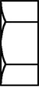
H. On the right side of the threads, draw a line from the bottom crest up 1/4" (1/4" bolt). Draw another line from the midpoint of this line beyond the end of the threads. This gives you a place to put the bolt head.
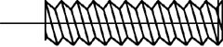
I. Move the bolt head from the middle of the right side to the intersection of the bolt threads and erase the two construction lines.
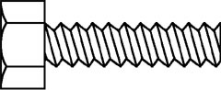Voila! You have drawn a good-looking nut to match your good-looking bolt.

