Fasteners & Springs UNIT TEST
Threads & Fasteners
Identify the parts of a screw/thread.
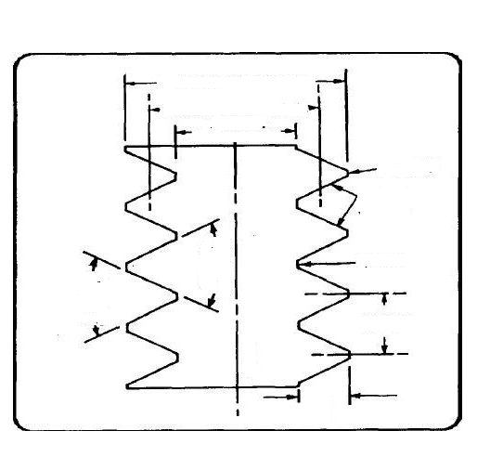
A
B
C
D

E
F
G
H
I
J
D
A – H –
B – I -
C – J -
D –
E –
F –
G –
Identify which of the following are Simple, Schematic and detailed drawings of a screw.
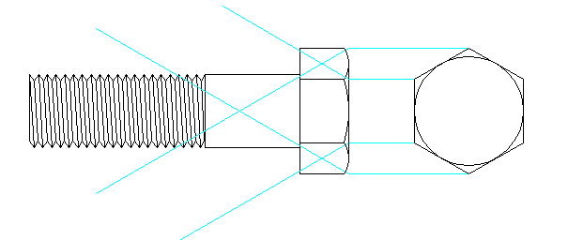
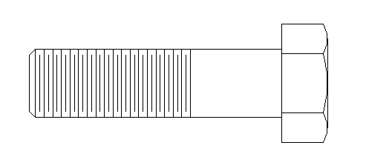

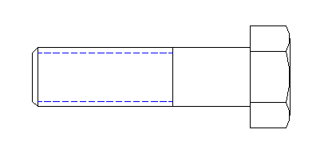

What does all of the following of a callout for a screw mean? 