Fasteners & Springs UNIT TEST Answer Key
Identify the parts of a screw/thread
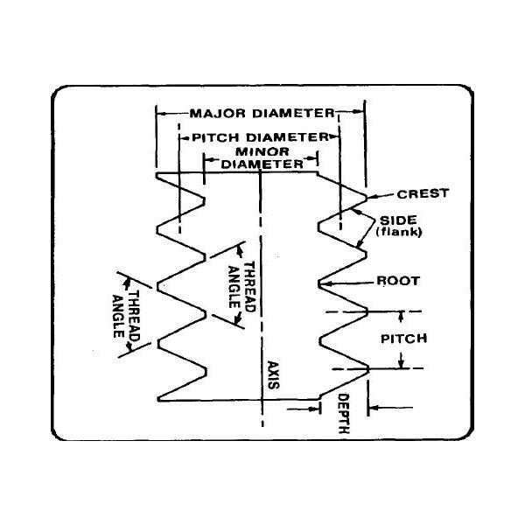
A – Major Diameter
B – Pitch Diameter
C – Minor Diameter
D – Thread Angle
E – Crest
F – Root
G – Pitch
H – Axis
I – Depth
J – Side or flank

Identify which of the following is Simple, Schematic and Detailed drawings of a screw.
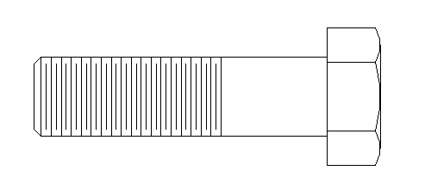 Schematic
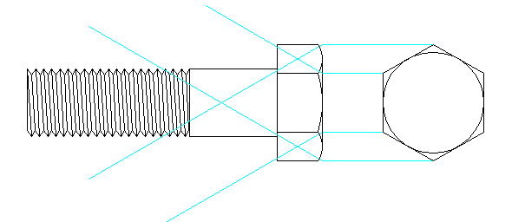
Detailed
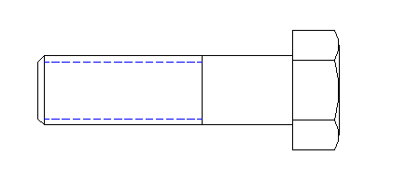
Simple

What does all of the following of a callout for a screw mean?

