Identify the parts of a screw/thread
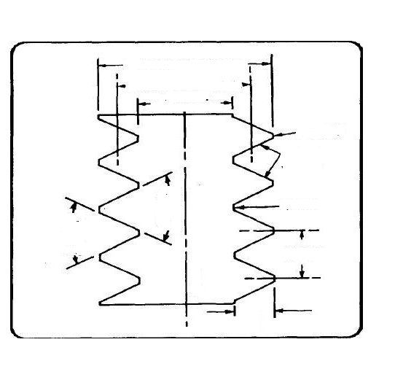
A
B
C
D

E
F
G
H
I
J
D
A –
B –
C –
D –
E –
F –
G –
H –
I –
J –

