Identify the parts of a screw/thread
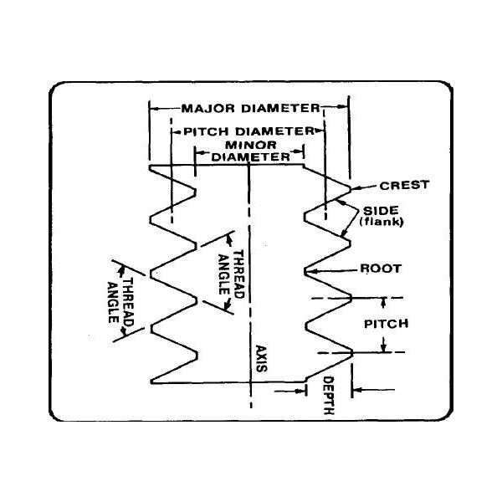
A – Major Diameter
B – Pitch Diameter
C – Minor Diameter
D – Thread Angle
E – Crest
F – Root
G – Pitch
H – Axis
I – Depth
J – Side or flank

