Day 1 Assignment
Mechanisms: Belt & Chain Drive Systems

The following part model will be created: MOTOR MOUNT

Study the following drawing before creating this model:

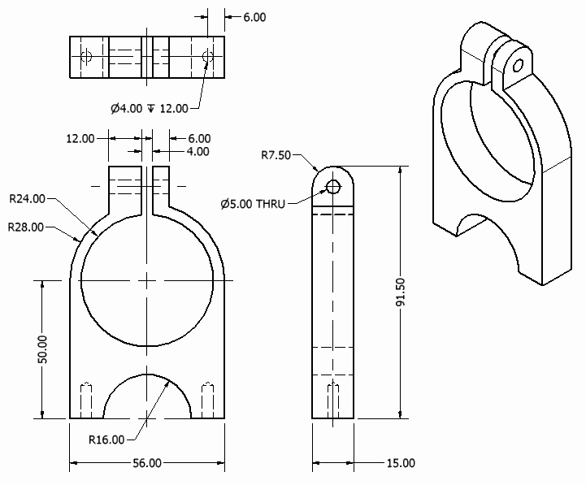

Create a Part file
- Select a metric format and insure units are millimeters
- This takes you into the Sketch environment automatically

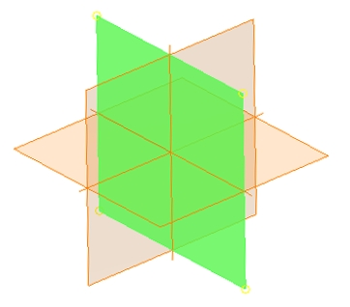
Create a 2D sketch located on the highlighted datum plane:

Create the following sketch. Note: Typically, the circle in the center would be a separate hole feature, giving the model flexibility for design changes.

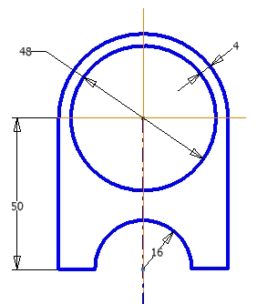

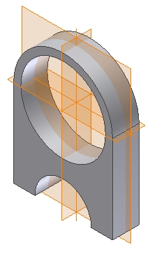

When the sketch is complete, extrude it 15mm as shown.

The default datum planes are shown in this model – you may have to activate their display properties in order to see them.

Create another 2D sketch located on the highlighted default datum plane.

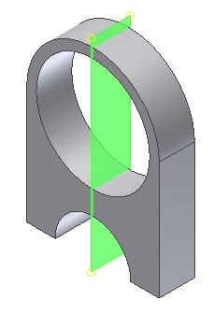

Create the following sketch.

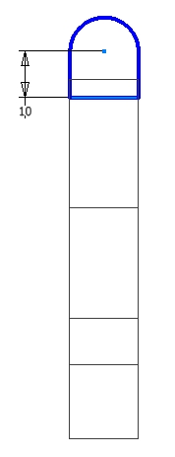

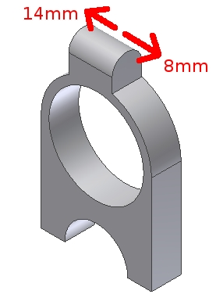

Use the sketch to add material to the top of the motor mount as indicated.

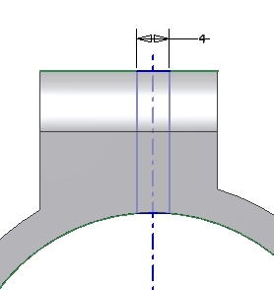

Create this sketch.

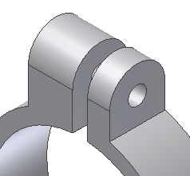

Use the last sketch to create a cut as shown.

Create a 5mm through hole located concentrically to the surface as shown.

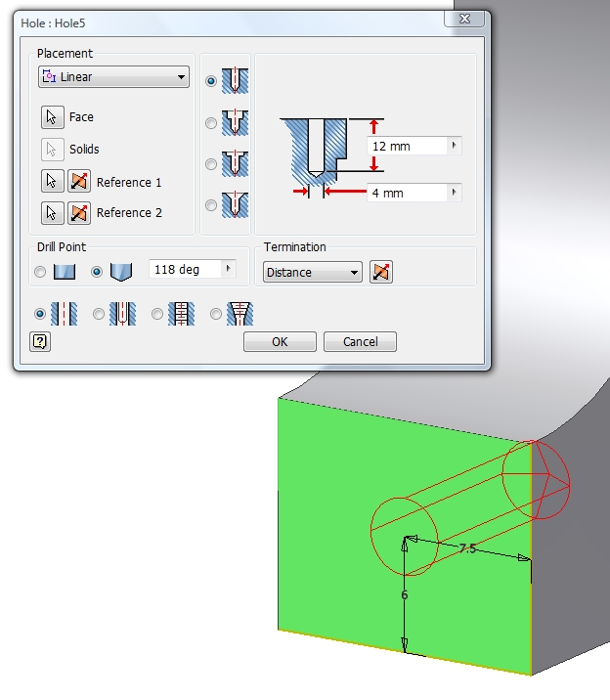

Rotate the model and zoom in so you can see the model as shown. Create the hole indicated.

Mirror the hole to the other side of the model.

This completes the MOTOR MOUNT part file. Create a drawing file using an A-Size sheet. Create the four views shown on page one of this document. At this point, don't add dimensions and other drawing notations. The working drawing of this part will be completed later.

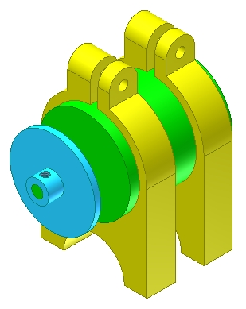

The following assembly will be created: MOTOR ASSEMBLY

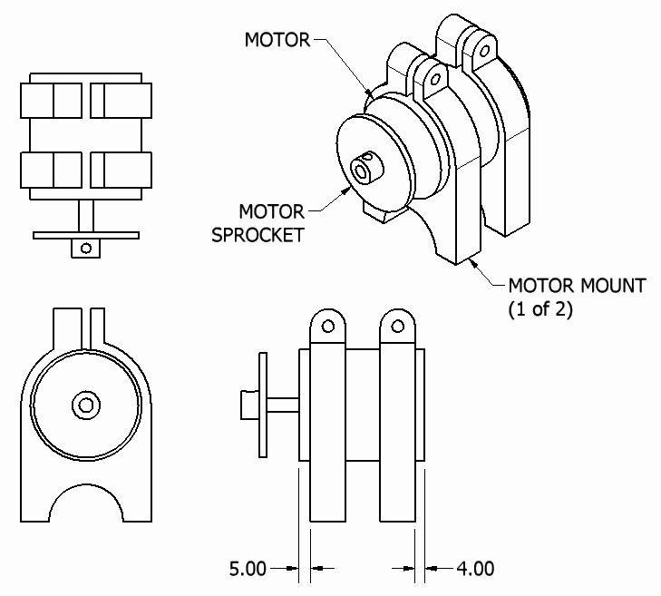

Create the other two parts used in the MOTOR assembly:
→ MOTOR
→ MOTOR SPROCKET

After creating all the parts for the MOTOR ASSEMBLY, create an assembly named MOTOR ASSEMBLY
→ Include all parts located and oriented as shown
→ Insure all parts are fully constrained.

