Day 3 Assignment
Mechanisms: Belt & Chain Drive Systems

Use the following drawings to create the TAIL PULLEY ASSEMBLY.

Three parts will be defined:
- TAIL BLOCK
- TAIL SHAFT
- TAIL PULLEY

An assembly will then be created:
- TAIL PULLEY ASSEMBLY

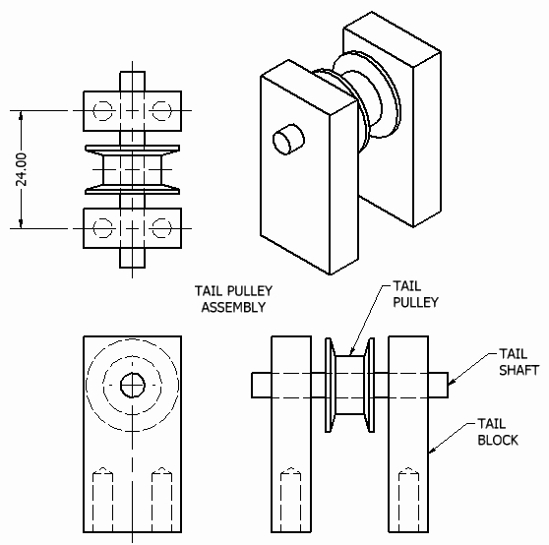

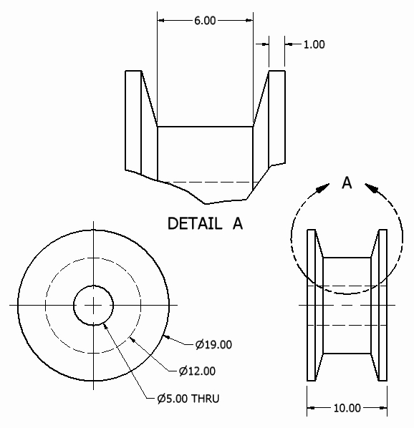

Tail Pulley

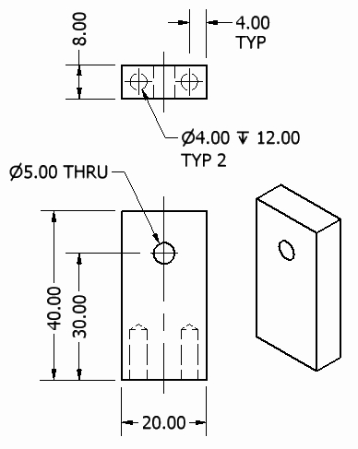

Tail
Block

