Day 4 Assignment
Mechanisms: Belt & Chain Drive Systems

Use the following drawings to create the assembly: DRIVE SYSTEM TABLE

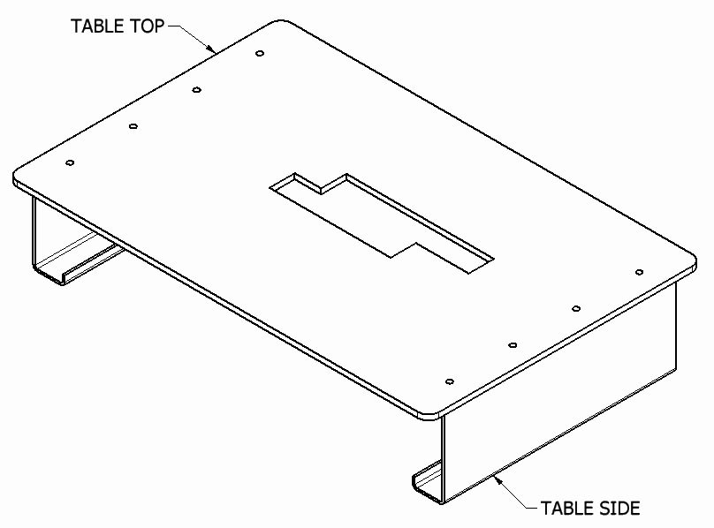



Review the drawings on the next two pages
Create these parts:
- TABLE TOP
- TABLE SIDE

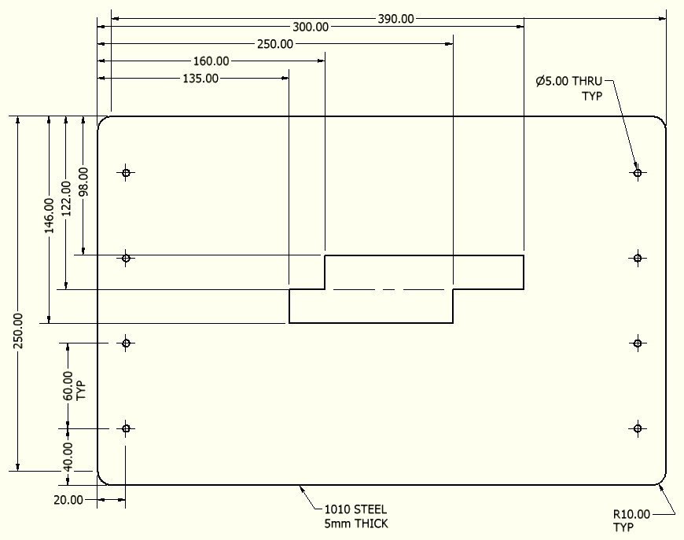

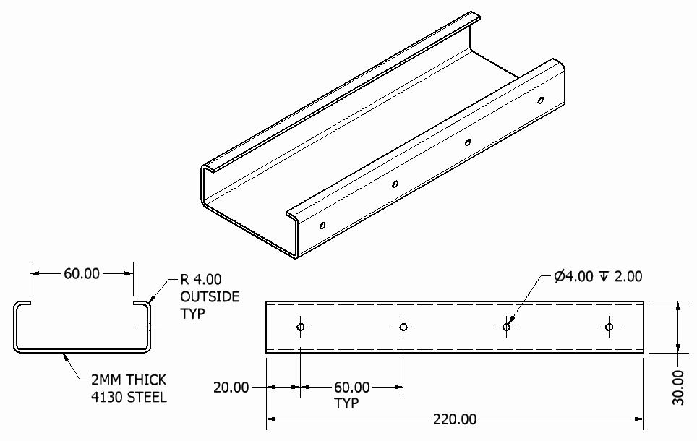

After both of these parts have been defined, create an assembly: DRIVE SYSTEM TABLE
- Align the holes and orient the parts as shown in the illustration of the DRIVE SYSTEM TABLE assembly above
- Save this assembly

A final assembly will be created: BELT & CHAIN DRIVE ASSEMBLY
- The following four sub-assemblies will be included

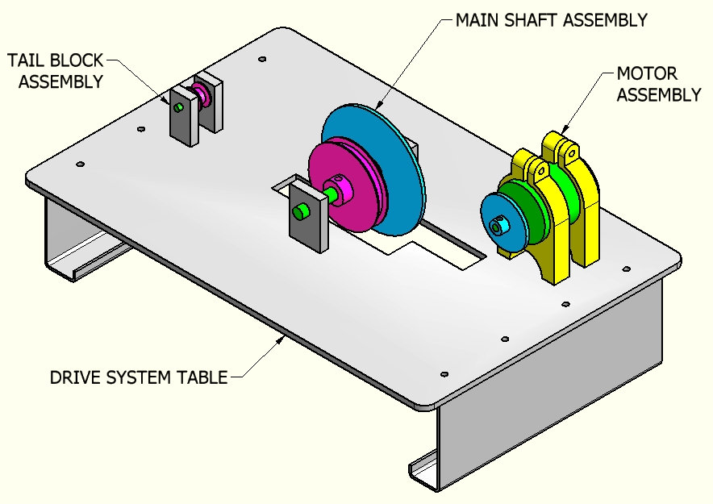

Carefully review the following drawings
Create the final model, BELT & CHAIN DRIVE ASSEMBLY by adding the following components as listed in this order:
- DRIVE SYSTEM TABLE
- MAIN SHAFT ASSEMBLY
- TAIL BLOCK ASSEMBLY
- MOTOR ASSEMBLY

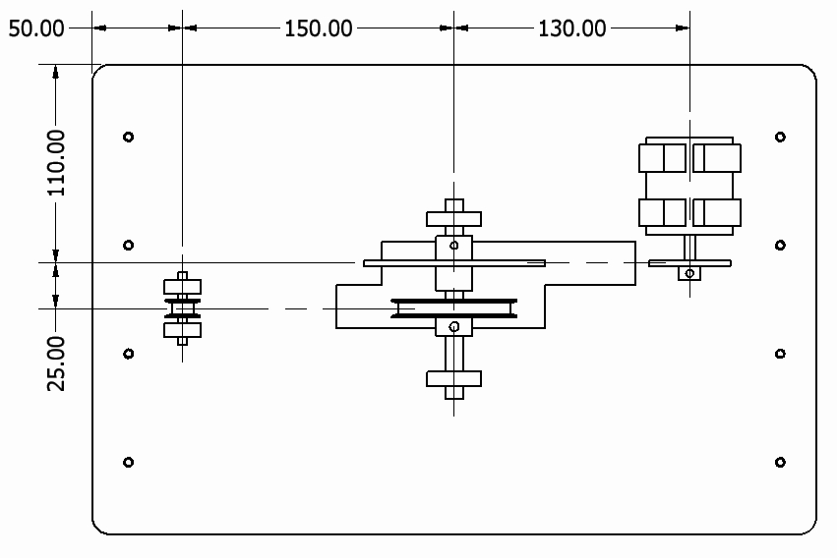

When the final assembly model BELT & CHAIN DRIVE ASSEMBLY is complete, automated belt and/or chain drive software may be used to define the various components.

Following is an example of using parametric CAD modeling software to create spur gears from simplified representations:

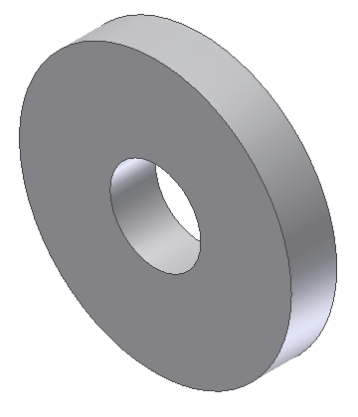
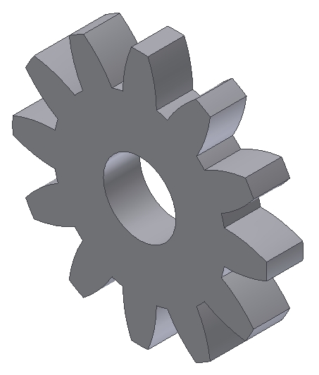

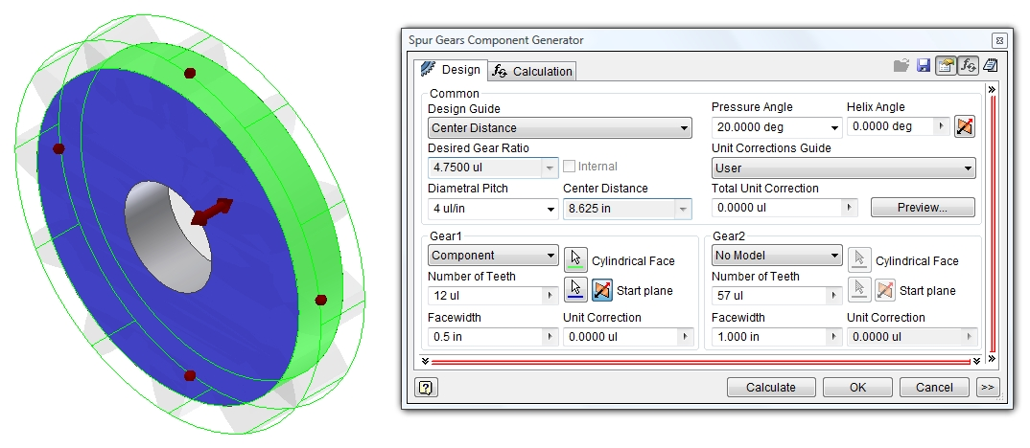
NOTE:
- Many times, especially prior to creating a set of final working drawings, simplified representations of belt and chain drive systems are used instead of defining the geometry representing the actual details of the drive components. Rather than using CAD geometry including belt teeth or sprockets with teeth, simplified versions are used instead.
- Before defining these simplified versions of belt or chain drive systems, the engineer must have reasonable knowledge involving many factors. Primary considerations include, but are not limited to the following:
  - The type of system used (belt vs chain drive)
  - The location of the components involved
  - The drive ratios desired

After this information has been established, a simplified belt or chain can be defined. The following illustration indicates how simplified belt and chain drives have been created.

Students should create two part files then recreate the geometry as shown.
- BELT
- CHAIN

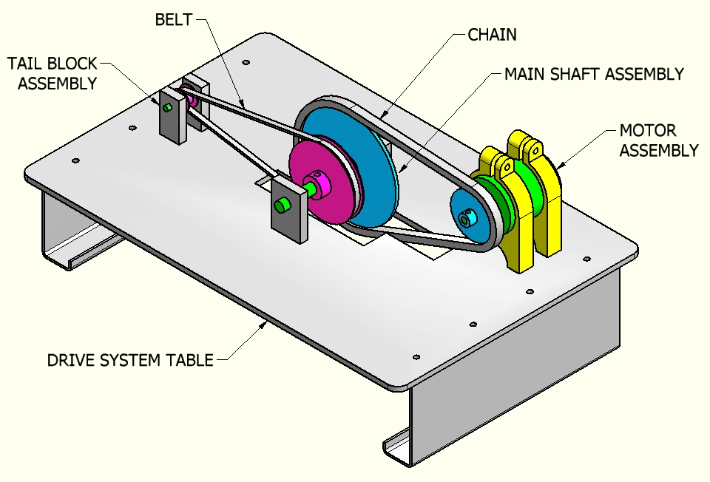

When defining the BELT and CHAIN part files, it is essential to create references to other components.

The desired result will provide automated changes to the BELT and CHAIN part files when other files are changed.

For example, when the MOTOR SPROCKET diameter is changed, the CHAIN part file should automatically update.

Also, a critical feature of parametric solid modeling involves drawing files which will also automatically update these changes as well.

