Shading Rendered Images of Models
Shading alters the colors of faces in a 3D model based on the angle of the surface to a light source or light sources.
The very first image below has the faces of the box rendered, but all in the same color. Edge lines have been rendered here as well which makes the image easier to see.
The second image is the same model rendered without edge lines. It is difficult to tell where one face of the box ends and the next begins.
The third image has shading enabled, which makes the image more realistic and makes it easier to see which face is which.
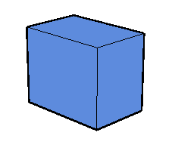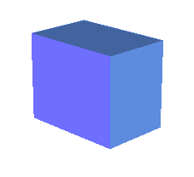

http://en.wikipedia.org/wiki/Shading



